STORIES OF CREATION

The debut collection by Slow Stone was born from a meticulously chosen slab of grey Saint Laurent marble, its observation and interpretation. With dark brown and copper tones that recall the earth, this stone is characterized by black and grey shades and white and irregular veins that allow each slab to be different from each other. It is the stone itself that becomes a source of inspiration thanks to the images created by the intertwining of nuances and veins.
One in particular revealed the face of a blindfolded man, the silhouette of a turtle and a wing: from this emerged the collection “Stories of Creation” with “Nommos”, the table “Prometheus” and the light installation “Wings of Cherubim” which, by their name, already represent a strong reference to mythology and the creation of humankind and the universe.

NOMMOS

While Prometheus was inspired by the figure of a human face, in Nommos the stone evokes the image of a turtle, an amphibious and terrestrial creature, often the protagonist of myths and legends.
The inspiration no longer comes from Greek mythology but from the ancient traditions of the Dogon, a population originally from Mali who worshipped the so-called Nommos, also called "Masters of the waters", anthropomorphic spirits from the system of the Sirius star system and settled on earth to dwell in a watery realm.
The name Nommos is therefore a tribute to these mythological creatures that, like the turtle, are characterized by the double bond with the earth and water.
And it is precisely this double bond that is represented by the Nommos piece of art in which the marble silhouette represents the turtle that rises from the water towards the mainland.
The hexagonal plinths, which recall the natural phenomenon of the Giants Causeway, surround the central structure and are created with materials that recall the five main elements present in nature: in this way earth, air, fire, water and ether correspond to wood, cut layered Lucite, brass and marble.
The effect within the Lucite hexagon elements that represent air and water was created due to the restrictions of a long waiting time for the desired material of solid blocks of colored Lucite. The artist and designer Samantha worked with the acrylic specialist to create the illusion of solid blocks, with the addition of optical glue sandwiched in between each layer to create the effect of clouds and water. The layers of Lucite were then polished to create an effect that is transformational; as one moves around the piece the Lucite hexagons change with each different angle of light. The unavailability of the solid Lucite blocks allowed for the creation of something more dynamic, and as on the Earth, it is these hexagon elements of air and water that bring the entire piece to life.
Nommos is a sculpture that can be used as a table or as a decorative element following the imagination of those who own it, as a real piece of art.

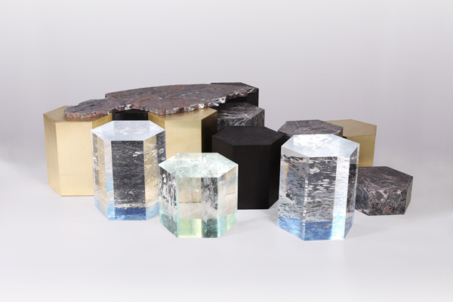
Grey Saint Laurent Marble Hexagon plinths of various heights
Materials used :

Brass
Lucite
Wood
Marble

Table size: 125cm x 185cm (approx.)

SLOW STONE
28 Ely Place, London EC1N 6TD, UK
www.slowstone.art – info@slowstone.art

OGS SRL PUBLIC RELATIONS & COMMUNICATION
Via Koristka 3, 20154 Milano
Ph. +39 023450605
www.ogs.it - info@ogs.it

