STORIES OF CREATION

The debut collection by Slow Stone was born from a meticulously chosen slab of grey Saint Laurent marble, its observation and interpretation. With dark brown and copper tones that recall the earth, this stone is characterized by black and grey shades and white and irregular veins that allow each slab to be different from each other. It is the stone itself that becomes a source of inspiration thanks to the images created by the intertwining of nuances and veins.
One in particular revealed the face of a blindfolded man, the silhouette of a turtle and a wing: from this emerged the collection “Stories of Creation” with “Nommos”, the table “Prometheus” and the light installation “Wings of Cherubim” which, by their name, already represent a strong reference to mythology and the creation of humankind and the universe.

PROMETHEUS TABLE

The Prometheus table can be defined as the main protagonist of the Stories of Creation collection.
The image of a blindfolded man’s face, created by the intertwining of the veins and nuances of the stone, reminds the face of Prometheus, a mythological figure who challenged the gods to restore fire to humanity, and it is precisely the imposing silhouette of this face set in the marble of Saint Laurent, which represents the starting point of the Prometheus table.
It is the marble slab itself that contains the face of Prometheus, which remained hidden for centuries before being discovered and transformed into a unique piece capable of combining the characteristics of a decorative piece of furniture with the elegance and creativity of art.
The head has been cut out of the Grey Saint Laurent Marble and the facial details have been emphasized using a water jet to etch out the details. Gold leaf has then been inlaid to represent a blindfold over Prometheus’s eyes, becoming a metaphor for being blinded by his desire as well as an expression of the fire itself.
During the working phase and to give more intensity to the gold, it is rubbed back to highlight the white veins of the marble.
The table top is made of burned wood to symbolize once again the fire power needed in ancient times to burn the wood used to heat and cook.
The use of polished bronze to create the base of the table is not a coincidence, but is an additional reminder of the importance of the fire used since ancient times to forge and shape all types of metal.
The entire structure rests on transparent Lucite legs that give the whole an impression of lightness and evanescence expressing the ethereal character of the myths and legends.

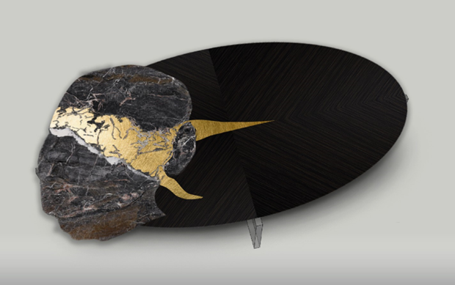

Grey Saint Laurent Marble and Shou sugi ban burnt wood, inlaid with gold leaf
Burnished bronze covered base
Cradled on clear Lucite legs

SLOW STONE
23 Ely Place, London EC1N 6TD, UK
www.slowstone.art – info@slowstone.art

OGS SRL PUBLIC RELATIONS & COMMUNICATION
Via Koristka 3, 20154 Milano
Ph. +39 023450605
www.ogs.it - info@ogs.it

