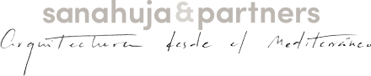
Cultural and Multifunctional space Les Useres

Description: Building for cultural and recreational activities
Place: Calle Figueroles L’Alcalatén, Les Useres (Castellón)
Construction completion date : 2018
Construction: Servicios, mantenimientos y obras Sevengar S.L.
Area: 500 m²
Photographer: ACF fotografía C.B.

"Project of minimums looking for a greatest community"

The typology of the building is a model of simplicity focused on achieving a very clear, useful, simple space and easy to maintain. However, it has been avoided to fall into a simple industrial tipology design, also trying to make the final result in harmonization with the environment. Basically and in broad strokes, we find an exposed concrete cube on which a flat roof lies. In the lower part of the volume it is harmonized with the predominant architectural style of the area by adding elements such as wood and handmade bricks.
The activities that will be carried out inside will be parties, meetings, conventions or fairs. For all this, it is necessary to comply with a series of legal requirements in terms of safety and health, which undoubtedly fulfills this project strictly. It is composed mainly of a diaphanous room where the different activities will be helded. On one side it has a bar counter, a toilet center, a locker and a warehouse. It also has a hidden flat cover as an interior patio where the facilities can be housed.

sanahuja&partners
www.sanahujapartners.com

Ogs Public Relations & Communications
Via Koristka 3, 20154 Milano, Italy
Ph. 0039 023450605
www.ogs.it - info@ogs.it

