Hotel Mercure
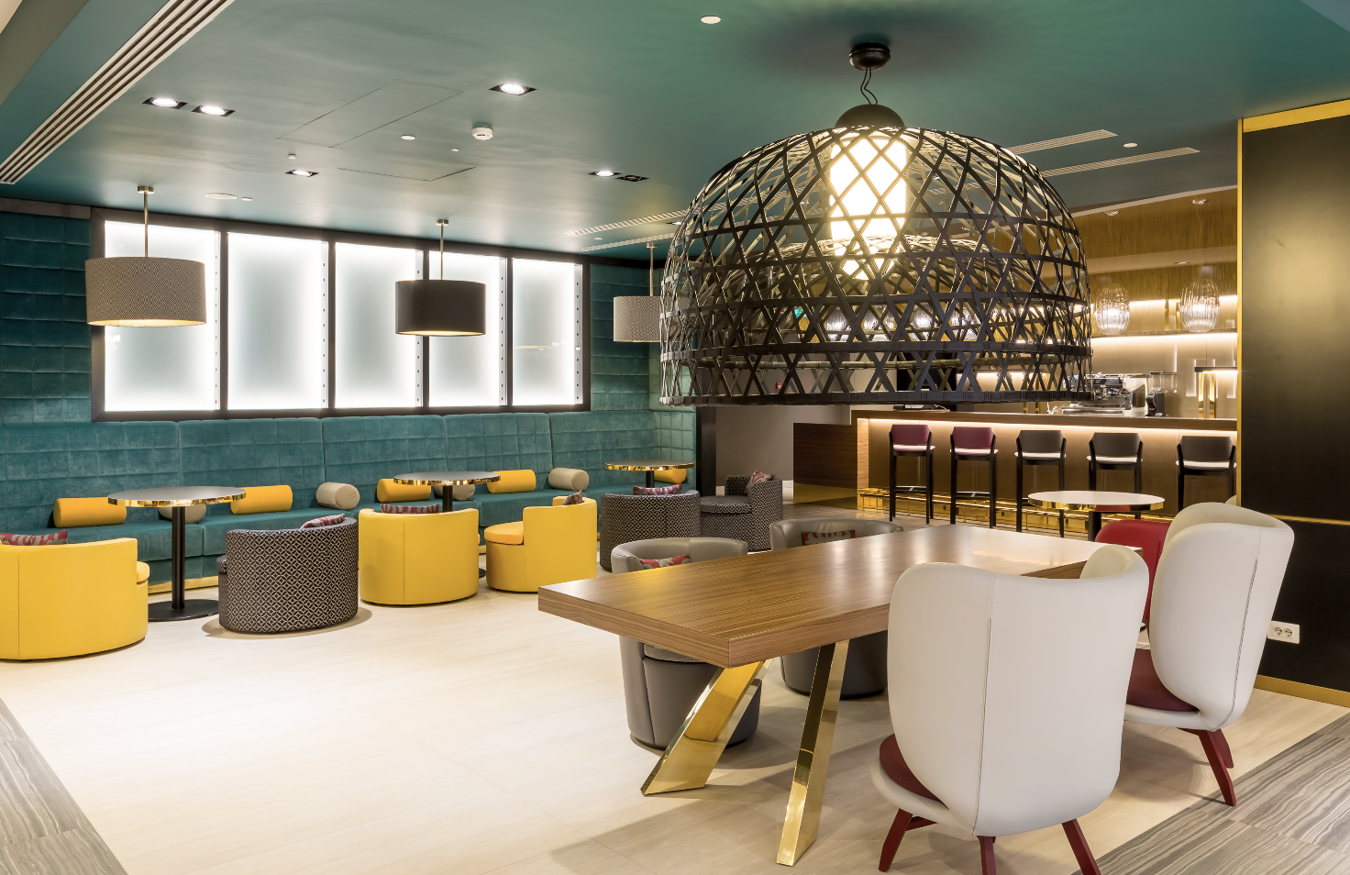
Almaty Kazakistan

The Mercure Almaty Hotel is a project where international chain standards and the charm of Kazakhstan are flawlessly fused together. A colorful, fully detailed and eccentric Interior Design is the main character in every space where textures and graphic decorations are inspired by Kazakhstan traditional art. The hotel located in a strategic position, in the city center, has eleven floors and boasts 117 well-appointed guestrooms with unique design inspired by local culture and traditional art. The spaces and services include two restaurants with the finest cuisine, lobby-bar, 4 spacious conference rooms and a relaxing spa-center with an amazing view on the mountain landscape. All the graphic elements remind the traditional decorations of the place. Starting from the brand wall in the entrance hall, to the moquette in the common areas, to the patterns of top tables, to the carpet and wallpapers in the rooms. Guests could perceive the tradition of Kazakh also in the choice of colors and color contrasts. In the lounge, the welcome space is created using huge lamps which recall YURTA, the traditional house of the nomadic people of Asia. The nature is another important theme in the design of the space and we can find natural elements in the artworks.
All the materials and details are matched by the attention to the latest trends without losing sight of the comfort scenario making the hotel the perfect combination to reach success for such an international target who is planning a business trip or a leisure travel.

NAME Hotel Mercure
LOCATION Almaty, Kazakistan
YEAR 2018

CABERLONCAROPPI ITALIAN TOUCH ARCHITECTS
Via Scipione Piattoli 7,20127 MILANO
Ph. +39.02.2871216
www.caberloncaroppi.com – info@caberloncaroppi.com

OGS SRL PUBLIC RELATIONS & COMMUNICATION
Via Koristka 3, 20154 Milano, Italy
Ph. 0039 023450605
www.ogs.it - info@ogs.it

