Modica Beach resort
Modica RG

Nestled in the overwhelming context of Modica, Sicily, the Modica Beach Resort is characterized by its simple and elegant lines that fit perfectly into the typical baroque context of the town.
Structure with a refined Mediterranean flavor, the Modica Beach Resort overlooks the sea and it is developed over 4 floors for a total of 111 rooms.
The furnishings, characterized by modern and elegant lines, welcome the guest in a natural and fascinating context where he can live and experience the sea in a different way. From architectural and graphic design to materials and fabrics, everything recalls the Mediterranean warmth and the tradition of the Italian coasts, evident also in the color palette in shades of blue, coral blue and sand color.
A special project with a truly unmistakable style.
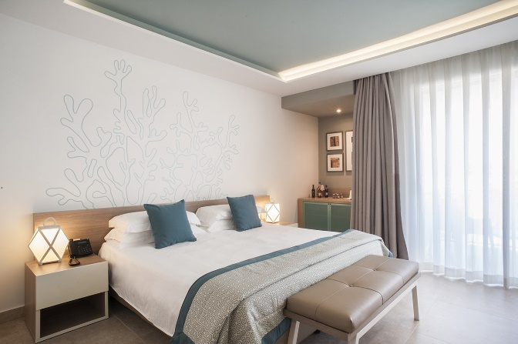
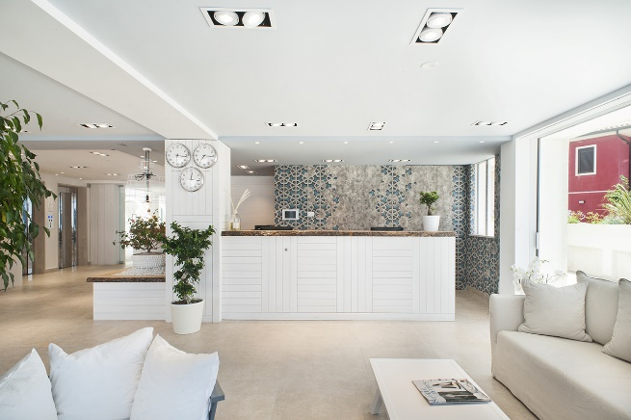

CABERLONCAROPPI ITALIAN TOUCH ARCHITECTS
Via Scipione Piattoli 7, 20127 Milano
Ph. +39 022871216
www.caberloncaroppi.com – info@caberloncaroppi.com

OGS SRL PUBLIC RELATIONS & COMMUNICATION
Via Koristka 3, 20154 Milano
Ph. +39 023450605
www.ogs.it - info@ogs.it

