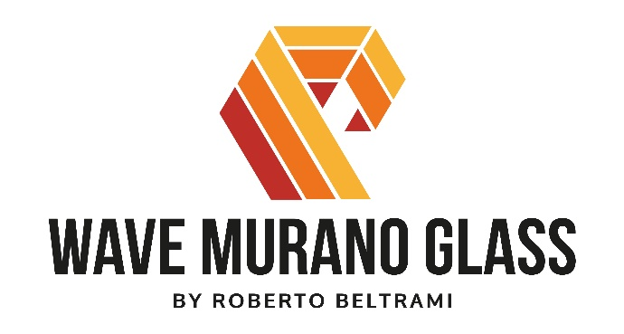
Vases, hanging lamps, sculptures, furniture: Wave Murano Glass catalogue includes all kind of creative possibilities that glass can offer to a skilled and courageous glass master like Roberto Beltrami. In the catalogue, you will find “historic” restyles created with avant-garde techniques and totally innovative methods born from formal and radical changes.
Wave Murano Glass presents many different innovative collections in terms of technical skills in producing glass and the originality and variety of solutions proposed to the market with a 360-degree vision in furniture.

SCILLA BASIN
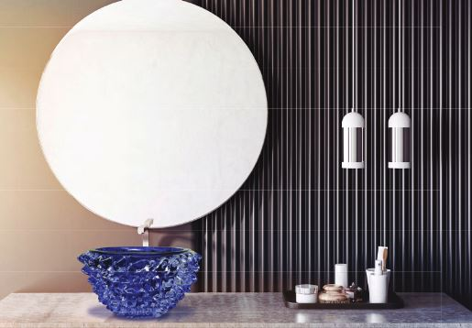
The extraordinary success of Spike vase made blown glass thought the ancient technic of “Rostrato” led the Glass Master Roberto Beltrami to go further in his artistic research by trasforming the vase into a bathroom sink. The vase, a precious artistic object, in Murano blown glass, worked with a special tool called “tagliol” (sculpting knife) at a hote temperature up to 1000 degrees, was turn into a sink and Scilla basin was created. The sink has the power to transform the bathroom in a museum. A sink that its unique as it is the vase and like the Scilla nymph of Greek legend. Scilla basin proudly joins the collection of Wave Murano Glass showing all its beauty: it is not just a simple piece of furniture but it is the witness of the italian savoir-fare that can trasform any object preserving its form and change in different uses. Scilla Basis is a high quality design piece that gives life to the space.
Rabindranath Tagore says “… and you continue to empty this fragile vessel and always fill it with new life”. Wave Murano Glass was inspired by one of its most beautiful vases to create a new piece, a new life. Welcome Scilla Basin.

SPIKE
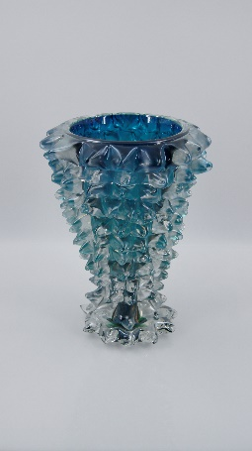
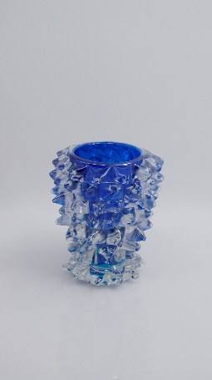
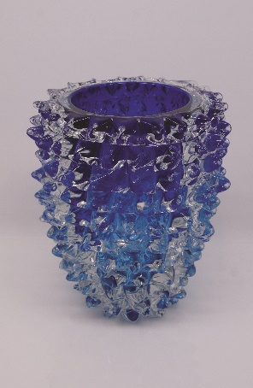
Enormous blown glass vases created through the fascinating technique of “rostrato”, enriched with chromatic and manual interventions. It is an ancient process that requires a particular speed of execution, concentration and precision.
The hot glass is quickly worked with a special tool called “tagliol” (sculpting knife) which allows to create a series of square shapes along the entire surface of the vase.

Subsequently, through small pincers, each shape is stretched to form a point that takes the name of spike. The whole process must be carried out in a very short time due to the high glass temperatures reaching up to 1000 degrees.

"Every time it's like a Russian roulette," says the master Roberto Beltrami and continues, "every slightest mistake can involve the risk of a severe burn but at the same time it is an intense and stimulating physical and mental exercise that requires great concentration and attention".

OCULUS
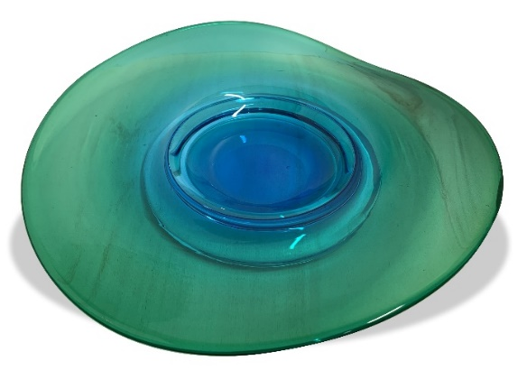
The Oculus collection products are flexible, oneiric and evocative. Only with the name, it reminds us a big eye got with a real technical virtuosity. The piece can be used as a table centrepiece, playing with the asymmetrical volute of its shape, or a decorative “hanging” element, also modularly combinable in order to create light, colourful and transparent shadows.

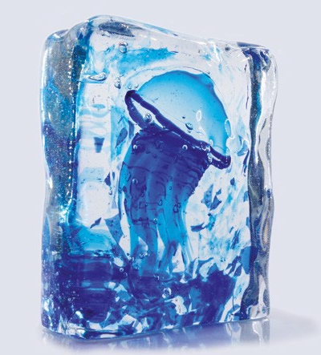
AQUARIUM
Aquarium is a solid Murano glass sculpture made with the “Sommerso” technique, with a colored jellyfish inside.
Sommerso is a form of artistic Murano glass that has layers of contrasting colors (generally two), which are formed by dipping a gather of colored glass into another molten glass and then blowing the gather into the desired shape; the outermost layer, or casing, is often clear.

GOTO
The Goto is a Venetian dialect word for cup. The Goto collection reminds the typical drinking cup hand-blown by the glass master with his own artistic mind. To keep hydrated in the hot furnaces (1000° C), glass masters drank lots of water... and lots of wine! With Goto, Wave Murano Glass brings a touch of true Italian art on your dining table. Goto is available in different measures, formats and colors
Little (h 8 cm)
Medium (h 11 cm)
Big (h 13 cm)

PUPI
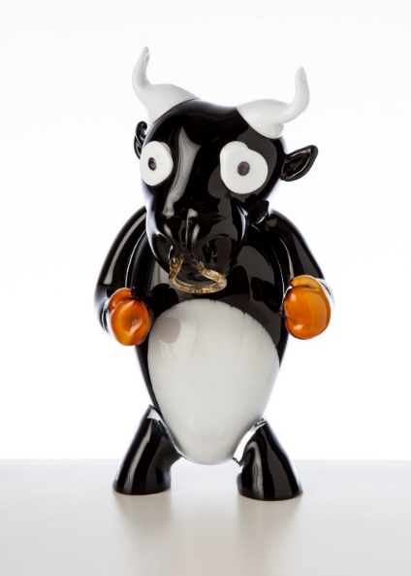
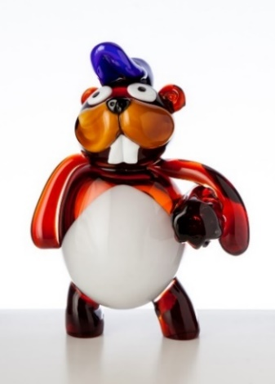
A pop-comic Murano Glass collection. They are PUPI, 100 % hand-blown Murano Glass, completely custom made and personalized. It is possible to choose the preferred “Pupo” such as cats, rabbits, bears, zebras, elephants, giraffes, crabs, snakes, reindeers, monkeys… and transform the Pupo in any character, in a doctor, cowboy, super hero, businessman, ninja, sheriff, baseball player. Unique sculptures in which the customer can choose the animal species, sample work outfits, clothes and gadgets by playing with the imagination and creating its own work of art.
The Glass master Roberto Beltrami played with his fantasy.
Everyone wants a Pupo!

FLUTE

The idea of the flute originally came from vases that were once made in Murano by heating the neck of old wine bottles and pulling them into thin spikes. This inspired a piece that ties its roots with the millenary glass tradition of Murano while having a modern design.
Flute is adaptable for any type of spaces, interior or exterior. You should play with colors and fantasy.

BUCATI

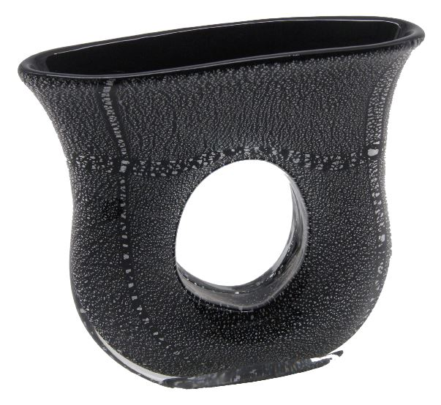
The so-called “vases with the hole”. An original idea not easy to realize which requires a specific technique to create the opening across the two sides of the red hot glass vessel. Bucati are enriched by the use of 24kt gold leaf and silver leaf stratified with black glass and coated with a final layer of clear glass that gives to the vase preciousness and brilliance. A characteristic of Bucati collection is the iconic window that grants the vase to maintain a see-through property in its colorful and decorative chromatic richness. Bucati collection is available in different colors: black, silver leaf, transparent glass.

SEDANI
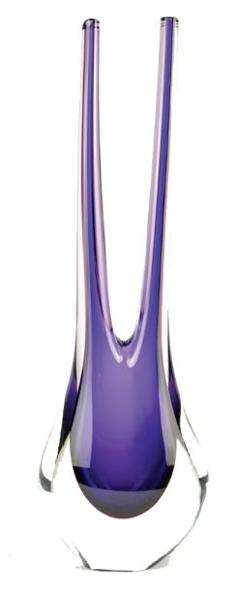
Have you ever thought to have a celery as a decorative pot? Sedani is a collection made up of beautiful and colorful vases which give energy and vitality to home decoration. Made of blown Murano glass, Sedani vases can adapt to any environments and spaces creating bright atmospheres. Thanks to the particular shape it is possible also to use the vase for flowers, thus giving it back its original functionality. Sedani collection is composed of unique decorative vases which, even if taken individually, have the power to majestically fill the house.

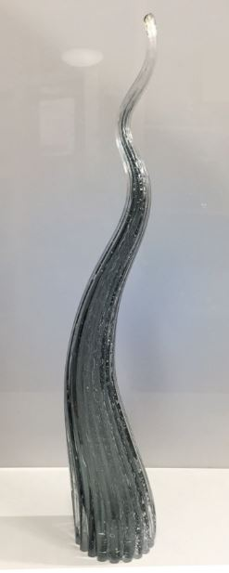
CURLY

Sculptures characterized by a particular shape, reminiscent of a dancing flame, extracted from a piece of double-layer mouth-blown glass.
All the air bubbles are made by adding organic substances to the transparent glass, which decompose and release gas bubbles giving the sculpture an elegant underwater effect. A glass Murano working technique that requires experience and knowledge of materials. The organic shape and the variety in the choice of colors catch the eye in the setting, giving brightness, richness and depth.
Curly can be used as a single decoration element or in a composition of several elements, thus creating a great impact effect on any decor.

Wave Murano Glass
Ramo da Mula 5/1 – Murano Venezia 30141
Ph. +39 3290433343
www.wavemuranoglass.com - sales@waveglass.it

Public Relations - Ogs srl
Via Koristka 3, Milano 20154
Ph + 39 02 3450605
info@ogs.it - www.ogs.it

