CÀOS – Silvia Bini

Project: Studio Svetti Architecture | Emanuele Svetti Architect
Photo Credits: Andrea Bartolozzi Photographer
Category: Retail
Area: 800 sqm
Start of works: June 2016
Status: completed in April 2017
Location: Viareggio

"Order is the pleasure of reason but disorder is the delight of imagination" [P.Claudel]

Inaugurated in April 2017, the Càos store is the last of the projects carried out by the Tuscan volcanic entrepreneur Silvia Bini, a reference name for fashion on the Italian and international scene.
Studio Svetti Architecture curated the design and construction of this exclusive space characterized by the simplicity of lines and shapes and which sees inside corners dedicated to prestigious brands such Celine, Gucci, Fendi, Balenciaga, Valentino, Stella McCartney e Saint Laurent.

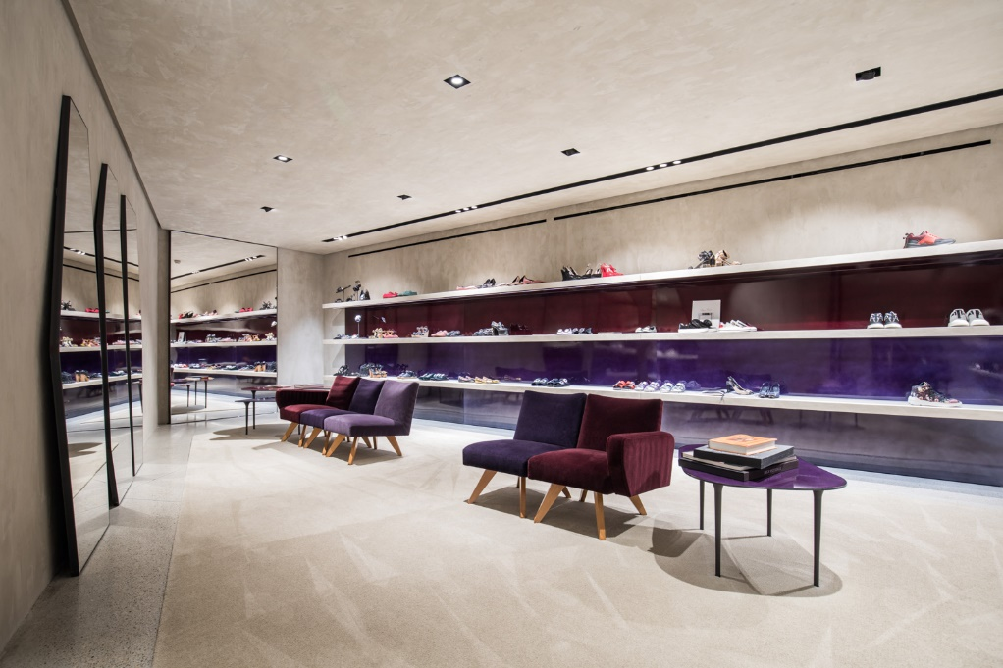
The new store in Viareggio is located in the premises of a historic building, the former Sorelle del Mare, on the city's waterfront. The guidelines of the original building have been maintained and the spaces distributed in succession on three floors, contextualized through different display systems, with a single fil-rouge: the celebration of the product.
The project intervention has upset those that were the morphological features of the existing environments through the elimination of every type of partition and thanks to the creation of a staircase body wedged in a triple volume. The minimal use of materials and furnishings gives a refined and essential character.
The space is dominated by the contrasts between the metal of the furnishings and the rough plaster of the walls or between the silk velvet upholstery of some wings and the materiality of the floor, the result of a wise mix of polished concrete and aggregates from local quarries.
Sinuous hand-crafted metal sheets, 3 mm thick, support the display, emphasizing the products against a neutral and dark color background.
The all tailor-made furnishings act as real architectural devices at the service of sales, in addition to articulating and hierarchizing every single internal space.

.

Suppliers
Construction company: AEFFEDI
Finishes: BM Clima
Lighting and Domotics: Zumtobel with Graziella Smart Technology
Glass doors and windows: Jansen Janisol and Toncelli Vetro
Wall finishes and coatings: Metropolis with Goti
Custom furniture: Casavecchia
Furniture and accessories: Nilufar, Knoll, Hervé Van der Staeten, Carl Hansen & Son, Rude design Collection
Glass furnishings: Vetreria Bazzanese

STUDIO SVETTI ARCHITECTURE ITALY
Via Lauretana 73, 52044 Camucia, Arezzo [Italy]
Ph. +39 0575 62530
www.studiosvetti.com - info@studiosvetti.com

STUDIO SVETTI ARCHITECTURE UK
71-75 Shelton St.Covent Garden, London [UK]
Ph. +44 (0) 7971 390 522
www.studiosvetti.com - info@studiosvetti.com

OGS SRL PUBLIC RELATIONS & COMMUNICATION
Via Koristka 3, 20154 Milano, Italy
Ph. +39 023450605
www.ogs.it - info@ogs.it

