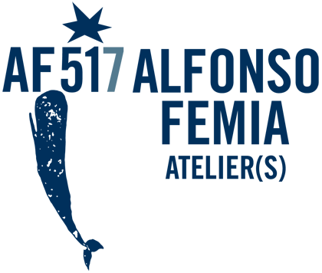

ALFONSO FEMIA / AF*DESIGN
Alfonso Femia, born in Taurianova, Reggio Calabria on 7 December 1966. Graduated from the University of Genoa - Faculty of Architecture in 1992. Enrolled in the Order of Architects of Genoa since 1994, of Île-de-France since 1995 and of Swiss architects since 2014. Alfonso Femia has been professor of Architectural Design at the Kent State University of Florence, and at the Faculty of Architecture in Ferrara and Genoa.
Founder of 5+1 in 1995, he created 5+1AA in 2005 and 5+1AA Paris in 2007. The 5+1AA studio in 2017 takes the name of Atelier(s) Alfonso Femia. Femia has won many international competitions and has been published in international journals. In 2015 he was the creator and founder of 500x100 video communication platform on the theme of the city. In 2017 he edited the IQD monographic issue 'Invisible Mediterranean', starting the research and reaffirmation of the centrality of the Mediterranean in the contemporary thinking. His research on the material has led him to collaborate with renowned design companies including: Castaldi Lighting, iGuzzini, PoltronaFrau, Casalgrande Padana, Martinelli Luce, Xilo1930, and Staygreen.
A lover of territory-cities, he defines time as the main subject of design and architecture. Man is time.
Flying with Wings and Lucifer are the collections designed by Alfonso Femia for 'Eterea' by Zambaiti Contract.

