Maurizio Morazzoni
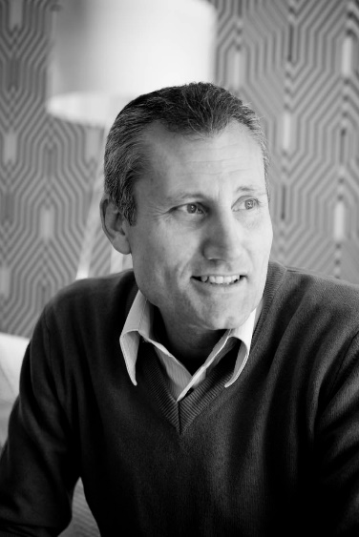
Architect from birth, Maurizio Morazzoni made his passion for architecture a philosophy of life. This ‘family’ passion was born by observing his grandfather transforming a piece of wood into a work of design and led him to follow this path with love and dedication, continuing to create and design.
Professionalism, technology and innovation are the three elements that characterize his work: a lover of art and fashion, he is always informed and updated on the latest trends in architecture and interior design. It is no coincidence that Milan is the city of inspiration for its architecture and its continuous ferment and dynamism. Each creation tells a piece of his history, each project he creates retains something of his own, something intimate, places where harmony and warmth reign. In his creations there is a strong combination of technological innovation, original craftsmanship, the search for art and the originality of design.
He never misses the opportunity to express all his creativity as shown in his Studio, the space for thoughts, research and the selection of materials, a custom-designed place that fully reflects his personality. Those who visit it, enter the world of the architect well interpreted by the sentence which can be read at the entrance and well summarizes his work: ‘Life is a raw material. We are the artists’.
All in all, Maurizio Morazzoni, an architect and an eclectic person, creates things and houses with an unmistakable taste and is the standard-bearer of Mariani Design and More blue colour, increasingly intense and strong.

MARIANI DESIGN AND MORE
Arluno - via Marconi, 12 (Italia)
Milano - via Visconti di Modrone, 8 (Italia)
Ph. +39 029017193
www.marianidesign.it - info@arredamentimariani.it

OGS SRL PUBLIC RELATIONS & COMMUNICATION
Milano - Via Koristka 3, (Italia)
Ph. +39 023450605
www.ogs.it - info@ogs.it

