Gaia Morazzoni
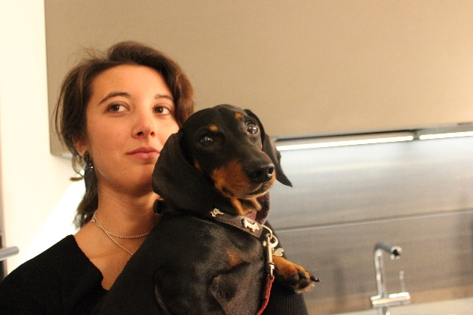
Gaia Morazzoni is an engineer, but her constant research is on colours. The home of her dreams is just like that: colourful, functional, full of positive sensations. Milan is her base, the city where she chose to live for its dynamism, its European character but also its very Italian taste. She grew up in the world of interior design, made up of creativity and art, a world to which she returns today after a course of studies in engineering that allowed her to acquire a more technical eye on the project to complement the artist's inspiration. In her work she stands out for her strong attitude for problem solving, her critical approach and speed in the execution of projects; an analytical mind capable of facing increasingly complex challenges without neglecting the details. She is fascinated by the transformations of obsolete buildings and this is the part of the business she loves most: restoring the existing real estate assets. She tackles each project in a team because it is from the comparison with other people that the most innovative ideas and solutions are born, allowing her to give the best with enthusiasm and commitment. Her favorite colour is blue, the distinctive and representative colour of Mariani Design, the Studio where she deals with architectural and interior design together with architect Maurizio Morazzoni, with the aim to carry on a historical name for the sector and an activity started more than 30 years ago. She is spokesman for the beginning of the fourth generation.
Today Gaia Morazzoni is the main actress of the Milanese challenge, that is the opening of the new showroom in the heart of the design district: "We have conceived - she tells us - the Milanese location as a large house, an example from where customers can take inspiration for their own house and choose the bricks to build their ideal home with us from our products and those of our partners”.

MARIANI DESIGN AND MORE
Arluno - via Marconi, 12 (Italia)
Milano - via Visconti di Modrone, 8 (Italia)
Ph. +39 029017193
www.marianidesign.it - info@arredamentimariani.it

OGS SRL PUBLIC RELATIONS & COMMUNICATION
Milano - Via Koristka 3, (Italia)
Ph. +39 023450605
www.ogs.it - info@ogs.it

