LE MASSIF
The mountain inside and out

A natural extension of the mountain that cradles and enfolds in an embrace full of intensity: this is Le Massif. Designed by architect Andrea Auletta and realized by Concreta as interior contactor, the hotel emerges from nature, an integral part of the majestic Alps and whose name defines the elegance and power of the mountains. Concreta is an interior contractor based in Postalesio Sondrio (Valtellina) that for 30 years with its own tailoring approach has been realizing projects around the wishes of its clients: sewing clothes on fantasies making them become a reality. Concreta offers turnkey solutions through an intricate structure that is based upon its philosophy of research, technology and service supported by many professionals involved in the phases of design and build. The advantage? A single Project Manager as counterpart, optimizing the management in the areas of intervention and respect of timelines, budget and methods requested. But above all else respecting the dreams. One of its latest project is Le Massif hotel.

Le Massif is inside the mountain and the mountain is within him: in all its impressive forms, in all its smallest details. Being in the mountain is a way of living life and Le Massif conveys the pride of the area and that of those who live and visit it. Located a few steps from Cormayeur at the foot of Monte Bianco it has views of the highest mountain in Europe and merits its five stars blending the warmth of wood, the intimate tradition of the alpine culture, with the Italian welcome that unites the hotel, resort and spa. The design concept recalls the Alps through rugs and fabrics specially designed to echo the patterns of the mountain sweaters, at the same time there is a touch of coveted trend and modernism that renders it refined and elegant. The light changes just as the mountain, giving the brilliance of its white coat that is mirrored inside, as is the suffused colors of the winter sunsets and those of the summer with their thousand hues and nuances.
The concept, inspired by larch and its ability to change according to the seasons, is enriched with décor in iron, aged leather, and naturalistic elements; in laser cut Corten steel, fabrics with tartan pattern and warm velvets. Typical cowbells inspire the design of some of the wall lights and the patterns of the carpet in the corridors that absorbs the noise of suitcases and footsteps.
For the external façade the effect of the wood is recreated through special titanium zinc plates. Stone is used for the flooring of the common spaces on the ground floor. Together they show a craftsmanship that is refined in detail and create an intimate elegant atmosphere that is informal at the same time.
Entering the hotel on the ground floor there is the Reception, the common spaces and the bar whilst the first floor is dedicated to the two internal restaurants where, under the attentive eye of the executive Chef Nicola Ricciardi, top class dishes are created that accompany the guests in the discovery of the gastronomy of the Aosta Valley through the careful choice of ingredients and the refined touches of both the French and Italian cuisine.
Available to the hotel guests not only is there a SPA, which alone occupies 800 square meters on the upper floor, there has also been built the gym and the heated swimming pool which extends towards the outside.

Le Massif prides itself with 8 floors and a total of 80 guest rooms and suites distributed from the second floor and above. Each room is welcoming and where you can admire the craftsmanship and the furnishings in their essentiality give rise to a timeless atmosphere.

The feeling of being at home, in the warmth, which shines through the wood, and the soft light warming the soul, the enhancement of each room through the natural materials and warm colors that wraps the space in a warm and intimate embrace. Wood is the undisputed protagonist in this jewel of the mountain. Untreated wooden slab floors, antique wood for the paneling of the rooms, wood that by definition reminds of the welcome. The headboards of the king size beds are in white eco leather and pillow tops and mattresses with pocket springs.

The suites occupy the mansard on the top floor with large terraces that offer breathtaking views of Mont Blanc. The air is one that is perfumed with the scents of larch and fir. The bathrooms fitted with porcelain stoneware are in effect mini spas with full wall showers and central showerheads. A real oasis of well-being that recall the shapes of mountain rocks and where you can immerse yourself after a day spent in the open air. Each of these handcrafted masterpieces is named and dedicated to a famous mountaineer who was important in the history of mountaineering.

Everything inside Le Massif evokes the surrounding nature and its immersion in the environment, thanks to the aesthetics that recall it but above all to the energy efficiency with an entirely green heating system, integrated by the production of electricity with a photovoltaic system. In this way Le Massif combines its attention to the environment with luxury giving the IHC Italian Hospitality Collection another prestigious hotel within the Leading Hotels of the World network. A place of elegant charm wrapped in the mountain that restores well-being to nature and gives itself to its guests. A 5 star.
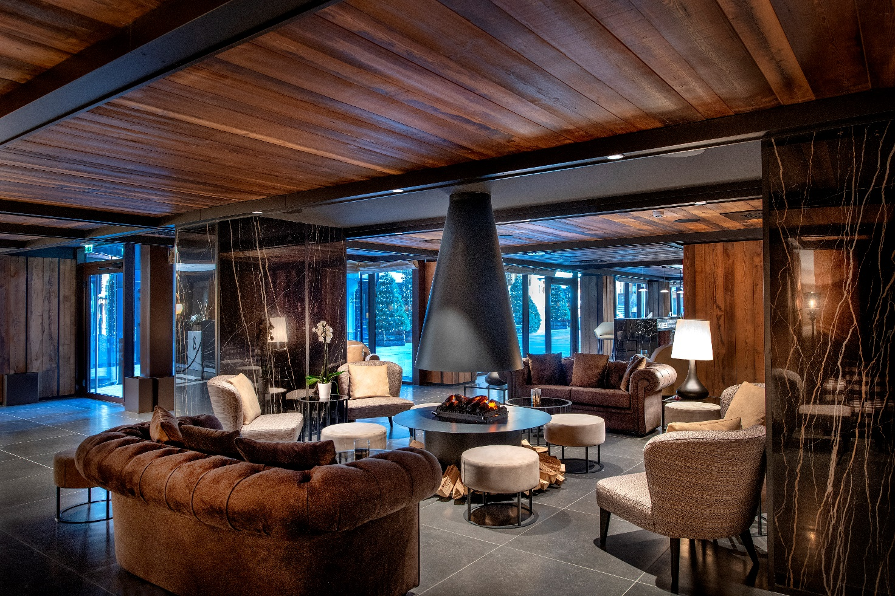

HOTEL DETAILS

Hotel Le Massif
5 star
Strada Regionale,38 – 11013 Courmayeur (AO)
Tel. +39 01651897100
www.lemassifcourmayeur.com
www.italianhospitalitycollection.com
info@ihchotels.it

- 80 rooms and suites
- 3 restaurants (Chétif and Steakhouse Cervo Rosso in the hotel, La LogeduMassif on the Ski slopes) 2 bars.
- PA-NI-NO: excellent Italian casual dining serves simple yet delicious snacks in LogeduMassif
- Spa: face and body treatments, rituals, packages, Turkish bath, sauna, swimming pool, gym.
- Kids All Inclusive: includes buffet breakfast, lunch, dinner, snack and a drink, (lunch and dinner are served with the staff of the Kids Club in one of the three restaurants with a special child’s menu).
- Babysitting service
- Kids Club: ages between 3 and 12 in the hotel and La LogeduMassif on the Ski slopes. Activities, games and sport with qualified staff from 9.30am until 17.00 and 18.30 until 22.30.
- Ski Pass: possibility to purchase ski passes prior to arrival or on arrival simply, quickly and without queuing from the Ski Concierge.
- Ski School: Le Massif collaborates with the best ski schools in Cormayeur. It is possible to book individual, group or family lessons before arrival through the Personal Travel Advisor or with the concierge. Available course: Ski, snowboard, cross country skiing, telemark, free ride, and heliski.
- Free Wi-Fi
- Private parking with direct access to the hotel.
- Eco-sustainable building with use of renewable energy.
- Transfers: the concierge can organize private transfers from and to the principal airports in northern Italy.
- Excursions: the concierge can organize private and group excursions. Freeride, heliski, paragliding, trekking, mountain bike, orienteering, tour to discover the wild nature, hot air ballooning, helicopter trips over the Alps and the glaciers, breathtaking journey on the peaks of Mont Blanc onboard the exciting Skyway, fly fishing or agricultural experiences, visits to vineyards and wine tasting, picnic in the nature, visits to the roman city of Aosta with private guide.
- 9 hole Golf course at Cormayeur (8km from the hotel).
- Services in Cormayeur : 2 congress centers for a maximum of 3000 people. Sports center with skating rink, swimming pool, tennis courts, squash, cinema, shopping area.
- Le Massif is a pet friendly hotel: Dogs under 10 kgs are welcome.

The Hotel Le Massif is a member of The Leading Hotels of the World.

CONCRETA SRL
Via Nazionale 14/A 23010
Postalesio (SO)
Ph. +39 0342 493567
www.concretasrl.com - info@concretasrl.com

OGS SRL PUBLIC RELATIONS & COMMUNICATION
Via Koristka 3, 20154 Milano (Italy)
Ph. +39 023450605
www.ogs.it - info@ogs.it

