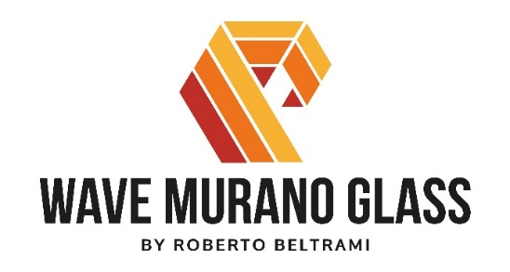
THE GLASSES OF VENICE MEET THE MAGIC OF CHRISTMAS
Wave Murano Glass’ story is a modern day fairy tale. A physics student in Boston with a passion for craftsmanship and materials encounters glass on his way and it is love at first sight. From this meeting, Wave Murano Glass was born on the island of Murano, where a team of qualified glass blowers and glass experts coordinated by the young glass master Roberto Beltrami develops exclusive projects, creating new and original proposals with glass and collaborating with prestigious furnishing and design brands.
In the furnace on the island of Murano, from historical working processes revisited with avant-garde techniques and on innovative paths resulting from continuous experimentation, come the collections that will make Christmas a special one.
CHRISTMAS TREE
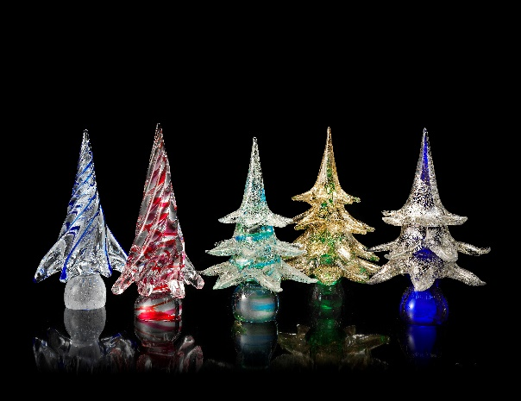
Is the collection of Christmas trees made of Murano glass with 24 carat gold leaf, where the light enhances the reflections of these iconic objects available in various shades of colours.

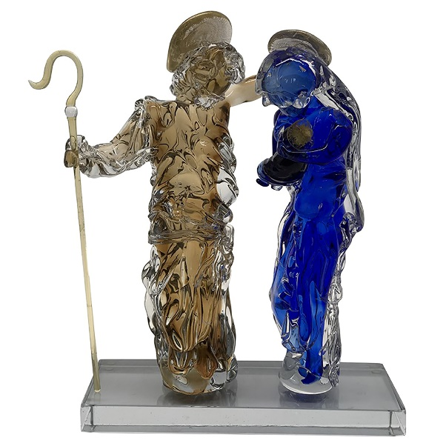
HOLY

Is a limited edition artistic piece of nine pieces made of Murano glass with 21 carat gold leaf. The two standing figures of the Holy Family, featuring extraordinary plasticity, are hand signed by Roberto Beltrami.

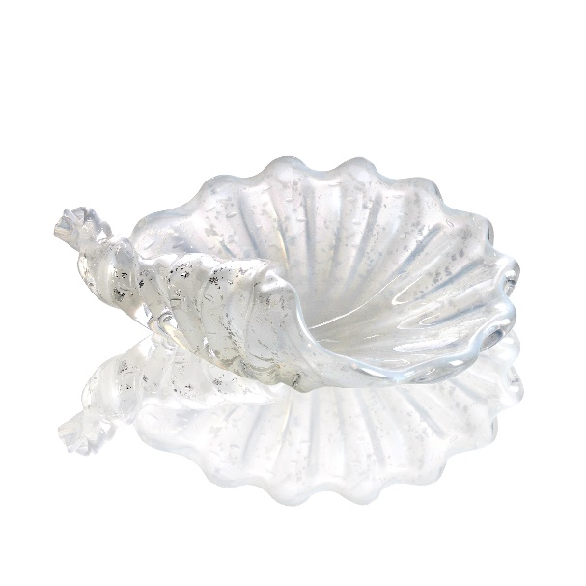
CENTERPIECE

A touch of class and a decorative element in Murano glass, CENTERPIECE cannot be missing on the Christmas table. In shades of gold, silver, amber and red, the centerpieces have shapes of flowers and shells, soft and rounded or linear and flat, to fit with any interior and furnishing style, from traditional classic to contemporary design.

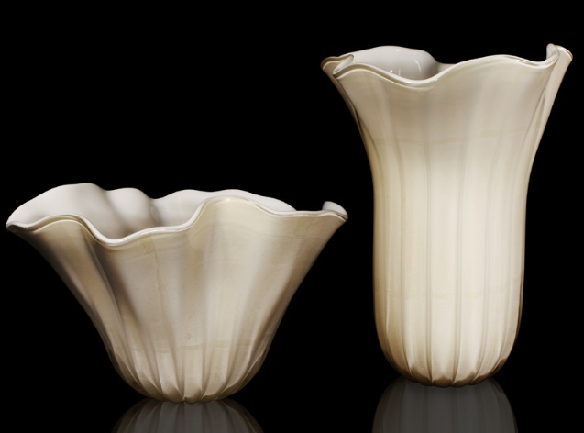
VASI
From the creativity and skill of Roberto Beltrami comes the VASI Collection, elegant pieces of interior decoration, elements that embellish the rooms as they are unique and exclusive works. The blown glass technique offers games of light that enhance the colours of the material, in the reflections and transparencies of orange, red, purple, blue.
The Collection - in the two variants Atena and Fazzoletto - is proposed in a wide choice of shapes and sizes, from the most classic creations to majestic vases that dress the space with brilliance.

When new shapes and original concepts worked in an ancient material meet the atmospheres and suggestions of Venice, here comes the magic of the Wave Murano Glass Christmas Collection.

Wave Murano Glass
Ramo da Mula 5/1 – Murano Venezia 30141
Ph. +39 3290433343
www.wavemuranoglass.com - sales@waveglass.it

Public Relations - Ogs srl
Via Koristka 3, Milano 20154
Ph + 39 02 3450605
info@ogs.it - www.ogs.it

