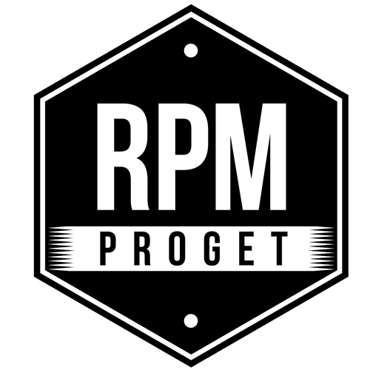

THE CHALLENGE OF ACOUSTIC COMFORT AT
‘MAESTRO BISTROT’ RESTAURANT IN ROME

Among the technical aspects of the project for the restaurant Maestro Bistrot in Rome, acoustics represents a priority.

"Maestro Bistrot is located near the Opera Theater - explains the team of RPM Proget Studio, which followed the entire design and construction phase - and captures a sustained flow of guests, mainly high-level clientele. The cladding theme has been a fundamental issue, since the restaurant is located under a well-known four-star hotel in Rome, whose rooms insist on the dining area.”

Boasting a consolidated and specialized experience in the design of food spaces in Rome and other cities of the world, in this project RPM Proget has addressed the issue of soundproofing in a particularly attentive way, through an in-depth study of the features of the space and a careful research of materials and furnishing solutions aimed at effectively solving the problem of noise transmission.

The project of this space of 125 square meters saw the use of Diamond slabs covered with a materic Kustra paper with pleasant aesthetic impact and capable to guarantee a high degree of soundproofing. As typical of RPM Proget's design philosophy, the aesthetic element of the Diamond slab cladding turned into a functional choice resulting in the acoustic insulation of the rooms located on the upper floors, right above the restaurant.

The use of an antiqued and rough-sawn parquet flooring helps to reduce the sound effect of footsteps, while a precious help to lower noise is the abundance of plants, which create a vegetal curtain and a pleasant environ as well. The presence of plants performs the dual function of contributing to sound insulation and enhancing the natural and fresh flair of the room. The green choice proved to be a winning solution and one particularly appreciated by the restaurant's customers.

As the Studio’s architects point out, the elements that were part of the project for Maestro Bistrot, namely: the wooden floor, the plants and the Diamond slabs, are fully consistent with a low environmental impact vision, which is one of the pillars of RPM Proget’s design concept.

RPM PROGET
Via Gregorio VII, 472, 00165 Roma
www.rpmproget.it/ - info@rpmproget.it
+39 06 66019011
OGS PR and Communication
Via Koristka 3, Milano
www.ogs.it – info@ogs.it
press.ogs.it
+39 02 3450610

