SKYLINE
by José Manuel Ferrero
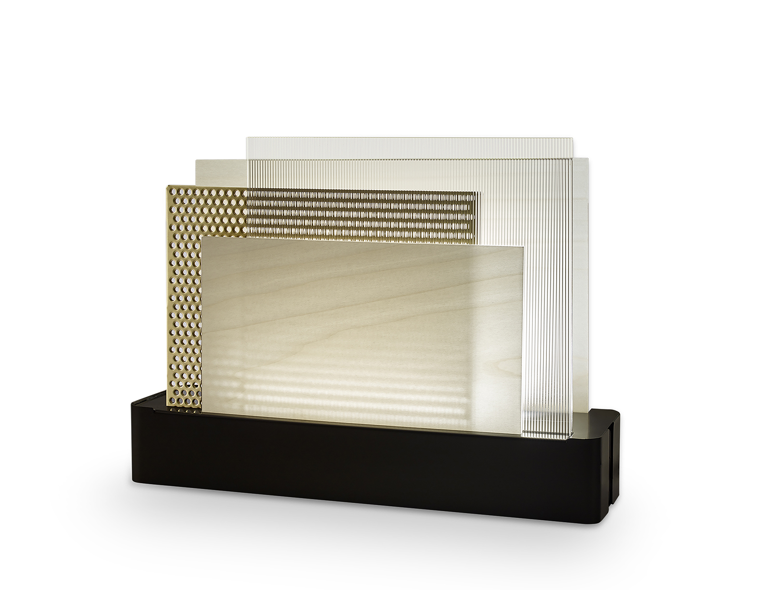

The Tailored Light

With the eccentric Skyline, designed for the Spanish company LZF LAMPS, the Valencian studio estudi{H}ac worked on the paradox of a textile-lamp, selecting a palette of materials and textiles to create a ‘moodboard’ lamp where new materials are combined with wood and where curtains of different sizes, textiles and opaque sheets are used to create a range of possibilities capable of producing ‘light games’ generated by the combination of the different elements.

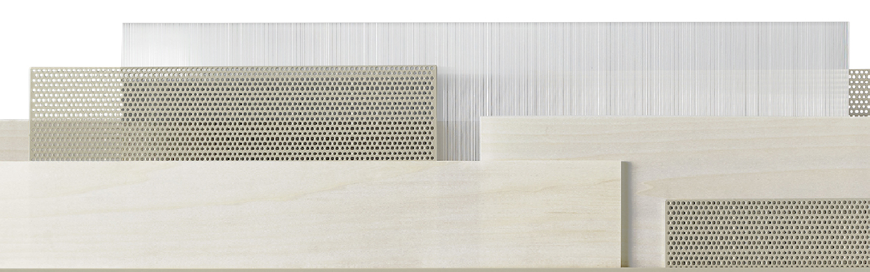
The resulting image is the skyline of a large city suspended and modulated by positions and movements, in which transparencies, textures and colors create unique effects with strong decorative impact. With a focus on detail, shapes and materials, estudi{H}ac has woven its concept of tailored elegance into the fabric of Skyline. The constructive simplicity of this light fixture and its versatility make it ideal for any living or working space. In the constellation of existing products, José Manuel Ferrero was able to identify and offer an original solution to his client company, which is translated into the purchasing decision of rather visionary customers looking for something different and unusual.

NOME: Skyline
CLIENTE: LZF Lamps
DATA: 2019
USO: interior lighting system
INSPIRATION: city skyline
MATERIAL: variety of materials: wood, textiles, opaque sheets
COLOR: metal finish colors: matt ivory, gold, Nichel black – wood finish colors: white, beech
DIMENSION: customizable

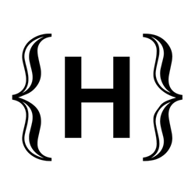
C/Turia nº 7 bajo
T. +34 963 219 622
46008 Valencia. Spain
press@estudihac.com – www.estudihac.com

OGS PR and Communication
Via Koristka 3, Milano
+39 02 3450610
info@ogs.it - www.ogs.it
press.ogs.it

