ALFI
by José Manuel Ferrero

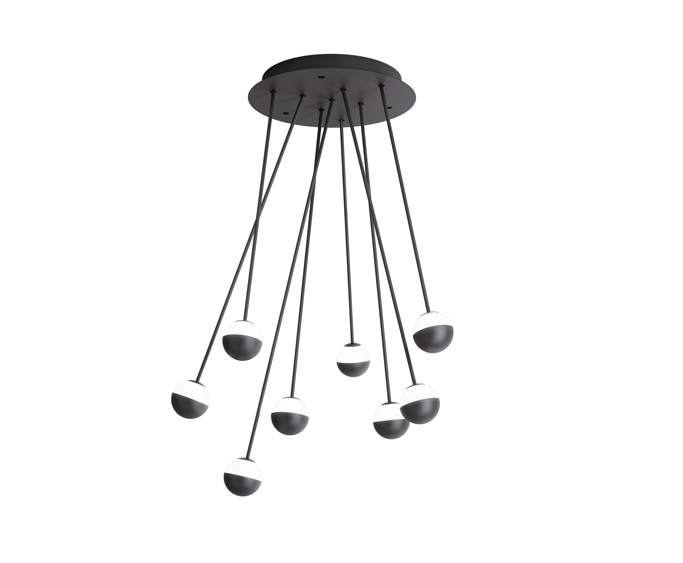
Pins of light
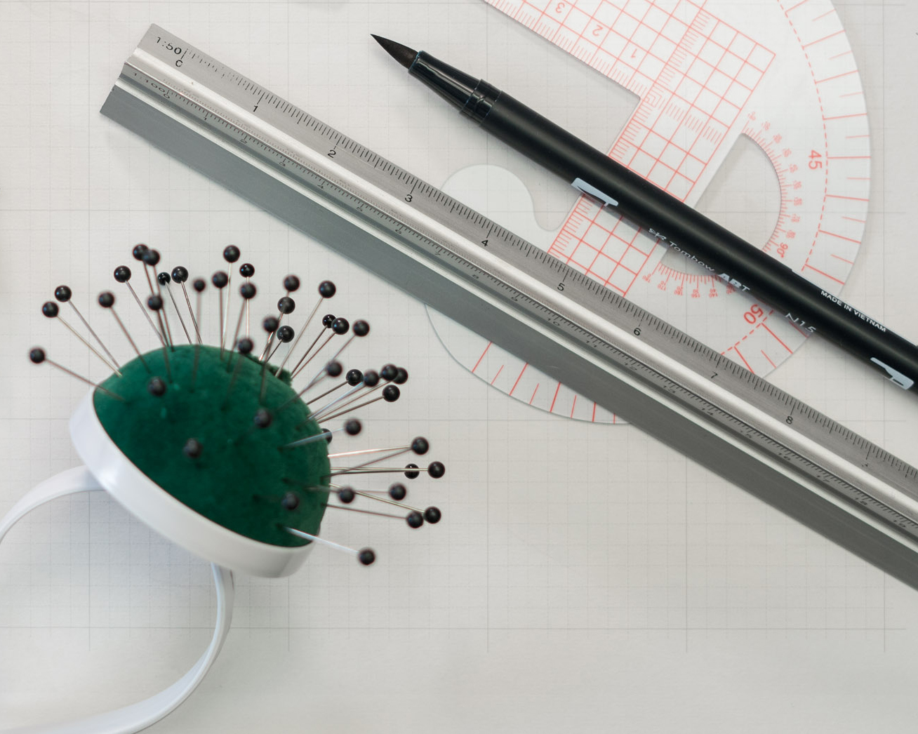
Highly representative of the design creativity of estudi{H}ac, Alfi was born out of the subtleness, lightness and strength found in the set of pins which is of such as in the dressmaking trade. Alfi has been designed for the Spanish company Estiluz as a lighting system, where the combination of compositions and movements modulating the position of each 'pin' creates a microcosm of possibilities leading to plenty of different solutions. Therefore, this lighting source becomes a real 'play of light' to characterize one's habitat in a unique and personalized way and, at the same time, it is conceived as an ideal tool to modulate and control the function of light in the setting. Here functionality combines with a subtle irony alongside the possibility offered to the end user to customize and 'wear light' in a sartorial way, and not surprisingly, since tailoring is one of the concepts that have always inspired José Manuel Ferrero's design approach. Estiluz starting point aimed to create a set of lighting fixtures intended to be used in a wide range of variations: ceiling lights, suspensions, appliques and free-standing lamps. estudi{H}ac has been able to identify and develop a creative path that made each lighting fixture of the Alfi system something unique and special.
Alfi lighting system has been used for a retail project: Rosanflor based in Valencia, a new flower shop.

NAME: Alfi
CLIENT: Estiluz
DATE: 2019
USE: lighting system / Led
INSPIRATION: pin
MATERIALS: metal and hard wired / No plug Glass shade with cap
COLORS: customizable
DIMENSION: customizable
AWARDS: NYCXDESIGN Awards in “Architectural Lighting” category, awards granted by INTERIOR DESIGN magazine.

C/Turia nº 7 bajo
T. +34 963 219 622
46008 Valencia. Spain
press@estudihac.com – www.estudihac.com

OGS PR and Communication
Via Koristka 3, Milano
+39 02 3450610
info@ogs.it - www.ogs.it
press.ogs.it

