ROSANFLOR
by José Manuel Ferrero

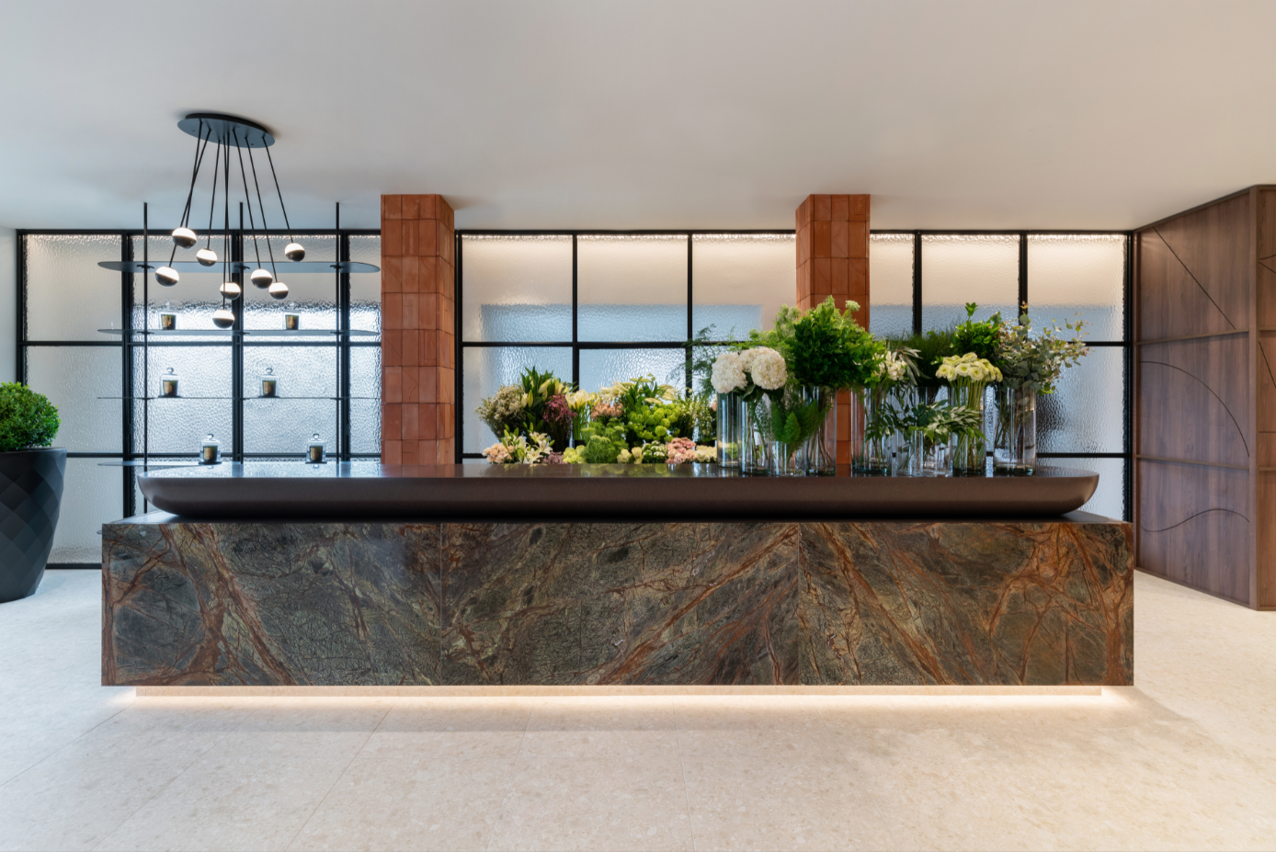

Natural elements for a green space

Rosanflor is a retail space, a flower shop in Valencia where the challenge between the materic and the abstract element has been fully exploited by estudi{H}ac. In the creation of this space, José Manuel Ferrero was initially inspired by three fundamental factors; earth, water and light.
The structure of a commercial space thus arises from the skillful game of transforming the basic elements of nature into concrete elements capable of embracing and enhancing the world of plants and flowers in ideal continuity and comfort. The earth element was at the base for the palette choice made of beige and terracotta nuances. The water element is recalled in the project through the use of glass windows with geometrical drawings and the use of light visible in the technical part and, at the same time, emotional which creates an ethereal atmosphere where flowers represent the centerpiece and key element. The resulting space, on a total of 120 square meters, is divided into two main areas: the first one is a gallery where customers can admire floral compositions and a refined selection of decorative elements, whereas the second one hosts other green compositions completed by a service area.
The beauty of the materials and the free game of light manage to create an extremely pleasant and airy space in which the vegetal element, a priority reference for the whole project, integrates harmoniously with the solid architectural materials, such as the desaturated beige ceramic terrazzo flooring and the central piece in the flower shop, a large sculpted counter combining an imposing marble Rain Forest Green block by Levantina, topped by a large brown KRION piece customized for this project.
Beyond and parallel to the solid structure of the counter, an almost impalpable textured glass resulting from a careful process of customization stands out. As a water colored curtain, the glass creates suggestive visual illusions produced by natural light which hide the secrets of the fascinating art of flower-arranging. To complete the structure of the shop, an imposing terracotta wall with a mobile shelving system gives flexibility to the disposition of floral bouquets and decorative ceramics, real protagonists of this place of business.
For lighting, the ALFI lamp, which fully embraces the concept of elegant essentiality and sobriety that underlies the design philosophy of estudi{H}ac finds here a perfect example and goes even further, to realize one of the guidelines that drives the work of José Manuel Ferrero and which consists in ‘not-to-be-repetitive’. Each project is a story and the Rosanflor flower store is no exception.

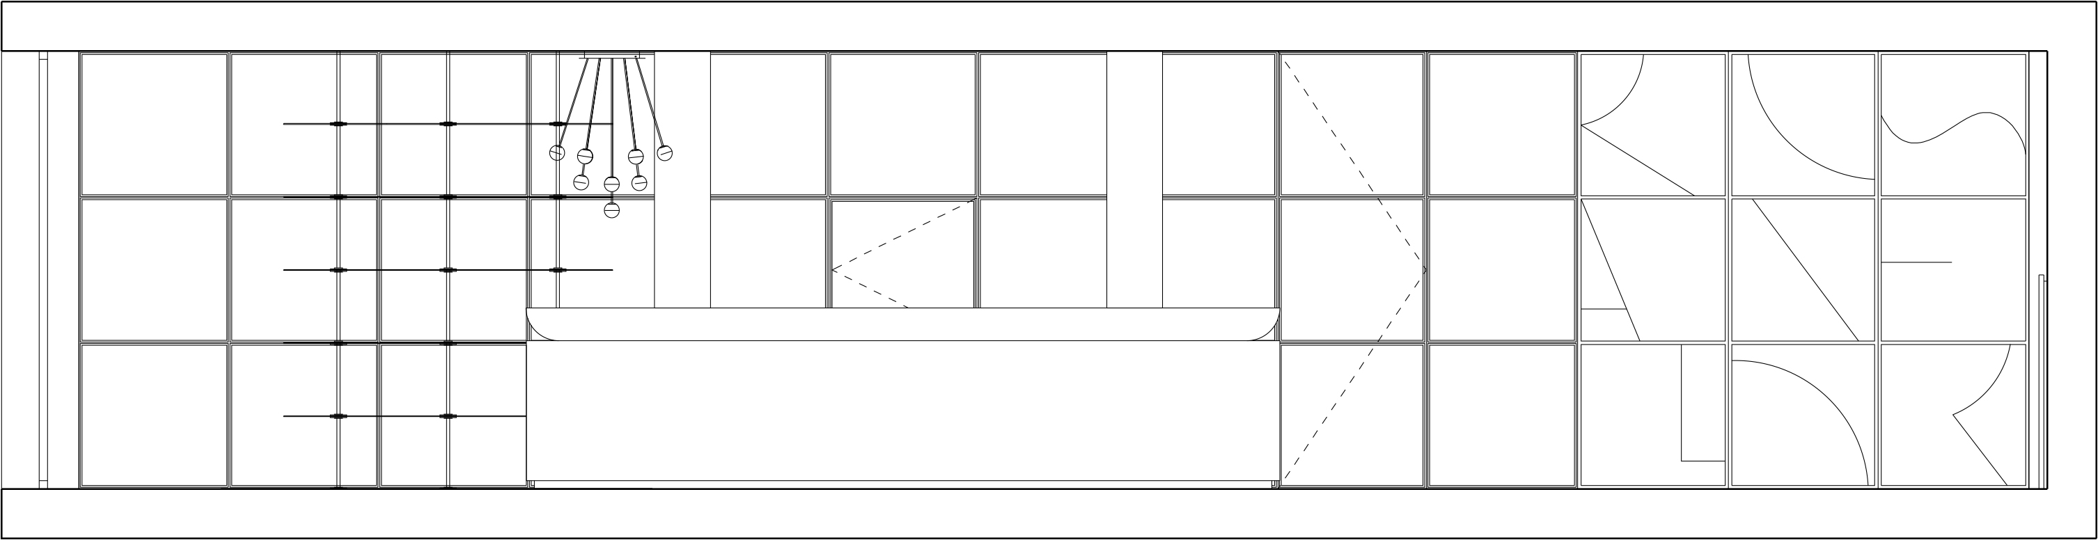

NOME: Rosanflor
SUPERFICE: 120 m2
LOCATION: Ontinyent - Valencia – Spain
DATA: 2020
TIPOLOGIA: interior design
FOTOGRAFO: Adrian Mora Maroto
USO: public space
INSPIRATION: earth, water, and light
MATERIALS: Rain Forest marble by Levantina, green Krion, glass, terracotta
AWARD: NYCXDESIGN Awards nella categoria “Architectural Lighting” della rivista INTERIOR DESIGN magazine

C/Turia nº 7 bajo
T. +34 963 219 622
46008 Valencia. Spain
press@estudihac.com – www.estudihac.com

OGS PR and Communication
Via Koristka 3, Milano
+39 02 3450610
info@ogs.it - www.ogs.it
press.ogs.it

