CLASSICISM REVISITED
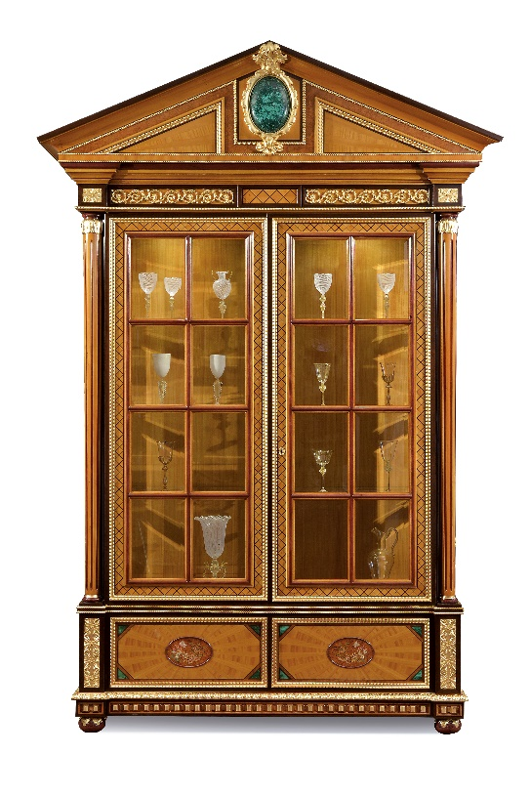
A dining room with two sumptuous cabinets, enhanced by a solemn fireplace in white stuccos framed by neoclassical pilasters and a precious chandelier in a reference to an ancient time for wealthy homeowners. Shiny marble floors and a fine carpet recall the green tones of the chair coverings. The table features rich inlays and straight legs with golden motifs in a neoclassical ambience where the attention to details can be perceived in each piece of furnishing.

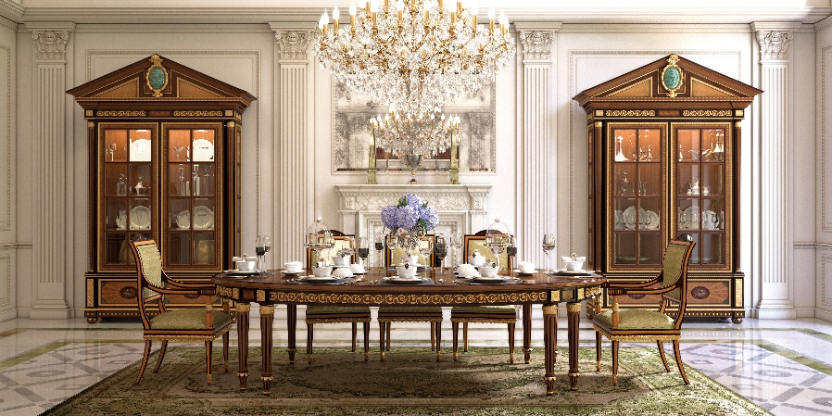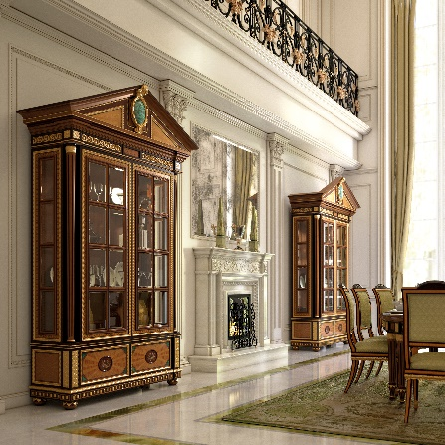

“Defining luxury through details”

ARMANDO RHO S.R.L
Via Per Cabiate, 111, 22066 Mariano Comense CO
Ph. +39 031 747463
www.rhoarmando.com - info@rhoarmando.com

OGS SRL PUBLIC RELATIONS & COMMUNICATION
Via Koristka 3, 20154 Milano, (Italy)
Ph. +39 023450605
www.ogs.it - info@ogs.it

