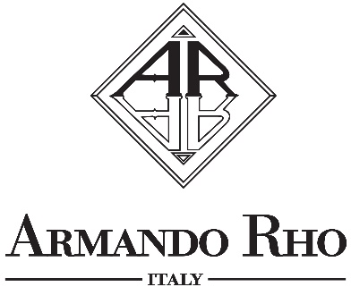

ARMANDO RHO’S COMMODE
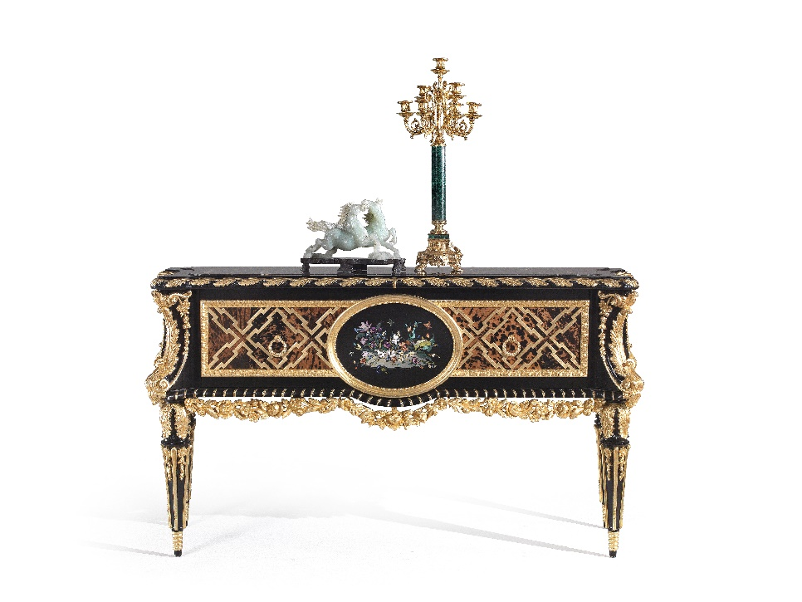

This commode is one of Armando Rho's masterpieces, representative of the French Louis XVI style. It is made in ebony with an insert in turtle shell surmounted by a gold plated grill that creates and elegant geometric motif. The oval center is in nero Belgio with a floral inlay of precious and semi-precious stones. Beautiful selected pieces of art make this commode more valuable and unique. The candelabrum is in Malachite, precious, bright with crystals deeper shades of green and the horse sculpture is majestically handcrafted. The result is a high-quality piece of furniture, versatile for its functionality, which harmoniously decorates different spaces of a house.

“Glamour inspired”

ARMANDO RHO S.R.L
Via Per Cabiate, 111, 22066 Mariano Comense CO
Ph. +39 031 747463
www.rhoarmando.com - info@rhoarmando.com

OGS SRL PUBLIC RELATIONS & COMMUNICATION
Via Koristka 3, 20154 Milano, (Italy)
Ph. +39 023450605
www.ogs.it - info@ogs.it

