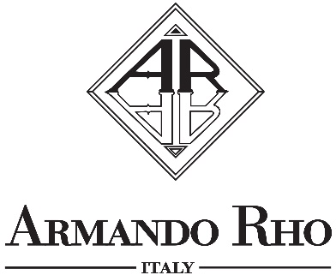

SYMPHONY IN BLUE

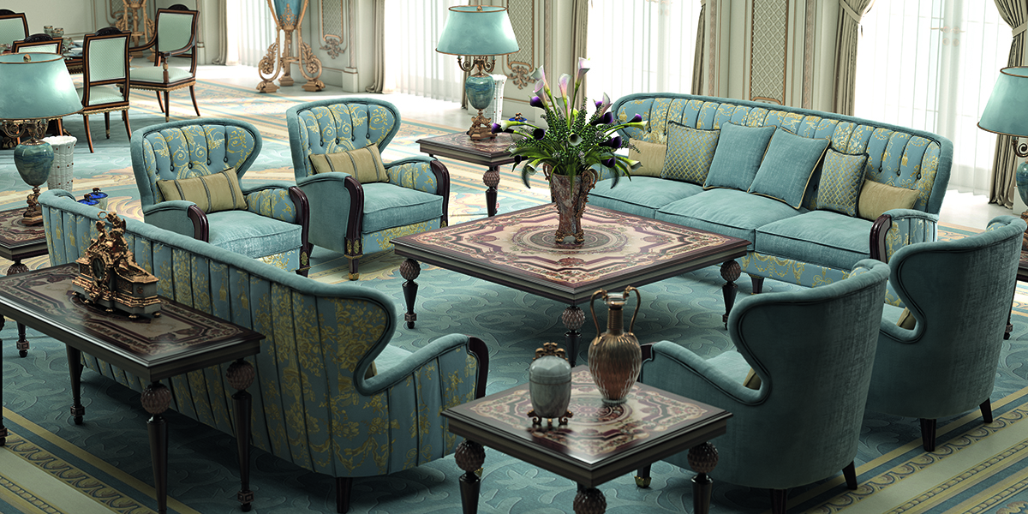

Generous spaces are a sign of ease and pleasantness but also a challenge: in this living room Armando Rho realizes the ideas of a Client who is looking for a place where to share conversation, hospitality and a prestigious lifestyle.
Upholstered furniture dominates this space with two sofas and four blue silk capitonné armchairs, divided by a large central table in which fine briar inserts create exciting shapes. These shapes are also recalled in small and valuable tables, to build a magical square that echoes gentle conversations.

“Espace from the ordinary”

ARMANDO RHO S.R.L
Via Per Cabiate, 111, 22066 Mariano Comense CO
Ph. +39 031 747463
www.rhoarmando.com - info@rhoarmando.com

OGS SRL PUBLIC RELATIONS & COMMUNICATION
Via Koristka 3, 20154 Milano, (Italy)
Ph. +39 023450605
www.ogs.it - info@ogs.it

