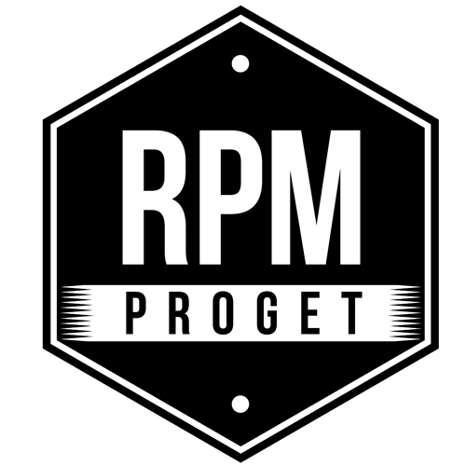

NUMA, 'THE GASTRONOMIC CAROUSEL' OPENS IN ROME

The Roman RPM Proget Studio proves to be once again a reality with great competence and strength of proposal in the design, furnishing and restyling of food spaces.
"The project - the Studio's team says – should always feature the knowledge of places and customer's needs as well as the guarantee of an 'artisanal' approach where attention to detail is essential, without forgetting the extraordinary magic arising from tradition, memory and vintage decorations, to create suggestions and atmospheres that fit with the gastronomic experience."
Numa Restaurant interprets this philosophy at its best.
Housed in a particular location in the heart of ancient Rome, close to Circo Massimo and the Palatino Hill, Numa Restaurant will be inaugurated in the first half of December 2020 on a space of 180 square meters for 90 covers, of which 35 in the dehors.
The story of this renovation project is introduced by RPM Proget in a two-voice dialogue with Davide Cianetti, internationally renowned Roman chef, soul and creator of the restaurant's gastronomic offer, who joined the business at the invitation of the owner Patrizio Longo, an entrepreneur of airport services with a declared passion for food spaces.

THE WORD TO THE CHEF
"Recreating 'lived-in' spaces with authentic materials is almost a duty to Rome, a city full of history, culture, and beauty - says chef Davide Cianetti. “This also applies to our traditional cuisine, which traces years of history and is a mix of various factors connected and intertwined with each other. In this case, our authentic regional cuisine must find its framework among 'real' materials such as wood, glass, marble and cement tiles. It’s pretty important that dishes are 'wrapped' in authentic architectural forms and this is exactly the commitment we share with RPM Proget when we build the premises. The sense of authenticity conveyed by the location is very important. Sometimes we see very beautiful, innovative and technological venues, which however lose something in romanticism, charm and sense of hospitality ".
"I myself have taken a technological path with strong emphasis on gourmet cuisine - explains the chef - but over the last ten years I realized that we must put customers first, creating environments that make them feel at home, that are warm welcoming and that put them at ease. Today, this type of venue is more important than ever before.”

THE GASTRONOMIC OFFER
Numa is the sum of a journey across the chef’s field experiences towards a leaner and more authentic interpretation of food, bringing out the taste of the products, searching for raw materials and their naturalness, trying to work them with respect and technically follow them flawlessly. Numa Restaurant will be offering a regional cuisine made with modern techniques, but with a traditional 'true' soul.

THE WHY OF A NAME
The restaurant is named after Numa, the second king of Rome, a long-lived man, a philosopher, a lover of peace and founder of the tradition. All aspects from which to get inspired. The restaurant is located on the Aventino Hill near Piazza Numa Pompilio, less than a hundred meters from Circo Massimo, the heart of Roman history, in front of the FAO headquarters, an expected source of international customers looking for the Roman gastronomic tradition.
Rome has a strong gastronomic identity and although Roman customers may welcome and have even lively curiosities for other cuisines, they always return to traditional dishes.

THE REVISITED PROJECT
The characteristics of the location and those of the project are explained by the RPM Proget studio. Designed and built in 2015, this space has generated some critical issues over the past five years. RPM took over the restyling of the venue to solve the problems and create a different and dazzling appeal. A pizza corner has been created consisting of an open oven with a brass cap, standing in the middle of the venue and immediately visible from the entrance.
Each phase of pizza preparation can be seen ‘live’; a good show indeed and the guarantee of a quality pizza made by hand at the moment. The pizzeria offers a gourmet situation with excellent natural products and special recipes, complemented by the offer of all those delicacies that cannot be missing in a Roman pizzeria and here feature a high quality level.

COLONIAL AND CIRCUS ATMOSPHERES
The restaurant has a colonial atmosphere. The armchairs at the entrance have floral upholstery, the traditional 1950s American style celine and rattan fans have been inserted. The flooring has been completely transformed with the insertion of coloured diamond-shaped cement tiles that recall the circus, from Circo Massimo in Rome to Fellini's memories. The circus is intended as a place for socializing and shared fun, but also for a variety of shows and attractions.
The restaurant dehors has a small vertical garden, mustard-colored and wood-colored Venetian blinds have been chosen for the large windows to create different atmospheres according to the time of day.
The outdoor space overlooks the tall and historic trees of Viale Aventino, with a changing scene over the seasons. To capture the whole charm of the place, three large packet windows can be opened to inspire the feel of a unique and airy ambience.
Rational routes have been set up in the restaurant for people with disabilities.

THE GASTRONOMIC CAROUSEL
Chef Davide Cianetti takes up the image of the circus and the merry-go-round to confirm that Numa Restaurant wants to be a lively environment, also from a gastronomic point of view, with a cross-cutting offer starting from breakfast and ending with dinner. Not surprisingly, the claim of the restaurant is: "the Gastronomic Carousel".
The setting changes during the day under everybody’s eyes, ranging from the pizzeria with an open counter to a gourmet area with local excellences, from a dessert corner with cakes on display, as in an old pantry to the cocktail bar for aperitif time. Without forgetting the cellar for chilled white wines and an open cellar for red wines.
The project is linked to social solidarity and sustainability initiatives with vegetables coming from areas hit by earthquakes and floods, to help redevelop local production activities and support the involved families.
Numa is plastic-free and only recyclable packaging and materials are used.

All in all, many different experiences are offered by this 180 sqm ambience born from the expertise and creativity of a team of professionals, who will be giving those choosing Numa the pleasure and taste of a 'gastronomic carousel' in a quality venue.

RPM PROGET
Via Gregorio VII, 472, 00165 Roma
www.rpmproget.it/ - info@rpmproget.it
+39 06 66019011
OGS PR and Communication
Via Koristka 3, Milano
www.ogs.it – info@ogs.it
press.ogs.it
+39 02 3450610

