NH Touring
Milano

Designed and realized by the architectural studio CaberlonCaroppi, the "Lobby Alive" NH Milano Touring is the new way of conceiving and experiencing the hotel lobby

The idea of ​​revolutionizing and reinventing the hotel lobby comes from the NH Group which, thanks to the interpretation of CaberlonCaroppi, managed to transform a simple place of transit into an experiential space and a meeting point open to the whole city.
The concept of Lobby Alive, conceived and developed by the studio, draws its inspiration from the genius loci of the city of Milan, from the history and typical atmosphere of the Milanese salons and from the Milanese modus vivendi such as the "Milan to drink" and the "Milan that work. " Thus, a true Milanese promenade was born inside the lobby, a path that takes the user through the history of the city and its most significant features.
Recently inaugurated in the center of Milan, closed to Quadrilatero della Moda and Central Station, Lobby Alive is a space with co-working areas, where to go to chat, to read a book or have a drink; a space opened to the Milanese community and their guests to offer a unique and unconventional hospitality experience.
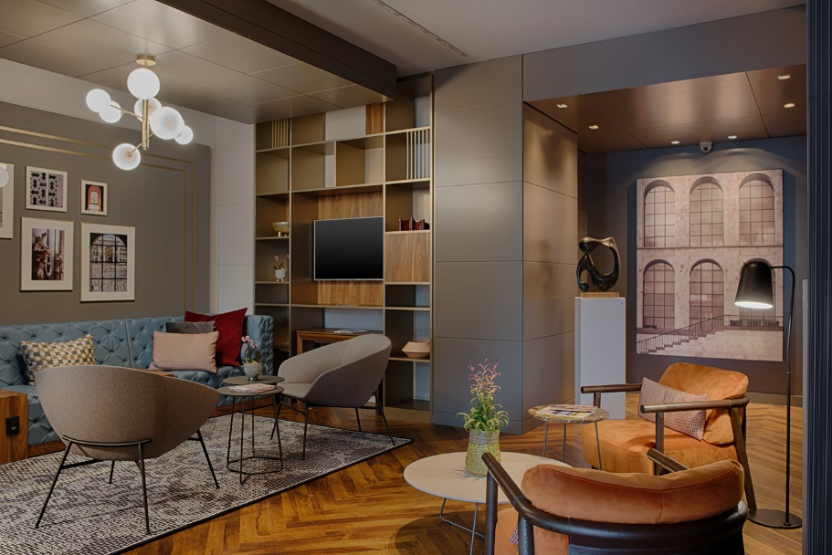
The Milanese promenade begins from the renewed reception, now placed on the right of the entrance and redesigned as a tribute to Milan and to some of its most famous monuments: giant posters of San Zotico and San Agapito - founded in Duomo - characterize the wallpaper which is the background of the reception desks. In a more modern and bright design setting, the reception desks become exclusive areas to receive guests in a more intimate way.

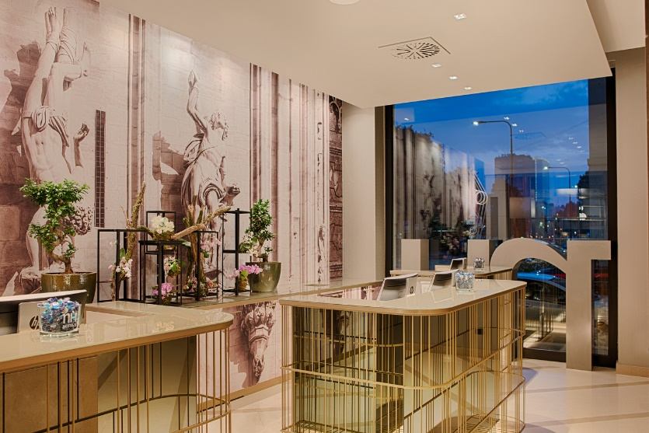
Next to the reception, the atmosphere becomes softer and at the same time authentic, recalling a typical ancient Milanese living room with warm and welcoming colors. Like the old houses in Milan - where the fireplace was at the center of "being together" - in this area, called Fireplace, guests can chat, browse through the design volumes arranged on the bookcases, discovering some curiosities about the history of Milan, resting on the comfortable sofas and relax in the warmth of the fireplace.
The "Milanese promenade" continues, giving life to another area with a more contemporary and cosmopolitan character that gives its interpretation of the "Milan that work". Sandbox, in front of the reception, is the area dedicated to co-working, a common area redesigned for those who, even while traveling, need a location to work and a place to socialize or share with people new ideas and projects. The large table located in the center, the sockets for recharging smartphones and PCs, the lights and comfortable seats, recreate the ideal place to work in peace and in a smart way. And if you need a little break, next to Sandbox there is the NH Hotel Group Candy Corner offering candy, cookies and fresh flavored waters to all hotel guests.

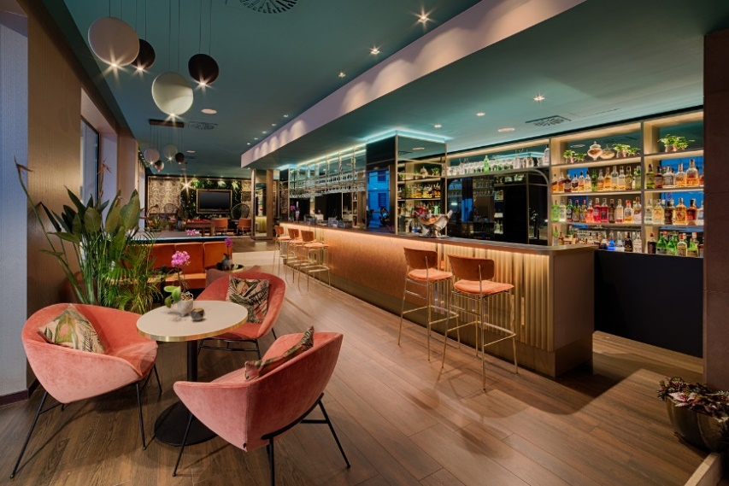
The concept developed by CaberlonCaroppi for “Lobby Alive” also extends to the brand new Food & Beverage area, inspired by the "Milan to drink" with the idea of ​​recreating a friendly and fun setting. In this area we find the Camelia's Yard - Milano Social Bistrot which includes the Cocktail Bar, where it is possible to taste some of the most innovative drink proposals, and the restaurant inspired by a storytelling linked to the ancient Milanese garden. The restaurant offers a unique gastronomic experience both for lunch and dinner. In this area, the atmosphere you breathe is fresh and joyful: a small garden reproduced through a wall of green plants, a Tropical style wallpaper, comfortable colored chairs and a large pool table invite you to relax and have fun, just to remember the convivial spirit of the Milanese condominium gardens of the '20s and' 50s, very well kept and with large green spaces, often hidden and therefore much more intimate.

Suppliers
Furniture - Calligaris Contract
Lights - Aromas del Campo

CABERLONCAROPPI ITALIAN TOUCH ARCHITECTS
Via Scipione Piattoli 7, 20127 Milano
Ph. +39 022871216
www.caberloncaroppi.com – info@caberloncaroppi.com

OGS SRL PUBLIC RELATIONS & COMMUNICATION
Via Koristka 3, 20154 Milano
Ph. +39 023450605
www.ogs.it - info@ogs.it

