PRIVATE HOUSE B104 – Castiglion Fiorentino (Ar)

Project: Studio Svetti Architecture | Emanuele Svetti Architect
Collaborators: Martina Nocentini Arch. e Francesco Gailli Arch.
Photo Credits: Francesca Pagliai
Category: Private House
Area: 650 sqm
Start of works: February 2013
Status: completed in April 2016
Location: Arezzo

Revisiting and updating in a modern key the lifestyle of a region rich in traditions, culture and artistic sense and contaminating its contents through ideas of cosmopolitanism: these are just some of the elements that inspired this project.
The starting point for the renovation of the farmhouse was the desire to preserve the aesthetics of a typical rural building in the Tuscan countryside, making the interiors the part meant to amaze guests and family friends.
The owner, Marco Benevieri, is the creative soul of a well-known jewelery company from Arezzo, and as such, he wanted the house to respond to those standards of original extravagance that bind him to stylistic choices in the goldsmith field.
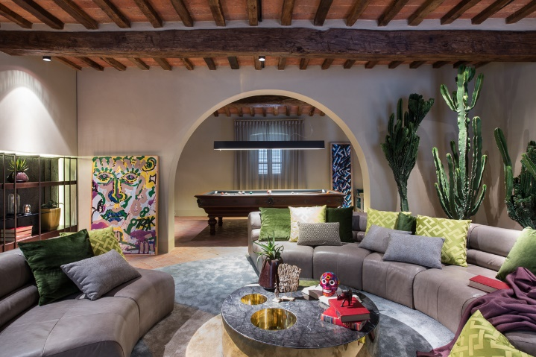
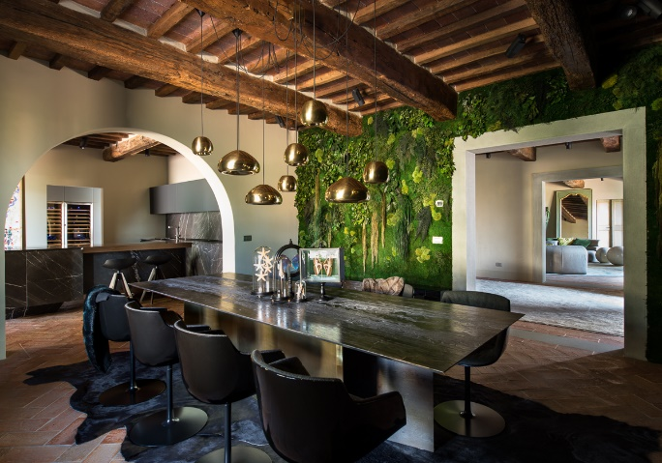

From here the Studio gave life to an elegant and sophisticated interpretation of the interiors, rich in objects and also characterized by the materiality of the structures, from the lime walls to the sandblasted and waxed beams.
Inside the various rooms there are many limited edition furniture objects designed by Studio Svetti Architecture for RUDE collection: the solid cedar wood table with a finished wax and ash top (manufacturing rediscovered in a local craftsman's workshop), twin consoles lacquered with inserts in metal, the kitchen completely covered in marble with suspended peninsula and the spectacular circular sofa in the living room on the ground floor.
The plot twist, however, is the vertical cladding with stabilized green of the walls of the dining area on the ground floor in the center of which stands the table with a cappuccino marble top designed by the studio for this home.

Suppliers
Lighting and Domotics: Graziella Smart Technology
Wall finishes and coatings: OIKOS PAINT
Custom furniture: New Bimar Contract and C&C Italia
Kitchen Basement: Del Tongo Industrie SpA
Furnishings and accessories: Edra, Moroso, Minotti, Lago, MDF, Tom Dixon, Dedar, Il Pezzo Mancante, Wall & Deco, Vitra, Antonio Lupi, LinfaDecor, Object de Curiosité, Alivar
Glass surfaces: Vetreria Savinese

STUDIO SVETTI ARCHITECTURE ITALY
Via Lauretana 73, 52044 Camucia, Arezzo [Italy]
Ph. +39 0575 62530
www.studiosvetti.com - info@studiosvetti.com

STUDIO SVETTI ARCHITECTURE UK
71-75 Shelton St.Covent Garden, London [UK]
Ph. +44 (0) 7971 390 522
www.studiosvetti.com - info@studiosvetti.com

OGS SRL PUBLIC RELATIONS & COMMUNICATION
Via Koristka 3, 20154 Milano, Italy
Ph. +39 023450605
www.ogs.it - info@ogs.it

