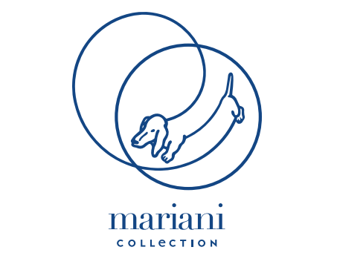
MARIANI COLLECTION
COMMERCIALISED BY DESIGN AND MORE
BY MARIANI
Shaping matter: this is where inspiration of Mariani Collection commercialised by Design and More by Mariani, comes from, a personal collection of products designed by the architect Maurizio Morazzoni that stands out for the use and the careful research of precious materials. Experimentation is the key word and at the basis of experimentation, there is matter. From the passion and work of the architect, who is always looking for new solutions, a personalized collection of tables, coffee tables, sideboards, cupboards, lamps characterized by a researched combination of materials such as metal, wood, crystals, marbles and personalized fabrics, also with innovative treatments. A collection created from a constant research over the years that allows to select the most refined marbles, to use atypical materials in the production of furniture. A research with the aim to create something new, never seen before and to propose to the market furniture that stands out for creativity and originality. Bookcases, tables, sideboards are the main part of the collection, where it plays a crucial role the wood, the authentic one coming from a handmade work in carpentry. Bookcases and tables, which distinguish for their details, for the choice and combination of different colors, for the customization of shapes and dimensions and for the ability to combine different materials each other. A collection that is never the same in which each detail becomes a high quality design object because it is personalized and unique, custom-made for each client, reflecting the personal taste, enriched by the masterful touch of the architect. Mariani’s offer become wider and more sophisticated day by day to propose personalized solutions that meet the contemporary taste to furnish the houses that transform today into tomorrow. That houses recognizable for their unique pieces of Mariani Collection, unique as each of us.

Ted Table
The Ted Table in its rectangular shape was born from the minimal need of giving life to an 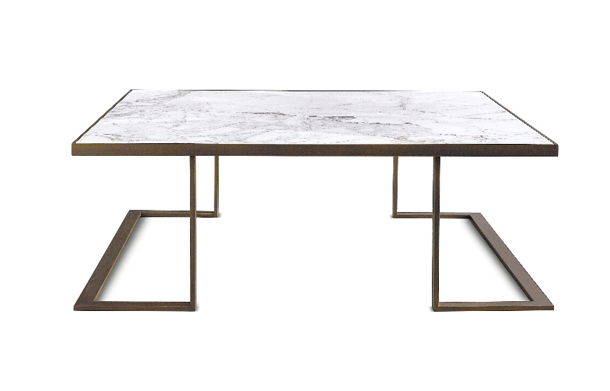unexpected geometric shape, as it is a game of illusion. Realized in burnished metal or black nichel with calacatta marble top, reducing the thickness of the materials to a minimum, the table elegantly shows its lines that intertwine with each other without interruption. Its characteristic is the essentiality of shapes and in its various perspectives it creates a harmonious and balanced visual effect. The standard measure is 100x100x25, customizable on client’s desire. The table Ted stands out for its quality and robustness despite the apparent slenderness.

Fettuccia Library

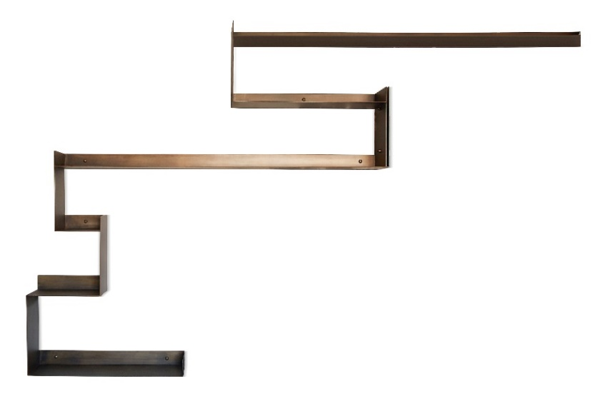Imagine to draw a line with a pencil freehand on a wall, a line with a perfect shape, as all the dots are precisely combined with defined traits: this is Fettuccia library characterized by its thin shapes, apparently simple but perfectly linear. With various dimensions and lengths, the library can be personalized as the client’s desire. Made in natural black burnished lacquered metal, it stands out for its clear and essential aesthetic. A library with a modern character that needs to be filled up with objects, books and all the personal belongings that represent the life of each of us. With a great visual impact, it gives an original and unusual touch to the setting, making the house more unique.

Bax Sideboard

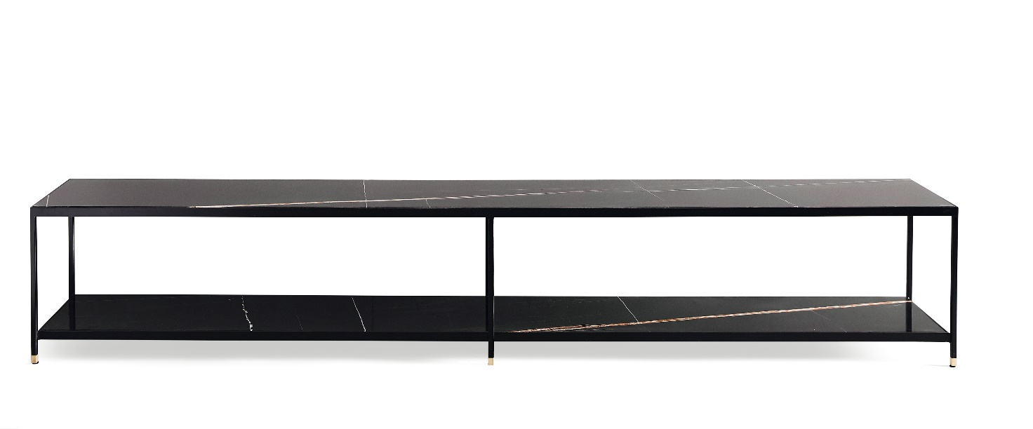

Simple and essential but all you need. This is Bax sideboard, with its industrial charm, made in black or burnished metal with satin brass feet. Customizable in its materials, the top can vary from matt to glossy lacquer to various types of marble. Researched in details, it is created to meet different needs within urban style environments. It stands out for its flexibility of use: from a library to TV cabinet to an element at the entrance to empty the pockets. Bax sideboard can be used in different home settings, in the dining room or living room, in the entrance or bedroom. A sideboard that can become everything the client images, giving to the space personality.

Rombo Table

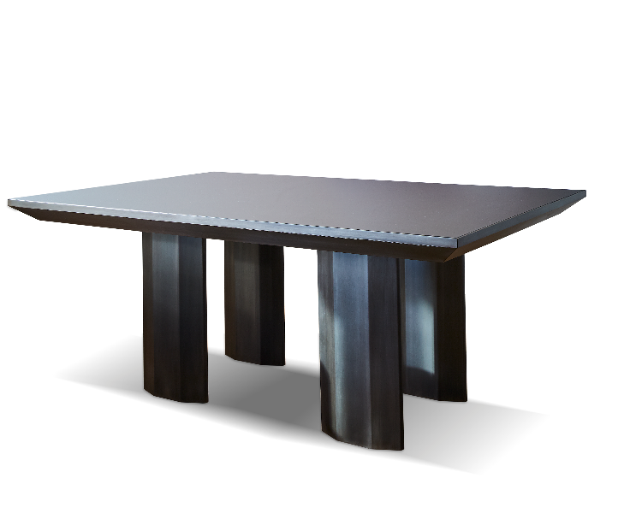Sculptural and massive, Rombo Table takes its name from the shape of its legs, designed to support the weight of the upper floor that is dematerialized in its dimensions thanks to the side bands inclined to perceive only a slight thickness. The table stands out for its preciousness and research in materials, realized in black or bronzed metal with a crystal opaque surface. An elegant and exclusive piece of furniture, with a modern design, ideal to create a very suggestive atmosphere. The table has standard measure 180x120x75, customizable on request.

Gastone Consolle

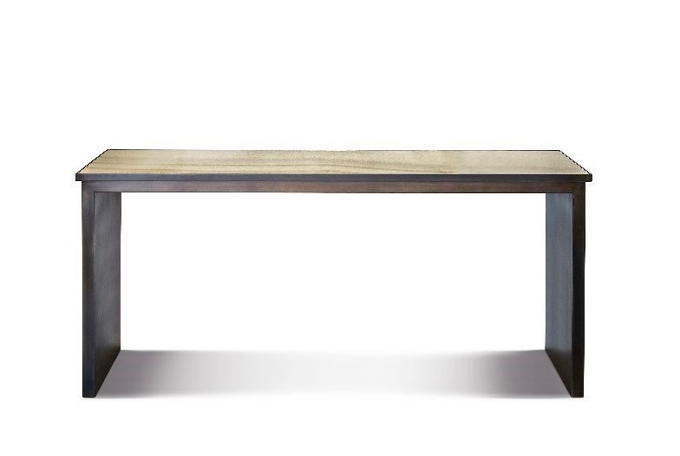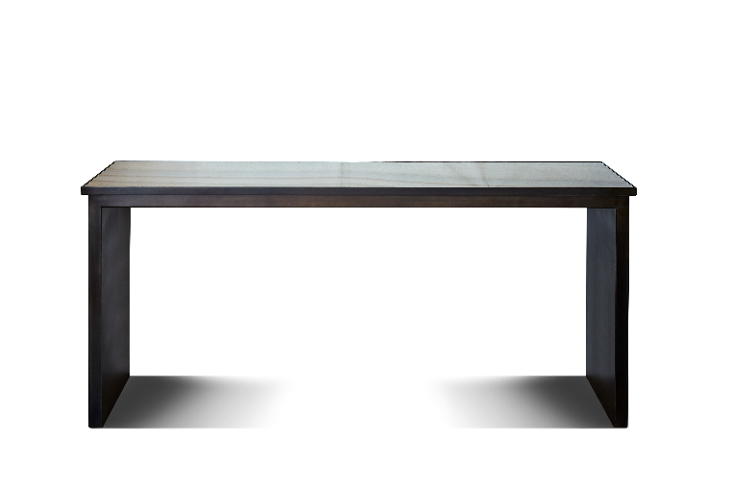Minimalist, with simple and clean lines, inspired by a dachshund, the dog that is characterized by the height proportionally less than the length: this is Gastone console whose length can vary from 130 to 300 cm while the width is 45 cm and the height 75 cm.
Structured by two very tick side panels, which guarantee strength and stillness, it has no structural elements visible in the part below the top. Made in burnished metal with calacatta marble top or matt washed top, it highlights the essentiality, balance and formal elegance without further decorative elements.

MARIANI COLLECTION
COMMERCIALISED BY DESIGN AND MORE
BY MARIANI
Arluno - via Marconi, 12 (Italia)
Milano - via Visconti di Modrone, 8 (Italia)
Ph. +39 029017193
www.marianidesign.it - info@arredamentimariani.it

OGS SRL PUBLIC RELATIONS & COMMUNICATION
Milano - Via Koristka 3, (Italia)
Ph. +39 023450605
www.ogs.it - info@ogs.it

