TRAINING AND DEEPENING FOR HOSPITALITY
APPOINTMENT IN MILAN IN SEPTEMBER

Guest Lab is a high-level appointment dedicated to contract, design and hospitality organized by Teamwork Hospitality, the network based in Rimini that since 23 years has been contributing to the growth of the entrepreneurial culture for the tourism and hospitality sector.

The second edition of this training day, with ideas and solutions on the themes of hotel design and redevelopment, will take place in Milan on 23 September 2021 in the elegant and prestigious setting of Palazzo delle Stelline, a few steps from Leonardo’s Last Supper.

The characteristic of Guest Lab is that of being a seminar event dealing wirh changes and trends in hospitality and offering a real glimpse into the future of hotel design.

This is a not-to-be-missed opportunity for training and updating for architects, planners and designers, who will be able to follow a rich program of interventions where the most renowned players in the hotel sector will speak, highlighting factors of success, present and future orientations, latest trends and most innovative brands.

Sector experts will hold seminars on the importance of air conditioning and soundproofing, functional layouts and budget planning.

During the event, internationally renowned architects will illustrate their most recent creations and offer food for thought on the most challenging issues related to the design and use of spaces for hospitality.

For more information on Guest Lab:
www.guestlab.it and www.teamwokshopitality.com

For press materials and interviews please contact
OGS PR & Communication: info@ogs.it

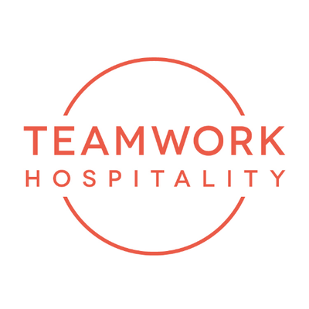

ABOUT US
Headquartered in Rimini, Teamwork Hospitality is one of the main professional actors of the hospitality world and brilliantly deals with consulting and training at 360 degrees for professionals in the sector. Thanks to a true galaxy of services, Teamwork Hospitality, whose President is Mauro Santinato, is able to offer the stakeholders of the tourism and hospitality sector the opportunity to do their job in the best possible way, obtaining the best results in terms of quality, customer satisfaction and profitability for their company.

TEAMWWORK HOSPITALITY
Rimini, Via Macanno 38/q
Ph. 0541-57474
info@teamworkhospitality.com
www.teamworkhospitality.com

OGS PUBLIC RELATIONS & COMMUNICATION
Milano - Via Koristka 3, (Italia)
Ph. +39 023450610
info@ogs.it
www.ogs.it

