LUXURY HOSPITALITY CONFERENCE MILAN
A WORLD IN MOTION

A not-to-be-missed event to discover luxury trends, anticipate guests' needs and develop new strategies is the Luxury Hospitality Conference scheduled at Palazzo delle Stelline in Milan on 23 September 2021.

Conceived by Teamwork Hospitality in collaboration with HotelmyPassion, a unique, elegant and niche blog site dedicated to the most demanding "Hotel Lover", lovers of beauty and in search of experiences, the event is aimed at hotel owners, directors and staff members, tour operators, destination managers, students and journalists. During the day, a rich panel of experts will address issues related to the world of luxury in hospitality.

Professional updating is the winning weapon to meet the new challenges of luxury. The luxury segment, in fact, is in good health. Despite the pandemic, 7 per cent of investors will continue to operate in this market, also in the light of recovery trends in the economic scenario.

The luxury hotel sector was the main driver of Merger & Acquisition activities in 2019, having totaled 115 transactions globally. In 2019, 3.3 billion euros were invested in hotel assets in Italy, with a marked preference for luxury ones, capable to satisfy the demand of the most demanding customers. A market that comprises 42 percent of total assets, for a value of 1.25 billion euros.

Luxury is also constantly evolving. Never before as in recent years, the concept of luxury has changed into the desires, perception and choices of tourists. How has it evolved, then, and how is the concept of luxury in hospitality still changing? What will be the new trends that characterize it and in what ways can luxury react to the crisis?

The answers to these questions will emerge during the Luxury Hospitality Conference in Milan and will be general managers of the most important and renowned luxury hotels and chains, CEOs of international luxury brands, starred chefs and industry experts from all over the world to address complex issues and challenges such as the evolution of the concept of luxury in hospitality, the new emerging trends and how luxury adapts to new contexts, the new generations of travelers and the expectations of guests in the post-pandemic period.
For more information on Luxury Hospitality Conference:
www.luxuryhospitalityconference.it and www.teamwokshopitality.com

For press materials and interviews please contact
OGS PR & Communication: info@ogs.it

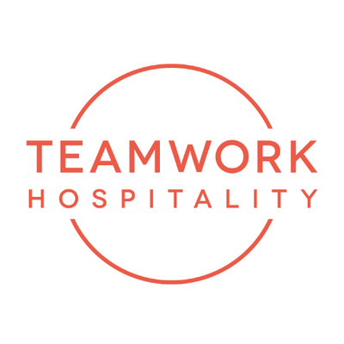
ABOUT US
Headquartered in Rimini, Teamwork Hospitality is one of the main professional actors of the hospitality world and brilliantly deals with consulting and training at 360 degrees for professionals in the sector. Thanks to a true galaxy of services, Teamwork Hospitality, whose President is Mauro Santinato, is able to offer the stakeholders of the tourism and hospitality sector the opportunity to do their job in the best possible way, obtaining the best results in terms of quality, customer satisfaction and profitability for their company.

TEAMWWORK HOSPITALITY
Rimini, Via Macanno 38/q
Ph. 0541-57474
info@teamworkhospitality.com
www.teamworkhospitality.com

OGS PUBLIC RELATIONS & COMMUNICATION
Milano - Via Koristka 3, (Italia)
Ph. +39 023450610
info@ogs.it
www.ogs.it

