PORTA Lighting Collection
by José Manuel Ferrero

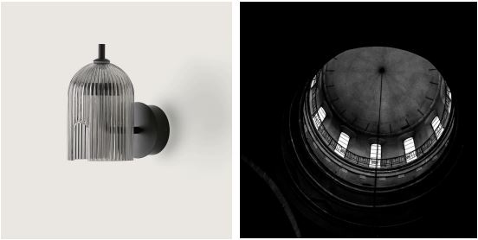

The iconic architecture of great vaulting and arches was the starting point when creating PORTA, a collection of lamps designed for AROMAS DEL CAMPO.
These light fixtures suggest taking some time to reflect upon the environment and sense the calmness and serenity while recalling the interior of a large vault with a central skylight. Moving from the outside to the inside through large arched doors with all the ribs and inner structures of that architecture has been translated into a light fluted glass casing. The rounded silhouette of the lamp and the fluted surface offer a moderate, harmonious sensation to contribute to a cozy atmosphere in just about any environment.
The tactile differences in the materials, the fluted glass and metal, create a look that’s somewhere between industrial and contemporary, discrete yet impressive, bringing the design to life to create the perfect light. Special attention has been paid to the details, emphasizing the two slits at the bottom of the casing; hence, the name.
PORTA is all about the two parallel arches that give the light fixture its own identity. One of them is the connecting point for the metallic support that forms the various lighting systems that can be created which are ideal for home decor or even professional environments.

Worth highlighting is the modular Chandelier that can be created by combining the different diameters to achieve a dramatic visual effect, full of small shades.
The collection is comprised of pendant, wall and tabletop lamps
Client_ AROMAS
Website_ https://www.aromasdelcampo.com

C/Turia nº 7 bajo
T. +34 963 219 622
46008 Valencia. Spain
press@estudihac.com – www.estudihac.com

OGS PR and Communication
Via Koristka 3, Milano
+39 02 3450610
info@ogs.it - www.ogs.it
press.ogs.it

