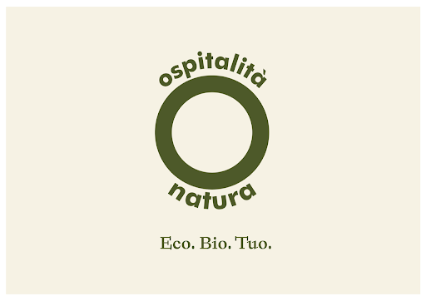

OSPITALITA’ NATURA
FOR THE CONSCIOUS TRAVELER

Italians want more and more sustainability and they want it at 360 degrees, even on vacation. The population of those looking for sustainability also in tourist accommodations is constantly growing. To date they are 7.5 million, while 46 percent of citizens say they are willing to pay more on the basis of the guarantee of spending a holiday that is also a choice for the environment. But not all the realities of the tourism world are ready to answer this question and others still struggle to keep up and need new impulses and skills to establish themselves as an "ecological tourist offer".

"For this reason - said Fausto Jori, CEO of NaturaSì - we have joined our forces with those of Ospitalità Natura, to create the first network that connects accommodation facilities that want to establish themselves and stand out for their commitment for the environment and those tourists who try to make responsible choices even when they organize a trip ".
An eco holiday, therefore, from overnight accommodation to catering to the activities proposed for free time. Those who adhere to Ospitalità Natura, in fact, use energy from renewable sources, use organic food raw materials, adopt an almost entirely plastic-free policy and resort to recycling and separate collection practices that reduce waste.

THE KEY WORDS
Together with "Eco" and "Bio", the key word of Ospitalità Natura is "Yours".
"Yours because Ospitalità Natura was born from a conviction: that we are all called to make our contribution to save the environment and live in a healthier way" explains Casto Iannotta, managing director of the Network and hotelier. “In the world of tourism there has been talk of ecological change and responsible travel for some time, but little or nothing has been done to facilitate this change. Those who have decided to commit to sustainability issues have remained hidden and travelers attentive to this issue are still lacking adequate answers. Ospitalità Natura wants to have this role: to sensitize tourists to make conscious and responsible choices and help the structures to make a path of evolution that takes them to a new level: the eco and organic one” concludes Iannotta.

Presented at Hospitality Day in the last 2020 edition, this year Ospitalità Natura will organize for the Hospitality Day event scheduled for 13 October 2021 at the Palacongressi di Rimini a green area dedicated to sustainability with practical testimonies of hoteliers who are positioned or are positioning themselves on the market as sustainable structures, testimonies enriched by technical contributions from experts in the sector on the issues of energy efficiency and cleaning.

The network already has twelve structures that decided to believe in and support the project from its early stages: such as the Hotel Select in Riccione, the Hotel Milano in Bratto della Presolana and the Hotel Mirtillo Rosso in Alagna. The goal of Ospitalità Natura is to reach one hundred structures in three years, establishing itself as a reference point for green travel.

“We want to fill an all-Italian gap. Countries such as Austria and Germany have already successfully launched and developed similar ideas, while we have been watching - concludes Mauro Santinato, president of Teamwork Hospitality, a leading consulting company in the world of hospitality and partner of the Ospitalità Natura project - and we want to bring our twenty years of experience to help create something unique that changes the way of traveling making sustainability close at hand.”

For more information on Ospitalità Natura:
www. ospitalitanatura.it and www.teamwokshopitality.com

For press materials and interviews please contact OGS PR & Communication: info@ogs.it

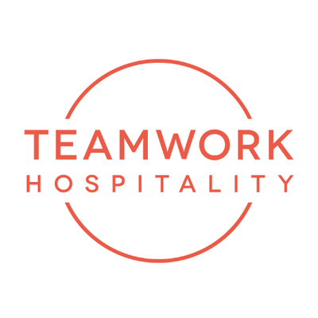

ABOUT US
Headquartered in Rimini, Teamwork Hospitality is one of the main professional actors of the hospitality world and brilliantly deals with consulting and training at 360 degrees for professionals in the sector. Thanks to a true galaxy of services, Teamwork Hospitality, whose President is Mauro Santinato, is able to offer the stakeholders of the tourism and hospitality sector the opportunity to do their job in the best possible way, obtaining the best results in terms of quality, customer satisfaction and profitability for their company.

TEAMWWORK HOSPITALITY
Rimini, Via Macanno 38/q
Ph. 0541-57474
info@teamworkhospitality.com
www.teamworkhospitality.com

OGS PUBLIC RELATIONS & COMMUNICATION
Milano - Via Koristka 3, (Italia)
Ph. +39 023450610
info@ogs.it
www.ogs.it

