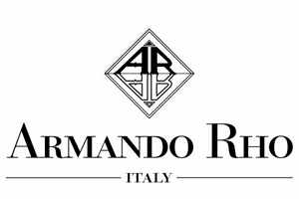

Royal Entrance

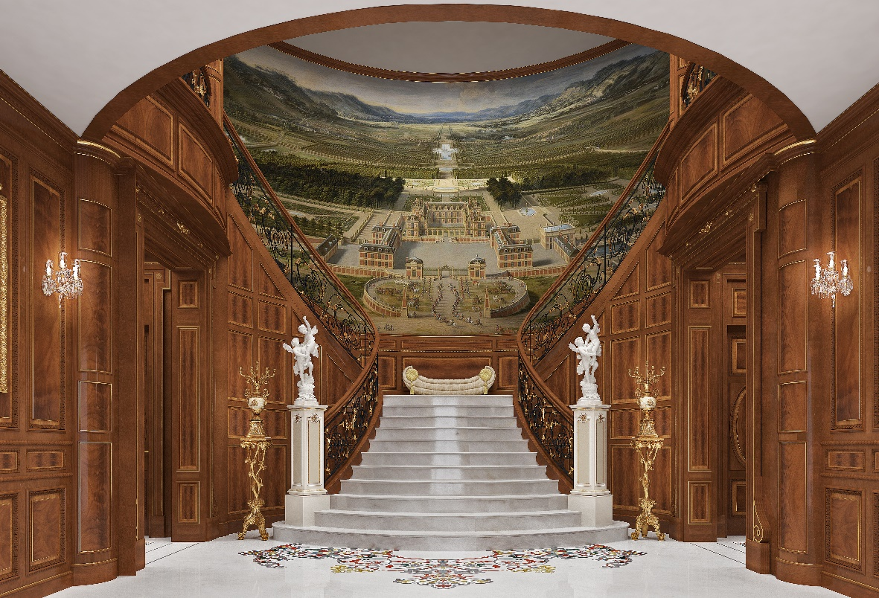

Crossing the threshold of a home means taking a step into the intimate world of its owner. Exploring the homes designed and furnished by Armando Rho means entering into a world of splendor and luxury, a symbol of authentic beauty, majesty and uniqueness, where every single detail is designed together with the client. As soon as you enter an Armando Rho house you are welcomed into a world that enchants, a world that makes you feel like you are living a fairy tale where refinement dominates. An entrance hall from which you cannot fail to be awestruck by the sophisticated contrast between the pure white marble staircase and flooring with the warmth of the wood that covers the walls and the eye catching colors of the mosaic. Once inside the entrance your gaze recovers from initial amazement to that of attention and curiosity, you begin to linger on the details: at the base of the staircase the veins of marble meet with a beautiful inlaid motif that is made with different shades of onyx, creating intrigue and an invitation to go upstairs. At the top of the staircase there is a snug bench, a historical piece of the Armando Rho collection that invites you to sit and pause for a moment to contemplate the enchanting beauty before officially entering the villa. At the side of the staircase you can notice the refined vase holders that are expertly hand carved and decorated in gold leaf. They sit together in perfect harmony with two marble columns depicting fine and graceful angels that enrich the reception and the welcome of guests. A balustrade in walnut, which is also used for the wall paneling, delimits the white marble staircase. Its soft color enhanced by the delicate insert of crotch walnut gives a slight movement to the surfaces; the contrast with the whiteness of the marble gives warmth to the atmosphere and makes it welcoming. The mosaic dominates the entrance, representative of a palace immersed in its boundless garden, a masterpiece of craftsmanship handmade by the company’s skilled artists. The entrance and the villa are in English style, designed and conceived by Armando Rho to reflect the particular yet refined taste of the client. A style that recalls an era of elegance worthy of the highest and most imposing nobility, which transmits and communicates the sense of life; all played on the tones and shades of the color of walnut and crotch walnut on the vertical surfaces with the pure white of the horizontal surfaces. The carefully chosen materials and the many precious details are perfectly balanced and in harmony with each other. Together with the handmade decoration the environment and the atmosphere is unique and unrepeatable. A Royal Entrance that demonstrates the ability of Armando Rho to interpret the customers dreams and makes them a reality. An English style entrance that takes you back to experience the great eras of the past and provide the warmest of welcomes. A style that combined with extreme attention to detail is revived in its furnishings, in the choice of the woods such as walnut and crotch walnut, in the refinement, and in the harmony of the materials. You cannot stop at the threshold and admire only the entrance, there is too much unexplored beauty waiting to be discovered; an invitation to enter and open the doors of the turn-key villa of dreams by Armando Rho.

ARMANDO RHO S.R.L
Via Per Cabiate, 111, 22066 Mariano Comense CO
Ph. +39 031 747463
www.rhoarmando.com - info@rhoarmando.com

OGS SRL PUBLIC RELATIONS & COMMUNICATION
Via Koristka 3, 20154 Milano, (Italy)
Ph. +39 023450610
www.ogscommunication.com- info@ogscommunication.com

