ALESSANDRO LUCIANI
The creative partner in the world of design.
When vision and creativity meet humanity and experience.
From the family business to international awards, a story full of emotions, vitality and innovation.

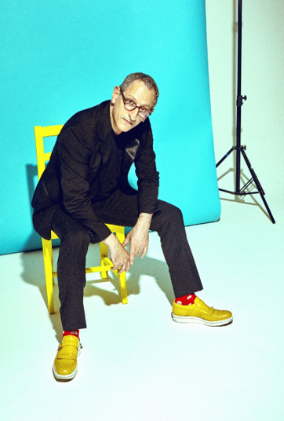

Alessandro Luciani is one of the most eclectic Italian and international designers specialized in the world of Retail. He defines himself as a "designer of human experiences" and in fact his extraordinary personal history and origins, which has influenced his design approach, play a fundamental role in the choices of his professional career. Inspired by a strong desire to go beyond the boundaries of the ordinary, he brings to his projects an innovative, anthropocentric vision, oriented towards sensory engagement and the creation of new experiences, contributing to individual wellbeing, creating a strong emotional bond between the setting, the product, the client and the brand.

Alessandro Luciani was born in a family with a history of over one hundred years in commerce, where innovation and quality have always been the strong points and where he has been able to capture all the dynamics.
He has an original path that begins many years ago and is rich of strong passions and interests, ranging from sport to music, fashion and technology. As a teenager he had a passion for designing and producing clothes and furnishing objects, and at the same time he was able to assemble discarded electronic components to create functional objects. Choosing between his passion for fashion and creativity and his passion for sport, Alessandro Luciani graduated from the ISEF in Aquila in 1992 with a thesis on a subject that had never been addressed before, "The psychophysical preparation of astronauts", a topic that already reflected his original and unconventional personality. After his studies, he joined the family sports shop where he worked for about 12 years.

It all began in 1993, when Alessandro Luciani decided to redesign and renovate the shop, transforming it into a completely new environment, where design, innovation and creative flair supported the real protagonists: the products displayed.

Working during the day and studying at night, he says: "I loved understanding how Americans were so good at displaying merchandise, making it look better than it really was and selling it".
Many people were wondering who made it and where he had obtained the furnishings, which were especially admired for their simplicity and ability to enhance the product, although in fact they were designed by Alessandro Luciani.

"I am a curious and passionate observer, I like to go in depth and I did it first starting from the family business, my real university, through the design of an optimized lay-out and the development of new furnishings that would allow me to apply Visual Merchandising techniques to make the product the protagonist and be capable of selling more".

At the age of 35, Alessandro Luciani, who was limited within the confines of his shop, decided to start again from the bottom in search of the same passion that he had previously left. On the strength of his natural talent and the success of his furnishings, which he began to sell, he managed to transform his innate passion for design, creativity and fashion into a profession that has led him to combine the practical and functional side of the shop with the creative side, reaching nowadays exceptional goals.
A visionary that since beginning was looking far beyond the limits of the obvious, he succeeds in creating polyhedral, performant and original projects. He easily gets into the client's psychology, reads their expectations, interprets their needs - even those that remain unexpressed - and creates a design philosophy that can be adapted from one context to the other, expressing their personality.

PROJECTS. VISIONS. DESIGN.
In 2011 Alessandro Luciani was selected by Pirelli Tyre, which, in the period after its debut in Formula 1, had started a brand awareness operation with the creation of a new concept to be realized for their main customers, through a design competition in which Luciani participated and of which he was the winner.
It was his first great professional opportunity to apply all his visionary skills and experience to important themes such as visual merchandising, the psychology of colors, the use of materials, sales and marketing techniques, aimed at enhancing the value of the product by rewriting the Hospitality paradigm, creating an extraordinary customer experience.
Since then, Alessandro Luciani has received many important awards and now has more than 25 national and international Retail Design awards, including the American "International Store Design Awards" for Huawei's first European Experience Store and the prestigious "International Design Competition" "Best of the Best" Class 2020 award from the Retail Design Institute USA for the "Spazio Lenovo" project recently created in Milan, in the central Corso Matteotti.

From the analysis of new Retail Concepts to the Interior Design and Creative Direction, Alessandro Luciani develops new spaces and creates new human and sales experiences, focused on the concept of multisensory, Omni channel and well-being. The most important feature is to create projects that bring innovation, convey emotions and look to the future, original on the market as the one for the Parafarmacia Dr.Fleming in Milan, a project in 2013 that went beyond all limits, breaking down barriers such as traditional pharmacy counters, introducing technological innovation and rewriting the rules of the a new relationship between Brand, Customer, Product and Environment.

“I feel like a pioneer of the idea of transforming waiting into welcome," Luciani says, "to move from the perception of lost time to that of time perceived positively as an opportunity for personal enrichment. The use of time in recent years is changing and radically influencing our habits. We spend a lot of time on social networks and live on the Internet. Thanks to new technologies, and artificial intelligence, all the services created will increasingly move towards the personalization of all our individual needs and will capture more and more of our attention and time.”

In Alessandro Luciani's projects, we can identify the will and the ability to go beyond the essential, with more energy, more color, with all the creativity, the attention to every single detail, taste and elegance and the expertise of doing things well, bringing "a breath of fresh air" to the world of design that is perceived and implemented as a point of arrival that transforms "what was there before into something tangible".

Thanks to a process of virtuous contamination between different worlds, passions and contexts, Alessandro Luciani's design approach to Retail Concept, Store Design and Interior Design is in continuous evolution. His curiosity and expertise take him into a vortex of new ideas and projects that expand into the world of Product Design.

Today as yesterday and even more tomorrow, at the center of the designer's concepts and creations will be the Person. That’s because only through knowledge and respect for the value of the person design can contribute to improve the quality and state of well-being of those who live and inhabit life.

It's time for a new vitality - Alessandro Luciani

Alessandro Luciani Designer
Head Office - Via S. Eusanio, 1
02100 Rieti Italy
Offices - Roma Milano New York
+39 335.5420070 - info@alessandrolucianidesigner.com

OGS PR and Communication
Via Koristka 3, Milano
www.ogscommunication.com
+39 02.3450610 – info@ogscommunication.com

