PIQUÉ ceramic collection
by José Manuel Ferrero

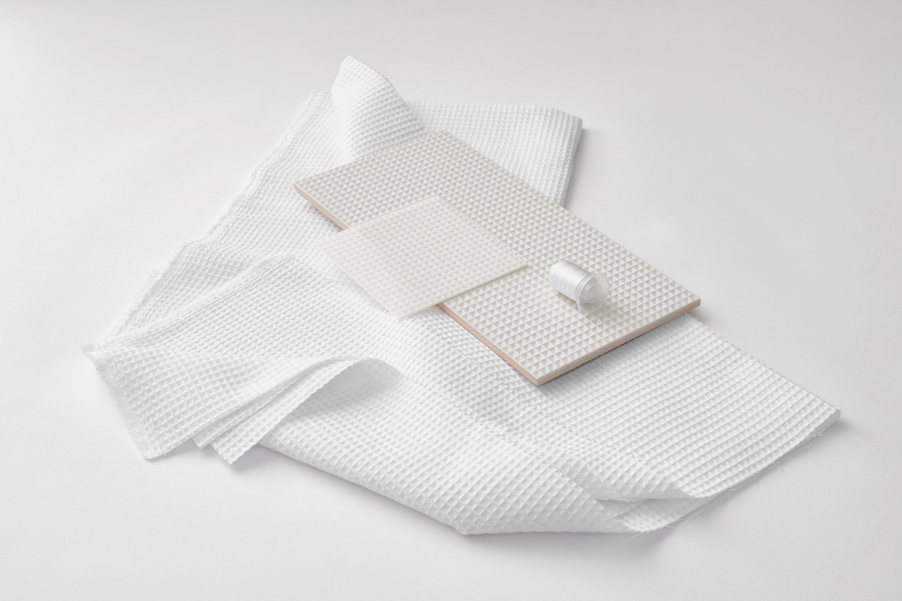

History and technology come together to begin the all-new ceramic concept José Manuel Ferrero of estudi{H}ac studio has created for Harmony, making it possible to express and transform a passion for textiles in a ceramic concept with an immense visual/touch impact.

In the late 18th century, the Lancashire cotton industry developed a mechanized technique to weave double cloths with a heavy weft included, giving rise to Pique fabric. Some sources say this fabric was specifically developed for parts of dress suits. This white tie male garment is the most formal clothing men can wear at major celebrations.

The textile textures and the search for geometry that could be broken down by layers to produce a study of three-dimensional volumes have been the basis for analyzing this type of fabric and interpreting it as an elegant and contemporary ceramic collection.

The Pique collection is divided into three parts with different ceramic proposals.

Piqué Waffle is the purest and most conceptual proposal. It pursues the idea of transmitting the most real texture of the fabric in its purest and most natural state. The combination of relief with a texturized micro-matte finish provides the realism sought.
It comes in 4 different tones: Anthracite, Bordeaux, Sand and White, all made of 20x40 cm porcelain.
.
Piqué Mosaic is an exploration of relief as a symbol of differentiation, thus creating a three-dimensional reverse mosaic effect. The play lies in the combination of grouting with a tone-to-tone effect or in contrast with the base color.
It comes in 2 different tones: Anthracite and White, all made of 20x40 cm porcelain.

Piqué 3D is based on a linear extrusion of the weft comprising the fabric to obtain two pieces with the most iconic of character. The different composition combinations create light and dark effects depending on the play on lights to boost the reliefs.
It comes in 4 different tones: Anthracite, Bordeaux, Sand and White, all made of 10x10 and 10x40 cm porcelain.
.

NAME: Piqué
CLIENT: Harmony
USE: ceramic collection
INSPIRATION: piqué textile
MATERIALS: ceramic
COLORS: Anthracite, Bordeaux, Sand and White
DIMENSIONS: customizable

C/Turia nº 7 bajo
T. +34 963 219 622
46008 Valencia Spain
estudihac@estudihac.com – www.estudihac.com

OGS PR and Communication
Via Koristka 3, Milano
+39 02 3450610
www.ogscommunication.com - info@ogscommunication.com

