PLISSÉ Furniture Collection
by José Manuel Ferrero

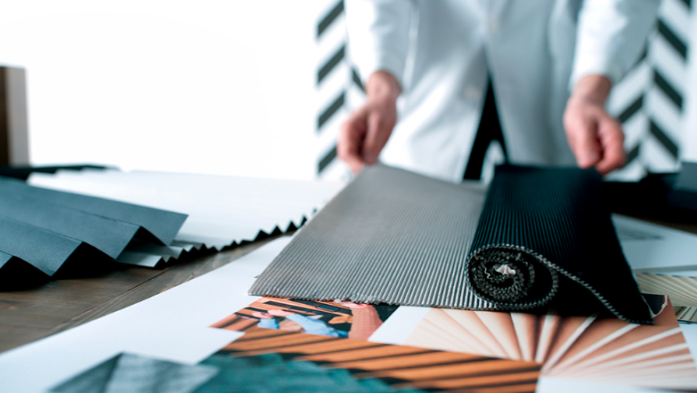

This is the first designer collection that José Manuel Ferrero of the estudi{H}ac studio has designed for the new brand VICAL DESIGN created by VICAL HOME.

PLISSÉ is a design with various artisan pieces manufactured naturally. This very
attractive and elegant collection is inspired by the incredible life of the multi-faceted MARIO FORTUNY and the work of the Parisian artisan firm LOGNAN.

The production of the pleated fabrics and the processes involved are the driving force behind the design of each one of the new proposals, which along with the synthesis and adaptation of these processes to the three-dimensional shapes, have turned the collection into a real exercise perfectly combining the concept and manufacturing process.

The natural and primary artisan work behind each one of the pieces give it unique and personal character. The combination of the wood carving with natural stone and rattan braiding with invisible metal structures generates a series of natural graphic textures that come together to bring volume to the pieces.

The care and meticulous study of the reliefs to create weaves and textures provoking an interesting play of shades and shapes with the light are worth highlighting.

The PLISSÉ collection is comprised of a variety of pieces grouped by type and a
combination of materials and processes.

PLISSE RATTAN is the delicate artisan work based on natural fibres. It’s surprisingly reflected in the entire family of sitting furniture (sofas, armchairs and chairs), tables, hanging lamps as well a system of modular folding screens with the interwoven fibres.

PLISSÉ WOOD Natural wood has been used to develop carvings with pleated geometrics combined in different scales to generate an interesting system of furniture and tables.

PLISSÉ METAL The synthesis of PLISSÉ is a graph with spiked lines applied to a system of flowerpots that combine metal and cement along with the design of a chair that reflects the entire conceptual universe created, becoming the icon for the collection.

PLISSÉ STONE presents a system of large-sized flowerpots that play with the pleats and aged stone texture. 100% artisan pieces that follow the same design yet are each unique.

NAME: Plissé
CLIENT: Vical Design
USE: collection of furniture
INSPIRATION: plissé
MATERIALS: wood, metal, rattan, natural stone
COLORS: dark green, black, grey, golden

C/Turia nº 7 bajo
T. +34 963 219 622
46008 Valencia Spain
estudihac@estudihac.com – www.estudihac.com

OGS PR and Communication
Via Koristka 3, Milano
+39 02 3450610
www.ogscommunication.com - info@ogscommunication.com

