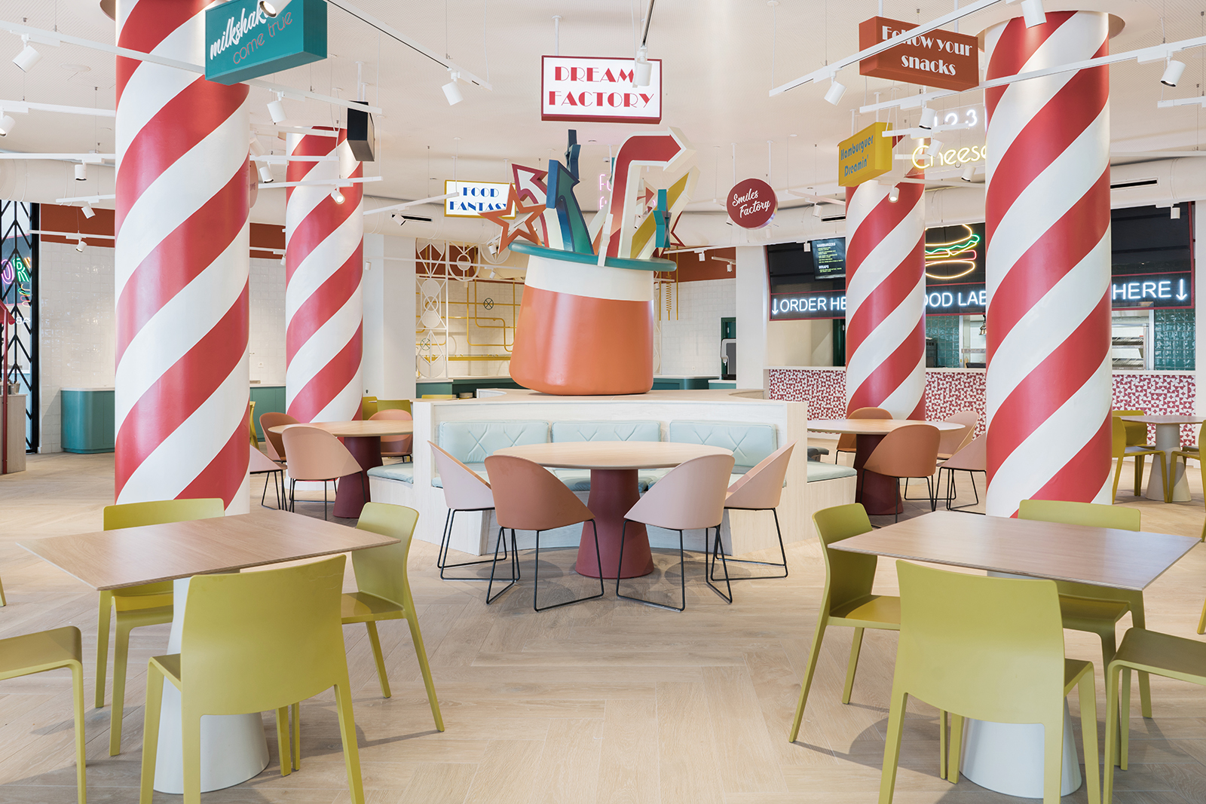

DREAMS FACTORY AT
FANTASIA BAHIA PRINCIPE HOTEL IN TENERIFE.

“A POOL RESTAURANT WHERE DREAMS COME TRUE”

The first impression communicated by estudi{H}ac founded by José Manuel Ferrero, is that of a great passion in always creating new and fresh visions for design products, interior projects and food spaces, following the studio’s philosophy, that is: designing for visionary clients.
A surprisingly graphic energy is among the points of strength of the team.
At Fantasia Bahia Principe Hotel by Piñero Group in Tenerife, the Valencian studio created the DREAMS FACTORY, a place where your dreams come true. A unique environment where freshness, happiness and emotions become part of the surroundings.
Designing for food spaces is a true challenge where one has to play on local suggestions, but also on the opposite, giving life to de-contextualized spaces with their own storytelling combined with a lively gastronomic offer.

The basic inspiration of this project comes from the idea of colour and fun. The premises and the layout of the space have been designed to create a brand new concept of Pool Restaurant, that covers an area of 600 square meters.
The layout of the DREAMS FACTORY features a central island surrounded by four impressive columns painted red and white, thus resembling four giant sticks of candy.
The large sculpture of a magical hat charged with positive energy dominates the central island. An array of graphic and colourful elements is projected inside, thus turning the site into a pleasant space-for-fun.

Food and entertainment joyful combine in the other areas of the Restaurant, such as the menu service area and the buffet area, where salads, desserts, ice cream and toppings are served. Funny shaped lighting fixtures and linear tables and chairs in smooth light colours welcome guests who are looking for a fancy food experience in a dazzling site.
The inside space is divided from the terrace by a system of movable doors, that have been tailor-made for this project. A ceiling-to-floor graphic design made with metal sections represents the local plant life of the Tenerife island.
In the outside space all nuances of the inside are combined giving life to a magical explosion of colours in form of a large mosaic specially created for the project.

NAME: Dreams Factory / Fantasia Bahia Principe Hotel.
CLIENT: Piñero Group
LOCATION: Tenerife. Spain
DATE: November 2018
PROJECT: Restaurant
INSPIRATION: On the history of the PAPIMBER is an adventurous traveler character created by Grupo Piñero
DIMENSION: 600 m2
FLOORING: Parket – Colorker
Mosaic – Hisbalit
Tiling – Cevica
TAILOR MADE FURNITURE: Metal confort
COMMERCIAL FURNITURE: Arper
Andreu World
Vondom
Resol
DECORATIVE LIGHTING: Marset
Iguzzini

LIGHTING DESIGNER: Iluminación Ambiente
PHOTOGRAPHY: Adrian Mora Morato

C/Turia nº 7 bajo
T. +34 963 219 622
46008 Valencia. Spain
press@estudihac.com – www.estudihac.com

OGS PR and Communication
Via Koristka 3, Milano
+39 02 3450610
www.ogscommunication.com
info@ogscommunication.com

