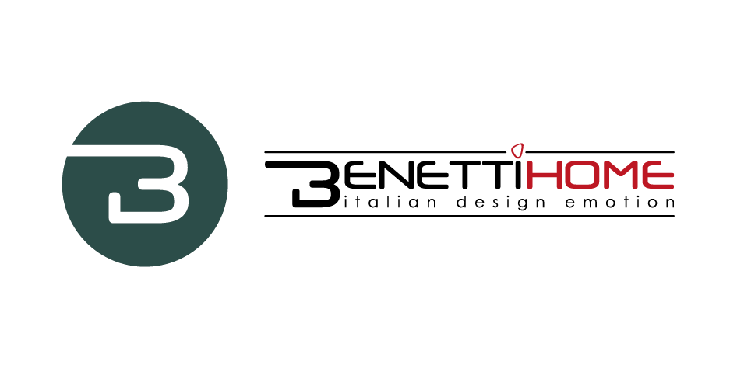
BENETTI HOME
CUSTOMIZATION OF PRODUCT AND SERVICE FOR INTERIOR DESIGN.

The scenographic presence of ‘green’ in the interiors is not only motivated by an aesthetic factor linked to trends, but also by the positive effects of relaxation and well-being generated by the sight and contact with the 'green' element at home, in the office, in commercial spaces, in food and hospitality premises.
This pleasure, which combines pleasantness and well-being, puts demands in terms of light, water and maintenance. BENETTI HOME, a young and dynamic Italian company, has developed a product with unique characteristics, both from a technical point of view and for the fantastic aesthetic impact, which effectively solves the critical issues that make the use of indoor ‘green’ uneasy.

BENETTI MOSS is the name of the zero-maintenance vertical garden for interiors made with a 100% natural and stabilized lichen, easy to manage, starting from installation, which is very simple and can be foreseen in the project step or even later in already furnished and 'lived in' environments. Featuring highest versatility of application, the garden can be placed on the walls and even on the ceiling. This product offers advantages from the point of view of cleaning, thanks to the absence of electrostatic charge that does not attract dust, ensuring stability and durability over time, as well as being unwelcome to insects. This panel features good sound-absorbing qualities and fire-retardant properties certified in class A by the rigorous American fireproof tests.

FROM PRODUCT TO SERVICE
Since the ‘moss’ idea was born about 15 years ago, it makes use of cladonia stellaris, a moss collected in the woods of Northern Europe, which is now widely used in interior design.
"I call it a democratic product - says Stivens Benetti, owner of the company - because today the use of this material on various supports for the most varied applications is widespread all around the world."

BENETTI HOME was born in 2016, but the company can boast thirty years of professional career of the owners in the field of interior design, as well as on a well-known brand on the marketplace. The company is a lean and dynamic business based in Novara, where marketing and commercial management are centralized. The company mission is to design spaces with the magic that comes from 'Italian design emotion', according to the corporate pay off and meaning the creation of an Italian design space that generates unique emotions, with a multisensory approach involving both the user and the environment.

"Our point of strength - explains Benetti - is our great design skill and a quick response approach in offering a timely and quality service, combined with a list of references difficult to mach, that allows us to count on customers like Amazon, Facebook, Google, Adidas, Yves Rocher. In Milan, just to name a few, we realized green walls for Mustela, in Verano Brianza for Media World. We are able to carry out extremely interesting projects not only in Italy, indeed mainly abroad and in particular in the United States, in collaboration with world renowned architectural studios such as Gensler or Perkins Will."

80% of company’s turnover is generated abroad with the United States as main reference market. Sales all over the world are made through a network of multi-brand agents and, in some cases, distributors. Starting from a catalog that provides a very complete offer and a strong aesthetic impact, architects and interior designers create projects carried out within international frameworks and supported by the presence of external professionals on behalf of Benetti Home.

KEYWORD: CUSTOMIZATION
Product customization is a key point. By choosing BENETTI MOSS vertical gardens, customers will rely on shapes and sizes capable to be adapted to any space requirement and designer’s vision, to create customized walls based on chromatic games as well as the combination of full and empty spaces, dimensions and volumes.
BENETTI MOSS allows to realize logos on neutral backgrounds, or vertical and horizontal stripes or decorative motifs in all shades of colours, as creativity is the only limit.
On the basic colour (cream) of the lichen when it is collected, food and totally non-toxic dyes can be added, choosing from a range of 12 colours in the catalog, even if green in its various shades still remains the prevailing colour. Not surprisingly, as we know that human brain elaborates the green colour as something positive and perceives it as a natural antistress.

Among BENETTI HOME’s latest proposals always in line with the philosophy of customization, there is BATIK MOSAIC, a new product presented in early 2020 and currently being launched.
A product full of promises and with interesting features, it is a very light and very thin resin mosaic on which real photographic images can be digitally printed, in any size, glossy or matt. It can be placed in any kind of environment, outdoor or indoor, suitable for wellness and spa areas, as it is resistant to humidity. It can also be applied over an existing wall, without requiring brickwork.

SOMETHING NEW IS COMING
Among the novelties arriving in 2021, there is BENETTI SOUND, an innovative idea linked to the theme of the vertical garden, which comes with an explicit and precise claim: 'If walls could sing .... " and which completes the range of BENETTI HOME products, making it even more original and attractive.

"It consists of an aluminum panel - explains Stivens Benetti - like that one supporting the MOSS and capable of producing sound as the result of a research to optimize sound and its diffusion, which benefits from high-level electronic and sound technology."
A driving product for the corporate image, BENETTI SOUND represents a new approach to the market, an innovative and engineering technology adapted to the vertical garden through sound panels, whose cost should be divided by the square meters covered by panels, thus making it more accessible.
These tools and technologies have been developed by a team of engineers and were aimed at obtaining a sound of the highest quality, consisting of panels with an exciter connected to an external amplifier from which the user can control the output sound in a simple and direct way, through its personal devices.

Through its range of products and services, BENETTI HOME offers the market solutions able to combine extreme ease of application and use with the pleasure of a perceived sensoriality that generates well-being.

Benetti Home
Via Giacomo Matteotti, 34, 28060 Granozzo NO
info@benettihome.com - www.benettihome.it

OGS PR and Communication
Via Koristka 3, Milano
+39 02 3450610
www.ogscommunication.com- info@ogscommunication.com

