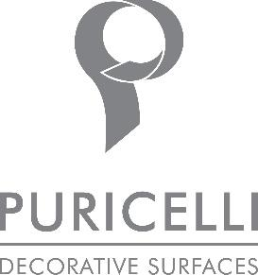

DECORATIVE SURFACES BY PURICELLI
A THOUSAND FACES TO KITCHENS AND BATHROOMS

Dedication to design combined with the acknowledged performance qualities of its decorative surfaces, the Puricelli Group, an accomplished reference brand for over 70 years, has achieved an important milestone with their new range for Kitchens and Bathrooms.

The Kitchen and Bath collection was realised with all its additional features in two varieties. Either a thin laminate designed to be bonded and edged on a thicker substrate of either wood, MDF or chipboard, or, of recent introduction, the Compact line i.e. a compact layered laminate of greater thickness ideal for use in both kitchen and bathroom furniture tops.

These two varieties have the added advantages of being easily formed in 3D and bevelled at the edges with normal carpentry tools, so avoiding the necessity to resort to specialised equipment as required by some solid surfaces. Kitchen and Bath can be coloured throughout to obtain an all-colour effect. As the surface is also coloured in thickness it does not require edging.

The most popular thickness for kitchen and bathroom tops is 12 mm. A 4 mm thickness is used frequently for wall panelling. Normally Compact is used where a thickness of 6-8 mm is required and for ventilated frontages or external uses.

Kitchen and Bath is also available in 0.7 mm, either bonded onto different supports, or combined with the same surface of a greater thickness as a coordinated edge. Having a coloured border to match can make all the difference to the design.

An attractive feature of this collection is the visual effect of natural materials that is on offer. Puricelli presents Puricelli MOON, a marble effect best seller and two popular wood finishes that are characterised by their velvety touch. Of recent introduction is a concrete effect that is also available for other agglomerates.

Likewise, rugged solutions feature within the collection and their appearance and touch are key characteristics. The decorative surfaces of the Puricelli Group are all phenol free certified, reflecting the continued commitment of the company to sustainability.

Puricelli’s decorative surfaces are antibacterial, making them particularly suitable for kitchens and bathrooms. They are a product of choice where hygiene, health, and safety are decisive.

Puricelli Decorative Surfaces
Via Nuova Valassina, 3 Costamasnaga Lecco
www.puricelli.it – info@puricelli.it
+39 031855051

OGS PR and Communication
Via Koristka 3, Milano
+39 02 3450610
www.ogscommunication.com – info@ogscommunication.com

