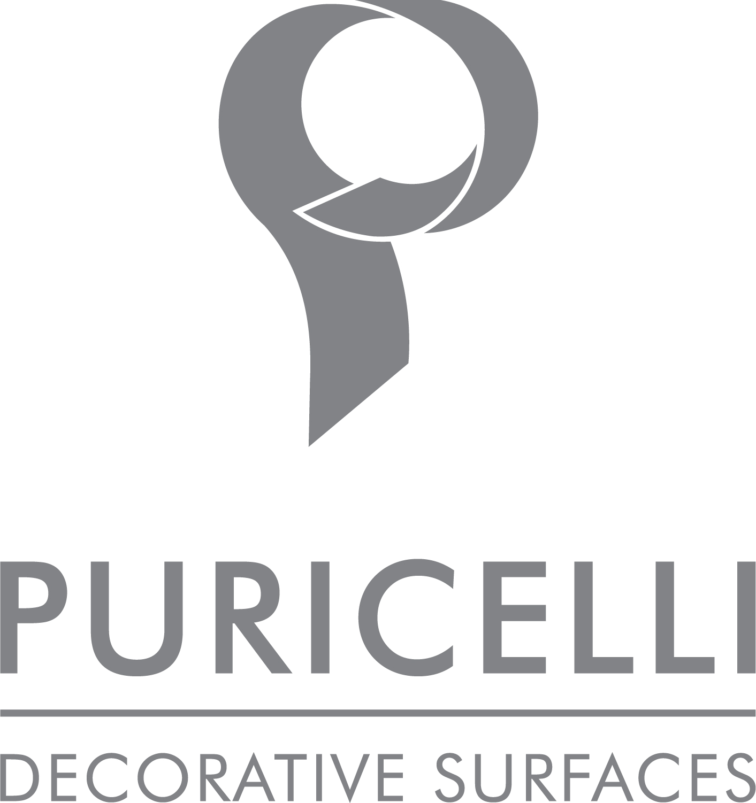

Decorative surfaces by puricelli
The story of a forward-THINKING COMPANY

The Puricelli group is a global company with its roots steeped in tradition and entrepreneurial ability. With decades of experience in the design and production of laminates, Puricelli is renowned for its expertise and devotion to innovation so placing it as a perfect partner when shaping the future of decorative surfaces.

In post war Italy the then young and innovative Cav. Luigi Purcelli sought to create a new affordable synthetic material that would revolutionise the coverture of homes, offices, boats, patios and the like. Initially Laminate was produced in Veduggio in Northern Italy however due to high demand, production had to be expanded.

In the early 1960’s, a new manufacturing site opened in Costamasnaga near Lecco where the company still has its headquarters today. Increasing demand for Laminate also came from outside of Italy and in the four years from 1968 to 1972 expansion continued with the opening of Puricelli Hellas in Greece and Puriplast Iberica in Spain.

Now the Puricelli group is head up by the founder’s grandson, Luigi Puricelli, and employs 250 people with production sites in Costamasnaga, Teramo, Thessaloniki, Valencia and Tunis. Under his leadership, the tradition of product innovation and development continues and expands as it faces new demands including that of sustainability.

“Today our company is one of the most complete in the world of decorative surfaces - explains Luigi Puricelli - We are able to produce laminate from one-tenth to 30 millimetres and our products range from flexible laminate coatings to laminates for high performance self supporting top level projects. An example being that developed for The European Council for Nuclear Research (CERN) in Geneva”.

“Our surfaces are an ideal solution for numerous markets - continues Puricelli - We produce for many technical sectors such as naval, medical, hospitality and are also a brand of reference in the vast area of furnishings for the home and workplace. In this particular sector, a strong design content with high performance in terms of resistance, versatility, health and safety, united with properties like antibacterial and non toxic are essential”

Laminate is a particular coating material where two thirds cellulose and one third thermosetting resins are used to overlap paper to obtain the desired stratification and thickness. Whilst in the press the resins are activated by high pressure and temperature so thinning, melting and solidifying.
Because of the temperature, pressure and relative catalyst a product that functionally is extremely reliable and durable is formed. A product that remains unaltered over time. The laminate is antibacterial and easily cleaned with non-toxic detergents.

Puricelli is an environmentally friendly company, its founder Cav. Puricelli was always been sensitive to the environment and his legacy continues today. Consequently, the company has implemented a number of specific changes to the laminate production cycle. Starting with the basic raw materials phenol has been eliminated from the resin. “We are the only company in Italy in our sector - explains Puricelli - to directly produce the resin. This allowed us over fifteen years ago, whilst we renewed our manufacturing plants, to eliminate the use of phenol. Our founder then had the strong conviction to follow a policy that respected the needs of the environment.

In recent years, public concerns over the environment have increased and Puricelli has launched a targeted communication plan that talks about the importance of phenol free products and zero emissions of harmful substances. As a result, the laminate produced by Puricelli has become extremely interesting as it responds to many of the new concerns raised by consumers today.

Moreover, the company is moving towards recycling its own discards of production to produce panels with innovative characteristics, some of which with improved performance over the original. This new and innovative process is under development but demonstrates the solid investment and purpose the company has in terms of sustainability and circular economic principals.

The actions respecting the environment and the flexibility and performance of the product itself legitimise the company claim ‘Puricelli, Natural core with Design’.

Puricelli Decorative Surfaces
Via Nuova Valassina, 3 Costamasnaga Lecco
www.puricelli.it – info@puricelli.it
+39 031855051

OGS PR and Communication
Via Koristka 3, Milano
+39 02 3450610
www.ogscommunication.com – info@ogscommunication.com

