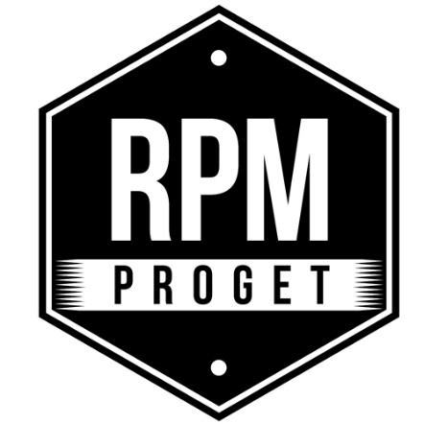

Reconverting an eating place, giving it life again and a new and appealing personality. This is the spirit of restyling, a recent trend in which many restaurant and bar owners are interested in. They don’t dare to renovate completely, preferring more and more the simple and fresh taste of renewing. In fact, every space has potential if you find a specialized team to give shape to the idea you have in mind.
RPM Proget is a design studio with a Roman heart but an international vision, specialized in the renovation of restaurant spaces up to the interiors of hotel facilities. The studio also offers restyling solutions, meeting once again flexibly the needs of a constantly evolving market. The studio has been found by the three established professionals Roberto Antobenedetto, Michelangelo Pepé e Patrizia Pozzi. Together they have created a creative and dynamic reality, always attentive to new industry trends without forgetting the objective of each eating place, which is to welcome customers making them feel at home.
For the studio, furnishing means passion, commitment and continuous research since an eating place is something alive. It constantly changes and evolves following the trends of the period or starting new ones, always improving in terms of aesthetics and functionality to offer the “right product in the best way.” The interiors realized by RPM Proget stand out for the originality and elegance in details as well as for the current and modern approach. This is the result of a deep knowledge of the industry combined with tradition, that can be seen in the vintage soul of spaces which creates a nostalgic flair of an updated past calling for friendly conversations. This call for a dialogue is reflected also in the Roman studio’s approach to its clients with whom it constantly interacts and communicates to realize step by step the owners’ dream.
In Via Trionfale in Rome, an eating place waits for its opening telling us a fascinating story of change and rebranding. It all starts with the idea of a strong restyling to give the restaurant bar a new and vibrant identity. The old-fashioned look and lack of light, in fact, makes the indoor environment of the restaurant bar old and out of date. The idea of a modern and friendly burger restaurant takes shape. RPM Proget call it “Taglio” (Cut), a strong and determined name and a landmark of a quality product evoking the magic atmosphere of the barbecue. With great attention and expertise, the RPM Proget team changes the face and spirit of the eating place. Keeping their internal technology, the counters have been modernized and freshened up with cement tile covers and tiles from the ‘60s for the front of the counter. Walls have been renewed leaving some exposed brick walls adding some brass lamps, vintage sofas for a retro style and comfortable seats with a thin upholstery for a fresh and dynamic design. The colors are also brightened with a dreamy sky blue and a vivid and lively red which is a metaphor of the flame of the barbecue made explicit by the red brand painted on the wall at the entrance of the place. In the second room, a refrigerator has been designed as a showcase to admire the fine cuts of meat, preserved and showed as a precious treasure.
Details build a personality and the restyling can represent a valuable tool to give a unique and consistent identity to the different eating places of the same chain. This is the case of Ba’Ghetto, restaurant chain offering dishes from the Roman traditional cuisine revisited with a kosher influence, a combination of two different cultures, in harmony for the timeless nature. With its rapid and successful expansion, first in the Capital, then in Florence up to Milan, Ba’Ghetto shows a well-defined layout and aesthetics recognized by the refined and modern style. This is another important project of the RPM Proget studio which reveals the harmonizing power of restyling.

Restyling is change but it is not synonymous with modernity as we can see in the Raf restaurant which, with a significant restyling by RPM Proget, preserves the love for the past. The classic style in fact can be noticed in the interiors with a wide use of a warm and cozy wood and the wood woven covered in mosaic which releases all the charm of the genuine and simple yet timeless Roman trattoria.

The restyling is thus a successful change full of advantages. It is affordable and effective in the result when you find the right way to implement it. RPM Proget remains a balance reference on the market to renovate cost-effectively and most importantly with great quality.

RPM PROGET
Via Gregorio VII, 472, 00165 Roma
www.rpmproget.it/ - info@rpmproget.it
+39 06 66019011

OGS PR and Communication
Via Koristka 3, Milano
www.ogscommunication.com – info@ogscommunication.com
+39 02 3450610

