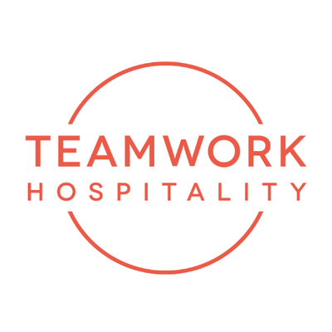
TEAMWORK HOSPITALITY
A GALAXY OF SERVICES FOR THE WORLD OF HOSPITALITY

Teamwork Hospitality in Rimini is one of the main professional actors of the hospitality world and brilliantly deals with consulting and training at 360 degrees for professionals in the sector. Thanks to an authentic galaxy of services, Teamwork Hospitality is able to offer the stakeholders of the tourism and hospitality sector the opportunity to do their job in the best possible way, obtaining the best results in terms of quality, customer satisfaction and profitability for their company.
Among the factors of success of the Rimini network, which has Mauro Santinato as its President, stand out the experience of its collaborators and partners and the passion in carrying out their know-how and skills transmission tasks in a constant flow of updating and interest in the dynamic and ever-changing world of tourism.

The areas of intervention of Teamwork Hospitality include a range of activities that leaves nothing unexplored in the fascinating and complex world of hospitality and in the different formulas to address the topic issues: marketing and sales, online marketing, corporate communication, hotel management, quality control and mystery guest, assistance with restructuring and new openings, professional training, economic feasibility analysis and operational marketing publications.

A SUCCESS STORY
Teamwork Hospitality was born in 1998, in years of great dynamism but also of only apparent tranquility. Shortly thereafter, the world of hospitality would have become much more complicated and stimulating at the same time. The era of the self-taught hotelier ended and the era of the hospitality industry entrepreneur began. The task of Teamwork Hospitality over the years was to anticipate change, simplify complexity, put it within the reach of its customers, so that they not only could understand it but also consider it something exciting and rewarding.

The objectives were many and one of the main tasks was to help the hotelier grow and work with passion, providing him with the necessary knowledge and tools and teaching him how to use them to optimize results. Even today - after 23 years of activity - Teamwork Hospitality and its brands contribute concretely to the professional and managerial growth of the sector.

CONSULTING AND TRAINING
Today the consulting activity of Teamwork Hospitality is articulated through marketing and sales interventions, social media, web and online reputation, corporate communication, hotel management, company check-ups and mystery guests, restaurant solutions, assistance in renovations, new openings, and real estate management.

A separate section of the network is dedicated to training, which offers custom made training formulas, classroom training, epic leadership and Teamwork Hospitality events.
Fundamental is the activity of economic feasibility studies, a tool that allows to establish, on a logical and rational basis, to what extent the entrepreneurial intuition or investment opportunity have a well-founded possibility of transforming themselves into successful tourism products.
Territorial marketing activities use the Product Club, the Tourism Marketing Plan and the Tourist Observatory as tools.
A rich series of publications makes available to professionals over 40 operative manuals addressing the issues of hospitality, from the most complex to the most practical, as well as studies and analysis of the sector's competitive scenario and economic-managerial research carried out on a territorial and sectorial basis.

TRADE FAIR COMMITMENT AND EVENTS
A wealth of industry culture and relationships as wide and articulated like that boasted by Teamwork Hospitality, also leads to success in the organization of fairs, conferences and events. Among these we mention Hospitality Day at the Palacongressi of Rimini, Guest Lab Palazzo delle Stelline in Milan, ITHIC (acronym for Italian Hospitality Investment Conference) in Rimini as well.
These are very important conference moments capable of transmitting culture, sharing knowledge and providing food for thought and visions on the future to professionals of the sector.

For further information on Teamwork Hospitality:
www.teamwokshopitality.com

TEAMWWORK HOSPITALITY
Rimini, Via Macanno 38/q
Ph. 0541-57474
info@teamworkhospitality.com
www.teamworkhospitality.com

OGS PUBLIC RELATIONS & COMMUNICATION
Milano - Via Koristka 3, (Italia)
Ph. +39 023450610
www.ogscommunication.com – info@ogscommunication.com

