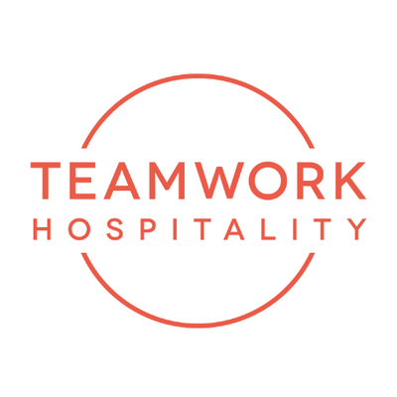

RIMINI CAPITAL OF TOURISTIC TRAINING FOR ONE DAY

Hospitality Day, ITHIC, Leadership from Chaos: three high-profile training events in a single day have filled the Palacongressi with tourism operators and leading names in the sector. With the welcoming speech by Minister Massimo Garavaglia.

More than 3,800 participants from all over Italy, more than 200 speakers, 25 international experts, 235 partner companies, 12,000 square meters of conference space: these are the results of Hospitality Day, a special day dedicated to the training for professionals in the hospitality sector, organized by the consulting and training company Teamwork, which was hosted at the Rimini Palacongressi on 12 October.

Mauro Santinato, president of Teamwork and developer of the event, affirms" I can only be satisfied with this edition, which brought international excellence to Rimini. After last year's edition, which took place with a thousand insecurities and the prospect of a new lockdown, this year the atmosphere was definitely more relaxed since the tourism sector, which has struggled so strongly over the last year and a half, is finally starting to see the light again. This year the level of the speakers was very high, as was the quality of the partner companies that supported the initiative. I have been delighted by the high level of enthusiasm and involvement from the tourism professionals who participated, and I am receiving a large quantity of positive feedback. If these results have been achieved after eight years, I can only consider Hospitality Day as a reference point for the Italian hotel industry, working towards the next edition".

Many high-profile names were involved, starting with Daniel Levine, one of the world's leading experts on hospitality trends, and Ted Teng, Global President of the Cornell Hotel Society.

Hospitality Day in Rimini is a unique event in the national scenario and offers five arenas each one dedicated to different themes: breakfast, room and service, housekeeping, green and design. The event was composed of many conferences and speeches, conducted by leading testimonials, general managers of the international hotel industry, trend analysts, entrepreneurs and operator, who were able to generated engagement and stimulating dialogue with their own specific experiences.

Many prestigious and authoritative personalities from all over the world have attended the event. Listening the experiences and advices of the best experts in the sector and meeting people who are looking for new ideas was the strength of this special occasion.

In parallel with Hospitality Day, ITHIC - the event dedicated to real estate in hotel industry – took place at the Palacongressi. Important international players in the sector attended the event, including Erich Falkensteiner, CEO of Falkensteiner Hotels & Residences, and Fabrizio Gaggio, Managing Director of Gruppo UNA. Minister Massimo Garavaglia also welcomed the event.

In a dedicated hall of the Palacongressi, attendees were also able to attend Leadership from Chaos, an event about revenue management on a European level, at the same time as the editions in London and Stockholm.

Simultaneously there was also the Federterme national assembly " Health tourism in Italy: a great opportunity for development".

In the afternoon, the Hospitality Social Awards were assigned, the rewards for the best social media marketing activities in the sector, which have now celebrated their tenth anniversary.

A day full of appointments and meetings. But also a day of celebration. A time when the Hospitality sector is finally starting up again and is showing its determination for the future.

For more information on Hospitality day:
www.hospitalityday.it and www.teamwokshopitality.com

ABOUT US
Headquartered in Rimini, Teamwork Hospitality is one of the main professional actors of the hospitality world and brilliantly deals with consulting and training at 360 degrees for professionals in the sector. Thanks to a true galaxy of services, Teamwork Hospitality, whose President is Mauro Santinato, is able to offer the stakeholders of the tourism and hospitality sector the opportunity to do their job in the best possible way, obtaining the best results in terms of quality, customer satisfaction and profitability for their company.

TEAMWWORK HOSPITALITY
Rimini, Via Macanno 38/q
Ph. 0541-57474
info@teamworkhospitality.com
www.teamworkhospitality.com

OGS PUBLIC RELATIONS & COMMUNICATION
Milano - Via Koristka 3, (Italia)
Ph. +39 023450610
www.ogscommunication.com – info@ogscommunication.com

