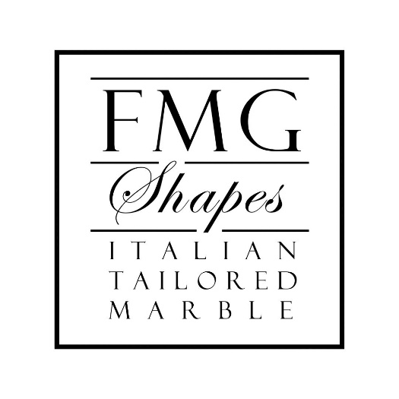

FMG Shapes in Chiampo is an interpreter of Italian luxury in the field of marble and high prestige stone materials.

The company, proudly family-owned, takes its roots from the ancient marble tradition present in the Italian valleys of Vicentino and is now in its third generation. Giovanni Farinon, the grandfather of the current owners, started its activity during the building boom of the Italian market to meet the stone demand of the domestic market. With the entry into the company of the second generation, represented by Ivano Farinon, in the seventies and eighties, production developed with an industrial presence on external markets and concentrated on the realization of tiles in modular 30x30 and 30x60 format on the American market. The entry of the third generation with brothers Daniele Farinon and Simone Farinon in the early years of the new millennium brought a change of strategy in the development of custom project, positioning FMG shapes as the ideal partner for the design, production, shipping and installation of highly complex and luxury custom projects, directly from Italy. The FMG Shapes company began working on great projects in the hospitality world, eventually expanding to residential and retail.

The industrial soul of the Farinon family has allowed to maintain a constant presence of the finishing activity in the company: the investments in technology have always proved valuable in order to be able to provide customers with a comprehensive service, ranging from design and finishing, to customized packaging for every single order.

“Designing – Daniele Farinon states – means finding solutions and operating on culturally diverse, often remoted markets, from Monte Carlo to Central Asia, from the United States to Russia, solutions need to be thought through right from the start to ensure quality service and customer care at every stage of the process, from concept to logistic and installation”.

The strength of FMG shapes lies in the presence in the field of Daniele and Simone Farinon, two complementary souls who combine economic and architectural training, management and entrepreneurial skills with artistic and creative inspiration.

The know-how of the craftspeople is fundamental in this activity; it expresses the artistic training of the stonemason who intervenes in the final phase of the production. This is explained by Simone Farinon: “FMG Shapes works with natural, precious and extremely delicate materials, the ability lies in the fact that for each material, different precautions must be taken during processing, so a bench finisher's skill is proportional to his or her experience in working with a wide variety of stones."

People and the environment are the values of FMG Shapes, which is committed to total transparency with its customers. The dialogue, the relationship and the service between the customer and the company, are fundamental to guarantee a quality service.

FMG Shapes stands out in the market for product customization and Made in Italy production with a view to continuous growth and development. As a spokesperson for innovation, in recent years FMG Shapes company has embarked on a 4.0 implementation process through software systems capable of controlling manual processes by linking them to traditional technical processes.

As Simone Farinon explains “FMG Shapes works with materials that cannot be regenerated and here, the focus on efficient and optimized processing is a key factor.”

A WORLDWIDE PRESENCE

FMG Shapes operates mainly in international markets with a presence in 25 countries. In recent years, it realized all the five-star hotels in Moscow, working with hotel chains such as Hyatt, Intercontinental, Four Seasons. In the countries of the former Soviet Union, the Swiss Hotel chain, present in Kazakhstan and Russia beyond the Urals and in Ukraine is interested in FMG Shapes’ activity.
Recently, the company’s activity has been steadily expanding in the United States, in New York and Los Angeles and in Israel, while work in the southern part of China has been revived, in Hong Kong, Shenzen and Shantung. A special place belongs to the Southern France market.

With 185 completed projects worldwide and a total of 4,000 surfaces per meter produced every month, FMG Shapes specializes in the craftsmanship and production of marble, but not only. The company also offers a range of materials from marble to granite, from limestone to quartz, quartzite and semi-precious materials such as amethyst, opal, up to mother-of-pearl, a very prestigious material, complicated to work with, but with extraordinary aesthetic results that FMG shapes is able to manage directly within the company.

DIALOGUE, CULTURE AND PROJECT STYLES

FMG Shapes works in close collaboration and synergy with architects and interior designers, the main actors, who bring their know-how, knowledge of materials and the technicality of the implementation. The approach with the architect and designer is particularly positive and follows the relationship with the company also in the phase of the visit to the quarry, succeeding in capturing the true beauty of the marbles and their natural veins that a single sample cannot express.

In the projects realized, there is always a balanced relationship between tradition and contemporary. If tradition is still a prevalent cultural factor in the Arab world, the Russian market compared to the taste of the great Italian or French palaces and in Moscow is increasingly demanding for a contemporary taste, in terms of forms even more than in terms of materials.

In projects realized in New York, those that will set the trend for the next five years – FMG Shapes sees the prevalence of soft non-minimalist shapes with a strong emphasis given to the material itself in its identity, without a strong contrast between different materials: travertine, with a very important historicity but basically "poor", juxtaposed to rich and ancient materials with a strong connotation of luxury. The new contemporary, today, is no longer the union of modern forms with exotic materials tending to beauty as an end in itself, but it is the imposition of a trend that binds materials of strong historical value with forms that completely differentiate the project and are strongly identifying.

In the world of hospitality, FMG Shapes stands out for its 360° presence, with projects and achievements from the common areas of restaurants and bars, to rooms and wellness areas. For each environment, the materials are studied, worked on and adapted to the different application needs according to coefficients determined by usage, wear, friction and drinkability.

FMG Shapes has engaged in collaborations with important architecture studios and artists for the realization of dedicated Collections aimed mainly at the world of hospitality and strongly identifying the FMG Shapes design and productive philosophy, which combines modularity and customization.

FMG Shapes – quality and design in the marble and stones craftsmanship

FMG SHAPES
Via Fabbrica, 4
36072 – Chiampo – VI – ITALY
Instagram: fmg_shapes
Linkedin: FMG Shapes - Italian Luxury Marbles

For press inquiries, custom interviews:

OGS PR and Communication
Via Koristka 3, Milan | Italy
ph. +39 02 3450610
info@ogscommunication.com
www.ogscommunication.com - press.ogs.it

