Press Office Ana Moix
T +34 96 321 96 22
press@estudihac.com

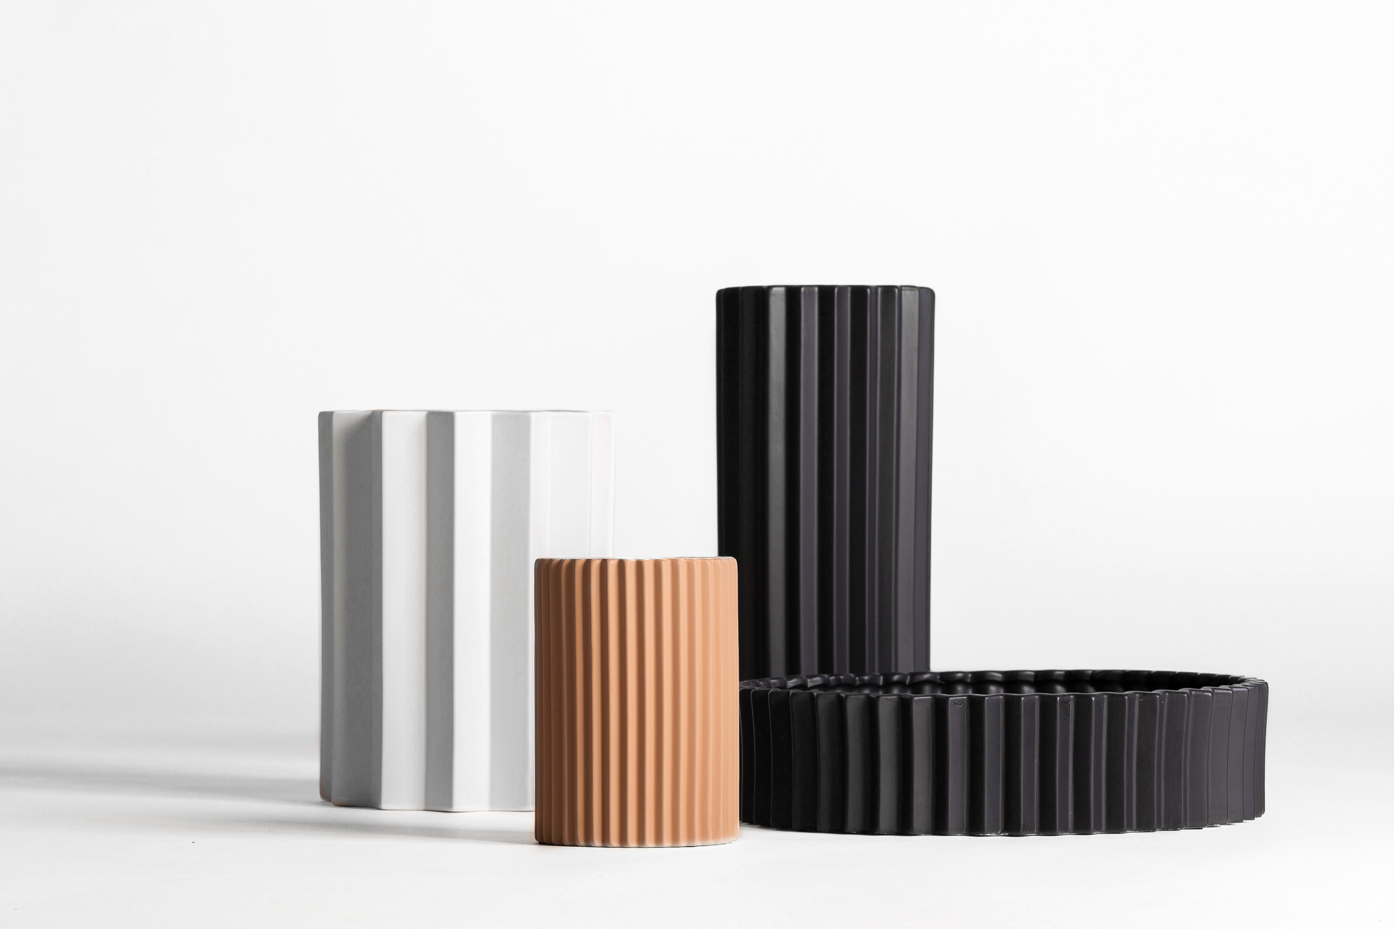

PLISSÉ
PLISSÉ POTS is the extension of the already presented PLISSÉ collection, reflecting the craftsmanship of natural manufacturing processes with design.

This very attractive and elegant collection is inspired by the incredible life of the multi- faceted MARIANO FORTUNY and the work of the Parisian artisan firm LOGNAN.

The production of the pleated fabrics and the processes involved are the driving force behind the design of each one of the new proposals, which along with the synthesis and adaptation of these processes to the three-dimensional shapes, have turned the collection into a real exercise perfectly combining the concept and manufacturing process.

The natural and primary artisan work behind each one of the pieces give it unique and personal character. The combination of the wood carving with natural stone and rattan braiding

with invisible metal structures generates a series of natural graphic textures that come together to bring volume to the pieces.

Client_ VICAL HOME
Website_ https://www.vicalhome.com/es/

For press inquiries and custom interviews:

OGS PR and Communication
Via Koristka 3, Milano
+39 02 3450610
www.ogscommunication.com - info@ogscommunication.com

