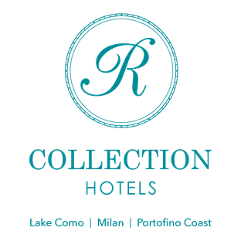
R COLLECTION HOTELS ENTERS THE METAVERSE WORLD.
THE FUTURE IS ALREADY HERE.

R Collection Hotels is part of a sale of NFT (Non-Fungible Token) and since January 31, 2022, at 12 a.m., the hotel group of the Rocchi family has been online on the OpenSea platform, in which everything holistic and experiential can be sold and bought, in the hospitality sector, in collaboration with Takyon, an extremely dynamic and assertive start-up in the world of Web3.

Takyon takes its name from the Tachione, a hypothetical particle having an imaginary mass and speed greater than that of the moon. It is in this climate that R Collection Hotels’ journey began to the Web3, that is, to the Metaverse, the parallel universe made of interconnected virtual spaces. These spaces offer new means of action and interaction in a three-dimensional dimension in which “physical individuals can move, socialize, work, share goods and experiences though their avatars”. This parallel universe and its transitional activities have recently attracted the attention of major market players, such as Facebook, which has strengthened its control over the parallel world by rebranding the company as Meta.

METAVERSE AND HOSPITALITY

With Takyon, R Collection Hotels has started selling a two-night stay for two people with dinner and massage for two at the Grand Hotel Victoria in Menaggio. The Group’s objective is to expand its portfolio of activities and experiences, by creating a platform in which customers can buy cryptocurrencies in the form of NFTs, goods and services such as a special stay, an unusual guided tour, an experience that is difficult to find in the real world, continuing to explore the futuristics potential of Blockchain, Web 3 and Metaverse.

Unlike all other platforms, this NFT brings a sustainable approach as Takyon collaborates with U2Y to make this stay eco-friendly, guaranteeing the customer a carbon neutral stay. The concept of virtual infinite development also considers environmental sustainability.

If it is generally possible to book stays through online booking platforms, the Grand Hotel Victoria in Menaggio has decided to add to the more traditional platforms an unprecedented one, where you can choose to book a hotel in a real or virtual dimension using new payment tools, full of potential.

This project was born from Takyon’s desire to create an innovative and decentralized booking platform that combines NFT and blockchain technology. This combination applied to the world of hospitality wants to reach a range of customers who are heading to the future and will be active in the metaverse. With Takyon, the customer purchases the right to a stay in an incredible way and when it happens in real life at the Grand Hotel Victoria di Menagio, the unique experience becomes real and unforgettable.

This is a new distribution channel whose benefits also lie in the exchangeability of the reservation within a community: Takyon’s objective is to develop accessible and unique services through the development of a property platform and a virtual currency.

R Collection Hotels presents itself as a representative of the future in the virtual world of hospitality, in a reality shared through the internet, a new concept of VR tourism that could lead to many benefits, both economic and functional. And this is just the beginning!

R Collection Hotels
Lake Como | Milan | Portofino Coast
Instagram: @r_collection_hotels
Facebook: R Collection Hotels
Linkedin: R Collection Hotels

For press inquiries and custom interviews:
OGS PR&Communication
Via Koristka 3, Milano
www.ogscommunication.com – info@ogscommunication.com
press.ogscommunication.com
+39 02 3450610

