Dr. FLEMING. A PILOT PROJECT BY ALESSANDRO LUCIANI FOR PHARMACEUTICAL RETAIL STORES

The philosophical approach to design of Alessandro Luciani, eclectic and innovative Italian designer, is focused on an anthropocentric vision oriented towards the involvement of emotions and the creation of new experiences that can contribute to generating individual wellbeing. Therefore, he defines himself as a 'designer of human experiences', reflected in his commitment and constant attention to the psychology of the client, interpreted through the reading of languages and purchasing behavior.

This allows him to translate his reflections and ideas into visionary projects that look beyond the limit of the ordinary to create multifaceted, high-performance and original concepts. Curiosity and competence take him into a vortex of new ideas and projects that also extend to the world of Product Design.

The project for the 'Dr. Fleming' prepharmacy, designed by Alessandro Luciani, is a very innovative concept for the world of pharmaceutical retail, which completely reconsiders and rewrites the relationship between buyers and sellers, or rather between the customer and the pharmacist, redrawing the rules of the relationship between brand, client, product and environment.

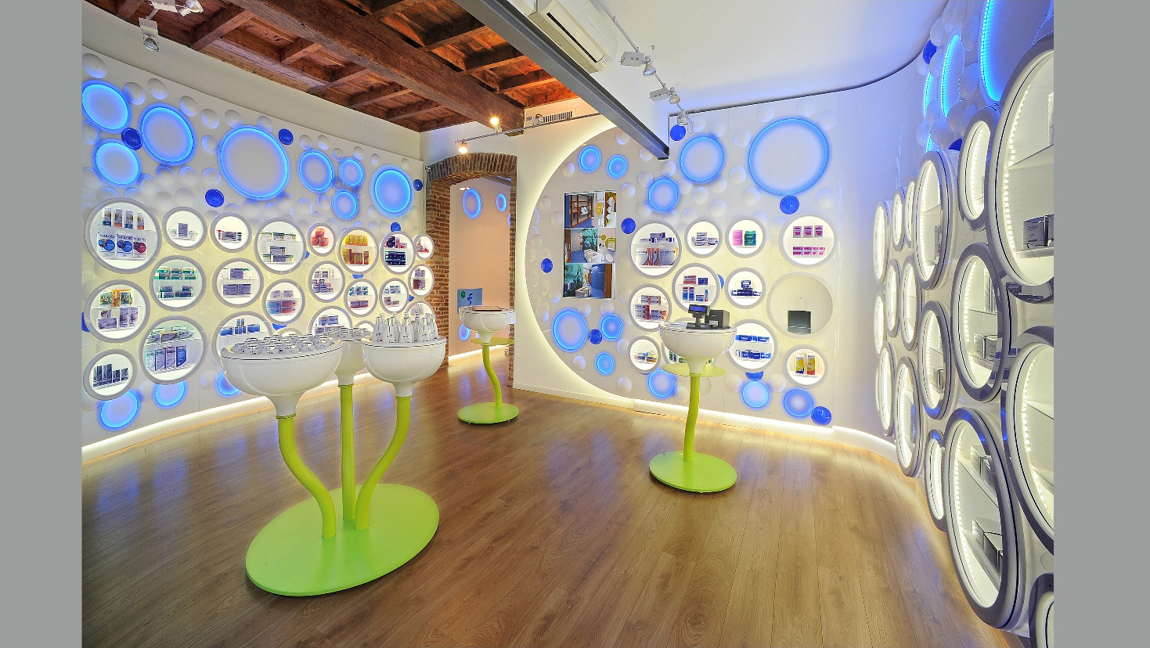

The innovation in this project - which came to life in 2013 in Via Pontaccio in Milan - is the elimination of the classic pharmacy 'counter', eliminating an imposing and divisive element and opening up the space to new ways of displaying, engaging and purchases.

A new model in which the traditional pharmacist-client relationship has been deconstructed, focusing on a vision that aims to abolish all psychological and hierarchical barriers between the client and the pharmacist, transforming the traditional relationship into a human and equal relationship, putting "Man" at the center, reversing the classic commercial dynamic by removing architectural barriers within the point of sale and generating a new relationship that brings the pharmacist to welcome potential clients, dedicating more intimacy to their personal health needs and to the commercial proposal.

From this point of view, the pharmacy becomes a meeting point for people, offering a new sales model with an innovative and original set-up, involving a significant rethink in terms of logistics: the presence of a mechanized warehouse for the management and supply of medicines and products for sale.

"I feel like a pioneer of the idea of transforming waiting into welcoming" - Luciani says - "to move from the perception of lost time to that of time perceived positively as an opportunity for enrichment and personal growth.”

The shop layout is divided into a retail area, a reception and relaxing area and a reserved service area, which guarantees the patient's privacy in maximum safety.

Light and color are the protagonists of this space; a chromotherapy experience is present over the entire point of sale, delicately involving all the senses also through aromatherapy and selected sound diffusion.

The walls are punctuated by a series of circular "bulbs" profiled with light for containing and displaying products. Light in shades of blue and water green is a dominant element and generates a sense of lightness, freshness and hygiene.

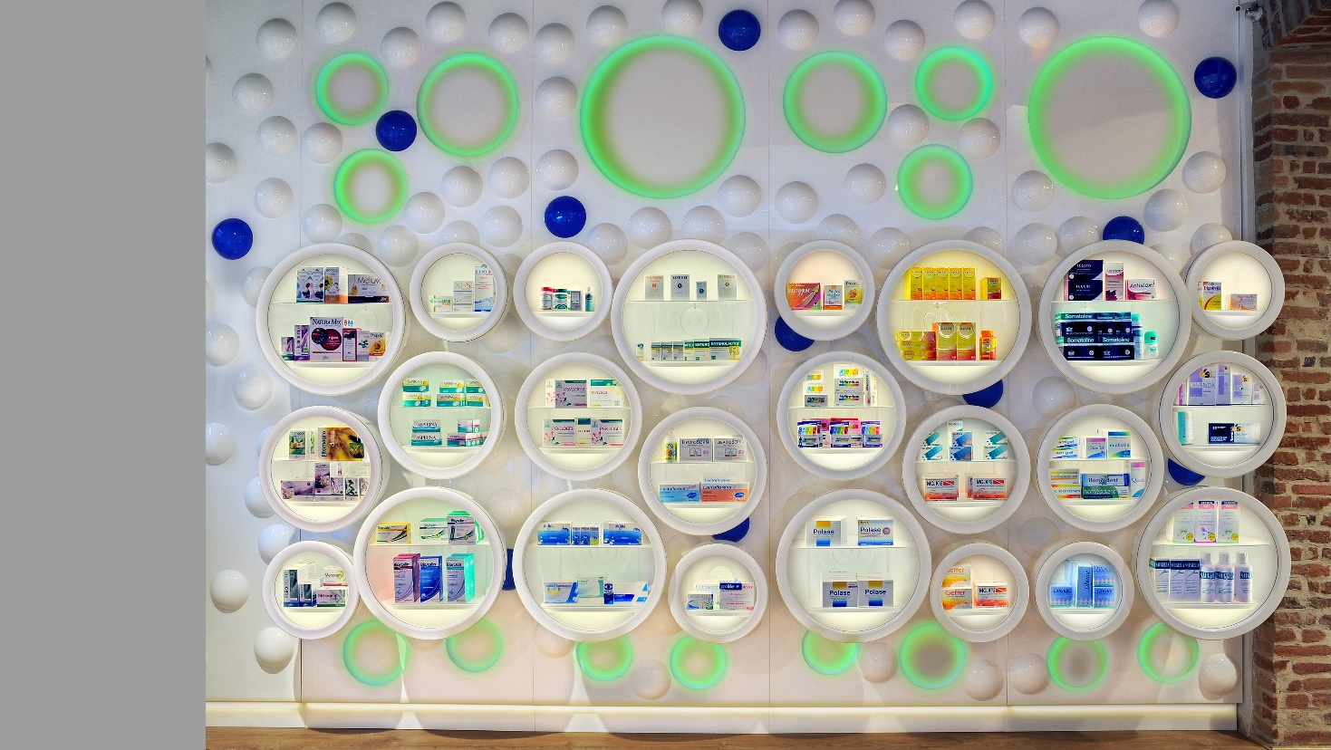

The lighting concept is completed by spotlights mounted on ceiling tracks. On the natural wooden oak floor, in a warm nutty shade, are display elements of various sizes, resting on colored metal supports with an organic profile, like flower buds blooming to life. There is no lack of wood warmth in one area of the coffered ceiling. A profiled brick arch marks the transition to the adjacent room.

Thanks to a continuous process of virtuous contamination between different worlds, passions and contexts, Alessandro Luciani's design path in Retail Concept, Store Design and Interior Design is constantly evolving. From the conception of new concepts to prestigious creations, up to the most recent projects, Alessandro Luciani has received numerous awards and recognitions, also at an international level.

Alessandro Luciani Designer
Head Office - Via S. Eusanio, 1
02100 Rieti Italy
Offices - Roma Milano New York
+39 335.5420070 - info@alessandrolucianidesigner.com

OGS PR and Communication
Via Koristka 3, Milano
www.ogscommunication.com
+39 02.3450610 – info@ogscommunication.com

