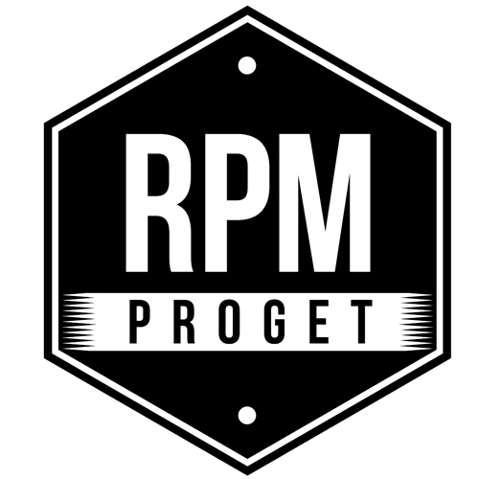

PALMA POKE’ OPENS IN ROME.
YOUNG-STYLE LOCAL FOR NEW FOOD RITES
SIGNED BY RPM PROGET

The RPM PROGET Studio began its professional path twenty years ago in Rome, where it continues to carry out an intense activity of design, construction and restyling of food premises.

Among the most recent projects of the Studio founded by architect Roberto Antobenedetto with interior designer Patrizia Pozzi and architect Michelangelo Pepé, PALMA POKE’ is a ‘Pokeria & Sushi’ that perfectly interprets one of the new food trends of young people.

Located in the San Paolo district, near the Roma 2 University, the restaurant has a target clientele aged between 18 and 30 and is managed by two young entrepreneurs, Andrea and Manuel, who have entrusted the specific expertise and recognized versatility of RPM the realization of their dream.

With two large windows on the street, the 35 square meter venue offers 20 seats inside and 15 seats outside, in addition to 35 square meters of basement, which houses the kitchen, bathrooms and dressing room. In perspective, a small room adjacent to the street level will be added, which will allow the capacity to be increased by a further 30 seats.

PALMA POKE’ is a dazzling, colourful and quite original space, because it goes out of the box and is meant to be a meeting point where to get and stay pleasantly together, enjoying the excellent offer of bowls based on rice, tuna and salmon, drinking beer or house-made cocktails.

The main element of the space is a big counter with 40 trays for the preparation of the bowls and 4 containers for the various types of rice, to be consumed on the spot or for delivery. The counter, suitably lit, is covered with wooden logs cut with a fish-scale effect that, reflecting on the blue display case, amplifies the nice aesthetic effect. Images of events and dedicated communication messages scroll across the three large monitors in the back-counter area.

The restaurant is identified by the particularity of the decoration. The walls are covered in hand-made majolica in blue shades and the floor is in oak-effect porcelain stoneware adorned with a large floral decor made with Clorofilla cement tiles produced by Ceramica Fioranese. The ceiling recalls the idea of ​​an aerial pergola, from which a cascade of greenery descends, that goes well with the swing, large wooden benches and wicker chairs. The scenographic effects were handled with skill by Federica Ambrosini and the captivating set of lights and colours invites clients to take a selfie and post the images on social media.

With this project, the RPM PROGET team confirms once more its specificity in successfully completing a path of study and research with the full satisfaction of the customer, to create each time original premises supported by a bright and attractive storytelling, which makes them recognizable and, at the same time, make them unique in the space-for-food scene.

RPM PROGET
Via Gregorio VII, 472, 00165 Roma
www.rpmproget.it/ - info@rpmproget.it
+39 06 66019011

OGS PR and Communication
Via Koristka 3, Milano
www.ogscommunication.com – info@ogscommunication.com
+39 02 3450610

