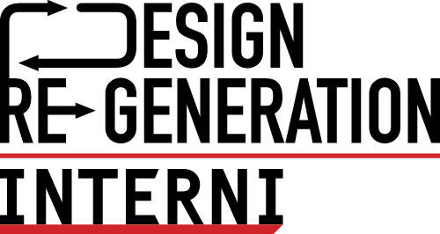
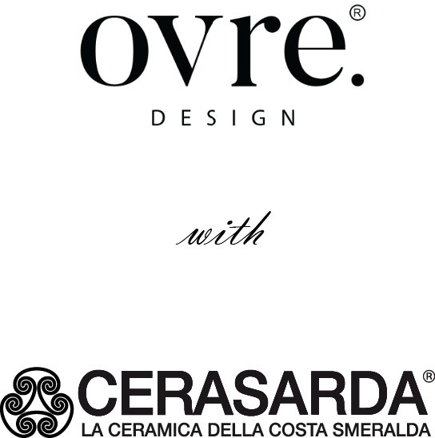

ELEMENTA BY OVRE.DESIGN
EXPLORES THE RELATIONSHIP BETWEEN MAN AND NATURE
UNDER THE STRONG SIGN OF CERAMICS

It will be an installation to experience and to discover through a game of reflections that reveals the symbols and language of the material, presented by ovre.design and Cerasarda and Romani Group on the occasion of the Milan Design Week and hosted in the INTERNI Design Re-Generation spaces from June 6 to 13, 2022 at the University of Milan.

The ‘Elementa’ project, conceived by the architectural studio of Giulia Delpiano, architect, and Corrado Conti, interior designer – based in Reggio Emilia – aims to explore the relationship with natural elements to present through the interpretation of the inspiring concept the new collection of the Atelier division of Cerasarda, the ceramics of the Costa Smeralda.

On the paths that lead man to the knowledge of nature, the awareness was born that no experience exists without observation, just as no matter exists without the awareness of its presence. In turn, only awareness can generate the respect and vision of a universe where the forces and tensions that work and regenerate themselves continuously, are translated into another matter, artisanal, fragile, unique, authentic and real.

There is all the complexity of the infinite possible realities behind the Elementa project, which reveals itself little by little while exploring the space-time dimension, which only finds its definition in the extent to which man enters into relationship with the reality he lives in.

THE FOUR ELEMENTS AND THE INSTALLATION

The first approach to finding balance with who we are and the universe of the senses, is the interaction with the four primary elements: water, earth, fire and air. For ovre.design, choosing the art of ceramics is the artisanal expression of this relationship, the sensory approach that involves all elements through the interpretation of man.
The installation realized by Intro contract is a journey from macro to micro, from the universe and its constellations to ceramic mosaics, through four physical elements that host decorative elements designed by ovre.design and produced by Cerasarda’s skilled craftsmen.

Each of the four stands of the installation is characterized by a color and decoration – carefully handcrafted – and places an element of nature in the center, whose luminous symbol is only revealed when the visitor sees it reflected in the mirror.

Each of the four elements is represented by mirrored ceramic vases, the lids of which are each surmounted by a sign of the zodiac - of water, fire, earth and air - acting as protective guardians of the twelve vases decorated with faces of powerful archaic signs.

The Elementa project wants to remind us who we are – understood as human beings - the sole creators of our physical and existential reality and succeeds in making this message more evident and explicit than ever through the ancient and timeless language of ceramics.

ovre.design®.
Via dell'Abbadessa 10, Reggio Emilia Italy
www.ovredesign.com

For press inquiries and custom interviews

OGS PR and Communication
Via Koristka 3, Milan | Italy
ph. +39 02 3450610
info@ogscommunication.com
www.ogscommunication.com

