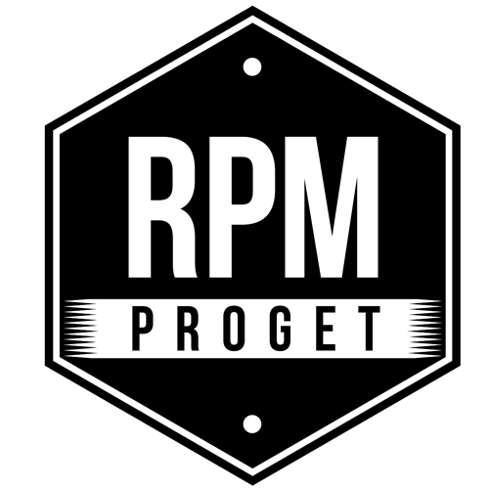

RPM PROGET REALIZED MATER PANTHEON,
VERY SPECIAL PIZZERIA IN THE HEART OF ROME

RPM PROGET is a reference term in the field of design and construction of spaces for food, a sector in which the Roman studio brings all the originality of its proposals, the search for authenticity and the value of a consolidated experience. The historical core of the studio, which has been operating in Rome since 2003, is made up of architect Roberto Antobenedetto, interior designer Patrizia Pozzi and architect Michelangelo Pepé, togheter with a team of young collaborators.

Among the most recent achievements of the RPM studio, there is a very special pizzeria, which has been able to combine new consumer trends with the taste of tradition and the most modern functionality.
MATER is a newly opened restaurant in the Colonna district in Rome, featuring four iron windows overlooking via della Maddalena with its beautiful church in a combined style Baroque-Rococo, located 50 meters from the Pantheon, in the ancient heart of the city.

The choice of the name is a remind to the historical context and a strong link with the past, but it also contains the flavor of a tradition that refers to the concept of mother yeast, the main ingredient of pizza. In fact, MATER is mainly designed for those who love traditional pizza with the shovel, but more of it, this is an atypical pizzeria, different from the usual venues of this kind. Extended over two floors, each of about 115 square meters, this venue has a total of 25 seats inside and 30 seats in the outdoor area. It’s an all-day-food venue, operating from breakfast to dinner and after dinner, designed by RPM to bring together three different souls: Pizza, Market and Cucina (Kitchen).

In the first entrance hall, an imposing counter displays a triumph of sliced pizza, fried foods, vegetables, pasta dishes and refrigerated food, all visible from the window, which is set up like a grocery store, with hanging cured meats, various types of products and pizza, in a tasty gastronomic dialogue with the windows of the historic Feroce butcher’s shop, which is opposite across the street.

The Market is showcased on a large wall next to the Cassa, where only products of Roman and Italian gastronomy are to be found, from pasta to oil, from cheeses to wine, from cold cuts to beer. Food and drinks can be purchased, may be after having tasted them on the spot, to bring home the pleasure of a good traditional Italian product. For this heavily used area, a CESI-produced cement floor with octagonal dowels was chosen, which helps give a touch of 'vintage' decoration.

Next to it, a room of 30 square meters with 25 seats with parquet flooring in treated natural oak and mounted in a Portuguese herringbone pattern, welcomes customers with tables and upholstered armchairs, a bench and a 5-meter Chester sofa. The idea is to offer a comfortable space where people can comfortably seat with their food tray and stay for a while, without any rush. In the room, a sunny, energetic, bright yellow is predominant and the decoration is entrusted to two large paintings depicting the Goddess of food and Crows on a Wheat Field by Vincent van Gogh. On the wall, there is a brick covering 7, 5 x 15 with a large structure used as a winery. The tiles lining the bathrooms and the two large LED signs in the window are also yellow.

The Kitchen is an open space, like a large raised control room, featuring state-of-the-art equipment - including two ovens by Castelli and Italforni - with a team of 10 people in charge of food preparation.
The service functions are hosted in the lower floor, together with the washing area, bathrooms with showers, the staff changing room and the warehouse.

"Those who love food are able to realize beautiful places dedicated to food, but above all they must be places designed to work well" says RPM architect Michelangelo Pepè, explaining the team's philosophy and their design approach always combining functionality, aesthetics and know-how in a successful mix.

RPM PROGET
Via Gregorio VII, 472, 00165 Roma
www.rpmproget.it/ - info@rpmproget.it
+39 06 66019011

OGS PR and Communication
Via Koristka 3, Milano
www.ogscommunication.com – info@ogscommunication.com
+39 02 3450610

