OGNI INDICAZIONE È FIRMATA APIR!
EVERY INDICATION IS SIGNED APIR!

San Marino (Headquarter) – APIR is a reference company in the hospitality and residential field for indoor and outdoor signage and safety signs, nationally and internationally. Signage ensures effective visual communication that aims to provide maximum information to customers to guide them in a simple and intuitive path. At the same time, signage must be an expression of brand identity, combining functionality with aesthetics to enhance the environment in which it is placed. APIR’s philosophy aims to offer the market solutions capable of enhancing signage as a public information tool and an element of design and furniture that expresses its creativity and high aesthetic impact.

As Pietro Angelini, owner of APIR, says: “Our goal is to create signage that is in tune with time and space, and that enhances the space and the project through the choice of font, shape and color. A well-functioning sign is one that we cannot see unless we look for it, that the eye only catches when the information is needed and that is present when the customer needs it. Signage always present but never invasive.”

Signage is present in every space. The first memory of the guest on arrival? The outdoor signage! APIR’s objective is to make the company’s image unforgettable by providing a wide range of solutions characterized by a variety of styles, shapes and materials. APIR offers original exterior plates with flags, backlit or with traditional outdoor lettering to create a welcoming and engaging entrance. Every sign can be customized: with traditional or linear, minimal or contemporary fonts, and with shapes ranging from classic to the increasingly popular lettering.

Thanks to the outdoor directional signage collections, it is also possible to create a series of totem and insignia to be placed in open spaces to easily guide guests to the services offered by the hotel.

And once the guest enters the hotel? They are certainly looking for directions! That is when APIR signage comes into play to indicate the different zones and interior spaces. This type of signage requires attention to detail and experience in understanding the customer’s need, in order to realize solutions in which information are clearly shown and received. Thanks to the consolidated experience in the sector, APIR is able to create products that satisfy the functional part combined with Made in Italy design.

APIR’s production is characterized by the development of unique collections that favor quality raw material such as brass, steel, plexiglass, iron and aluminum.

What signage is absolutely not to be missed in any environment? The safety one. "Safety signage must also be consistent with the interior and design of the project, respectful of current regulations and be able to effectively and clearly communicate all useful information, says Pietro Angelini." The company thus offers a complete range of panels and symbols suitable for all types of hospitality facilities: restaurants, hotels, shopping centers, offices and public places. APIR offers different stylistic solutions, from classic glass to painted metal signs that echo the colors and design of the facility, from regulatory signs to the most important escape plan. The choice of a custom-designed security sign is a result of the customer's better perception of the environment.

APIR stands out in the market as the main supplier and producer of quality signage, collaborating with the most prestigious architectural and interior design firms and the main players in the hotel sector. Between craftsmanship and industry, APIR uses cutting-edge technologies and materials, providing ad hoc solutions for hotels but also restaurants, residences and tourist villages, in order to make the environments more refined, welcoming and comfortable.

For APIR, every request is personalized! The company has carried out many prestigious and exclusive projects in Italy and abroad, developing the complete signage system requested by the customer, always remaining consistent with the style of the structure.

Details matter, even the ones you don't seem to see!
____________

A selection of APIR’s indoor and outdoor signage:

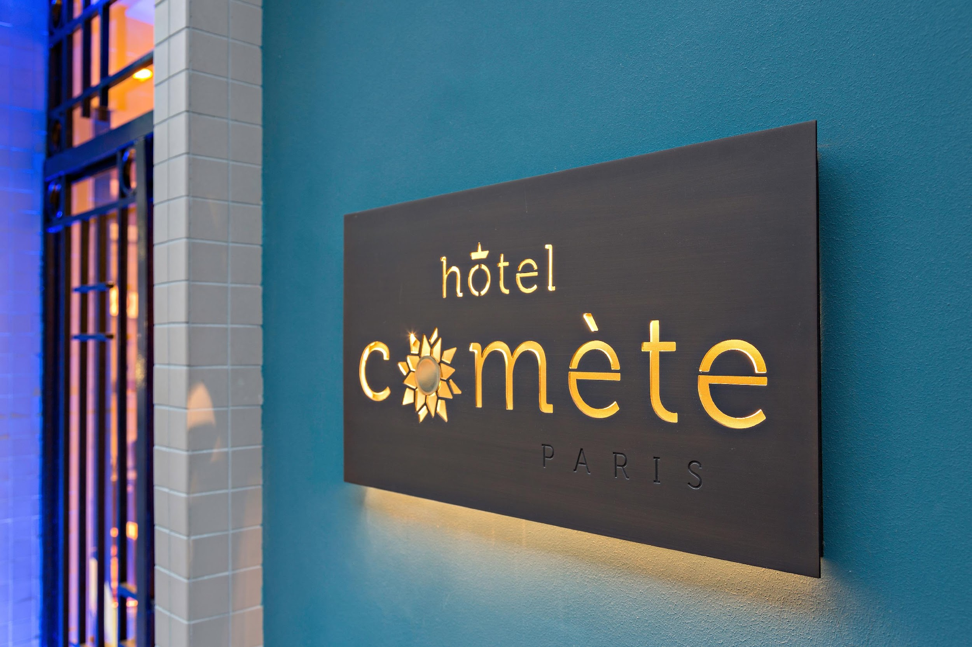
COMET. Outdoor signage. Project reference: Hotel Comète Paris

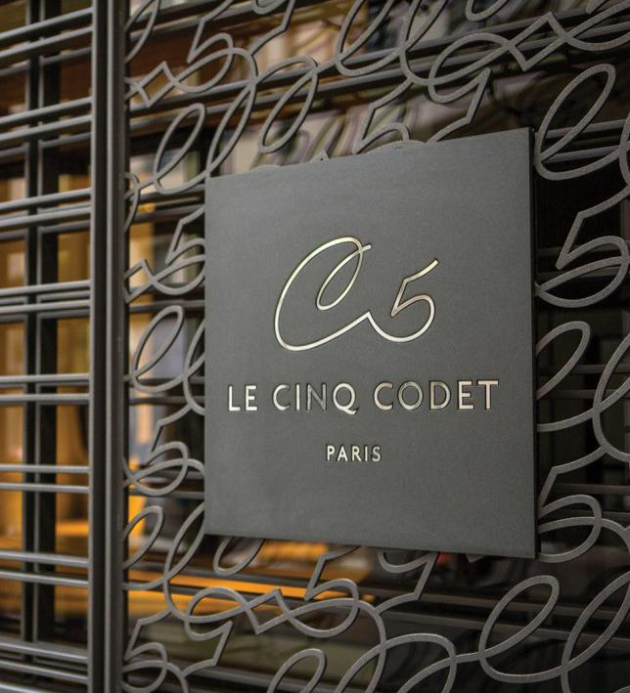
OKAY. Outdoor signage. Project reference Hotel Le Cinq Codet, Paris.

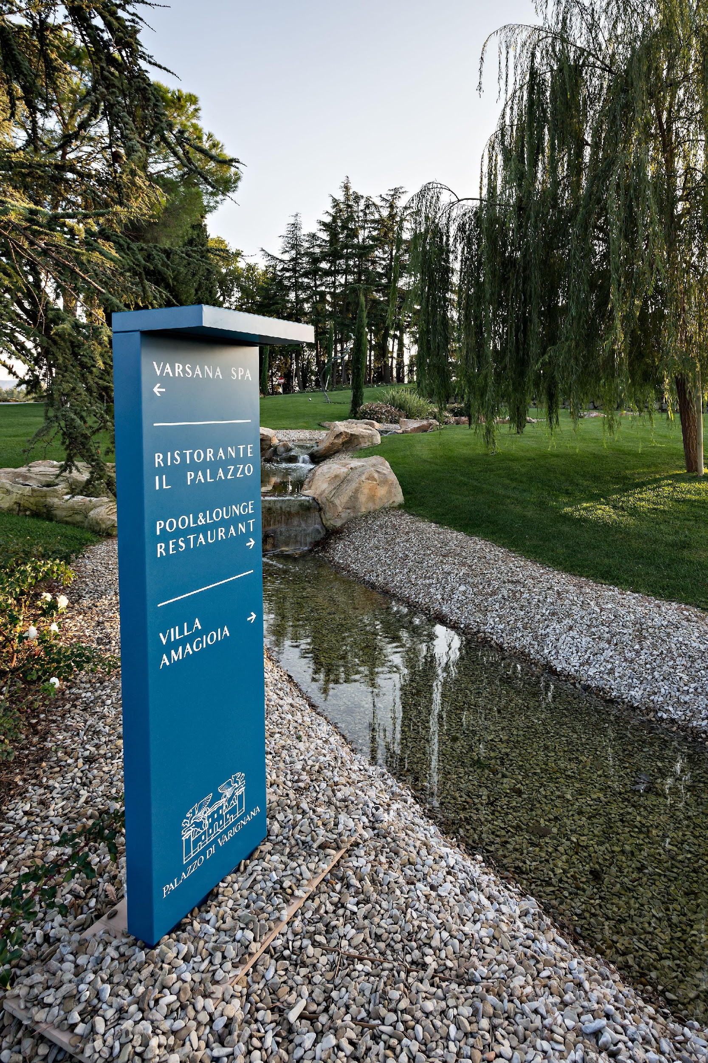
SPEAK. Outdoor signage. Project reference Palazzo di Varignana (BO), Italy.

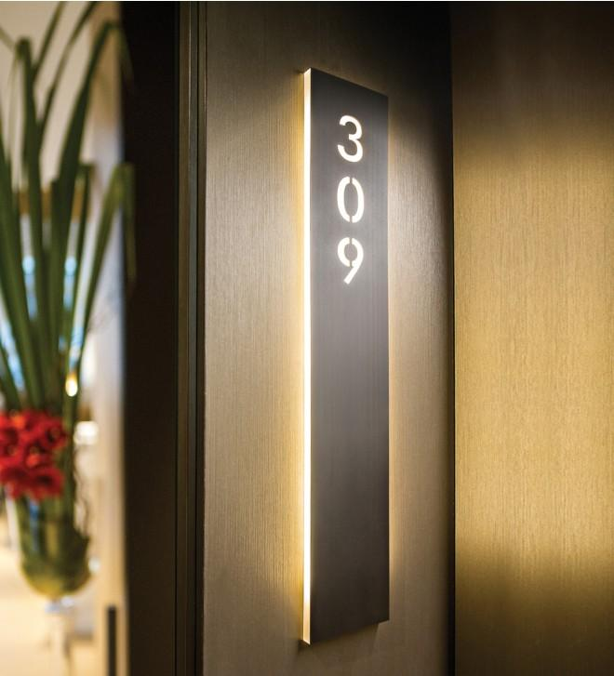
STRIPE. Indoor sign.

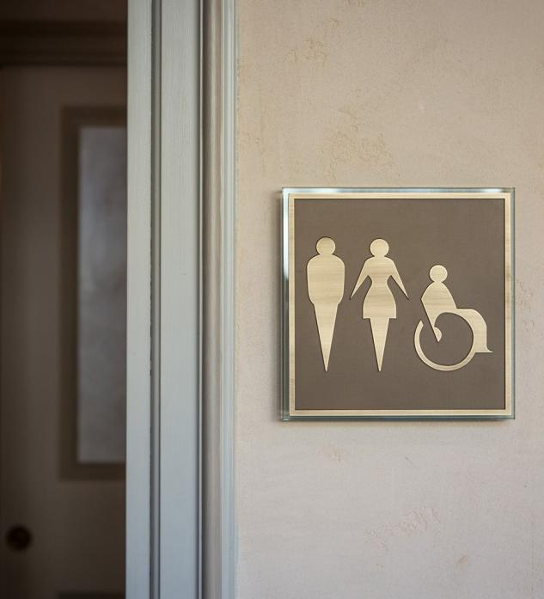
DIVA. Indoor sign.

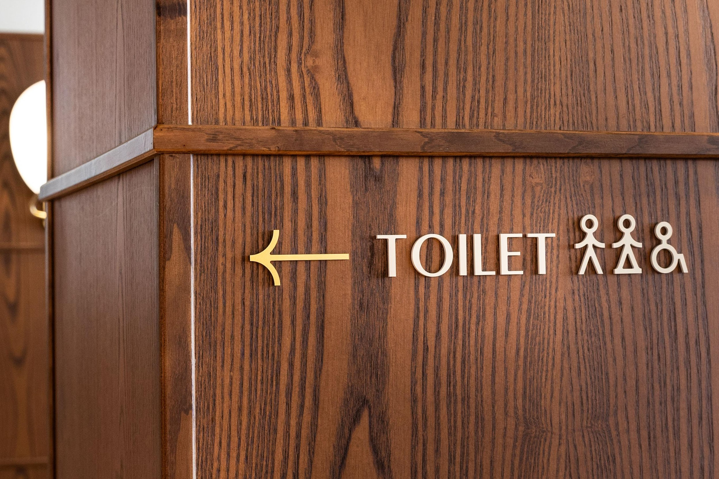
LET. Indoor sign.

Discover other products on the APIR catalogue.

About us

Since 1918, APIR has been designing and providing indoor and outdoor signs, furnishings, accessories and light switches for hotels, apartments, villas and luxury offices in Italy and Europe. A handicraft company, born as an engraving, with a consolidated family history, now in its third generation and whose headquarters and production site are based in Acquaviva in the Republic of San Marino.

APIR
San Marino (Italia)
Via Prato delle Valli, 58
47892 Acquaviva Repubblica di San Marino

For press inquiries and custom interviews:

OGS SRL PUBLIC RELATIONS & COMMUNICATION
Via Koristka 3, 20154 Milano, (Italy)
Ph. +39 023450605
http://www.ogscommunication.com - info@ogscommunication.com
press.ogscommunication.com

