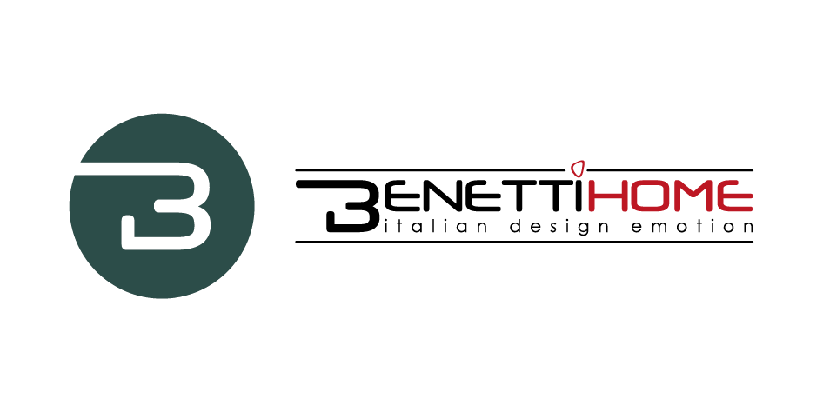
MR. FLOCK BY BENETTI HOME
SWINGING LONDON AND A NEW COLLECTION TO IMPRESS

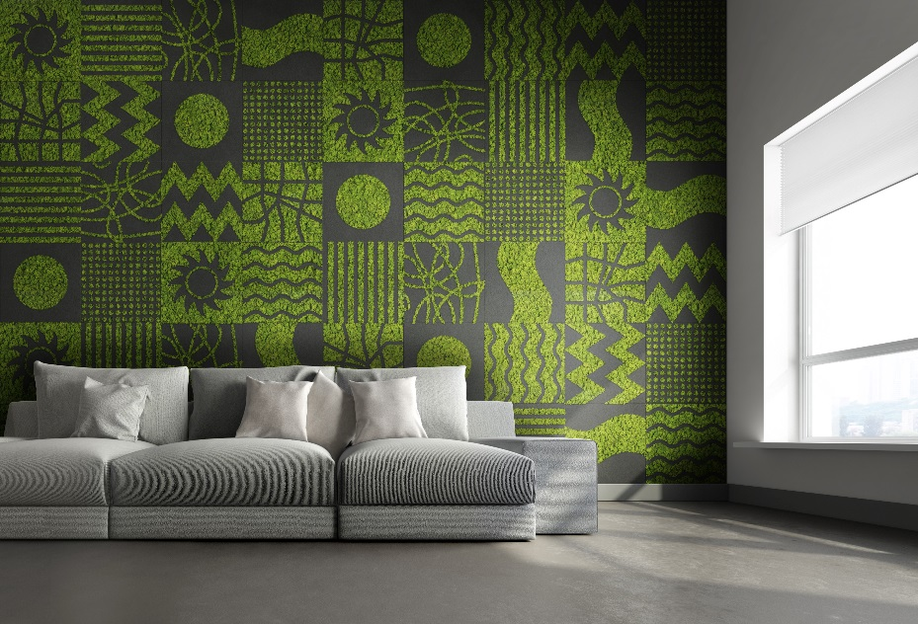

Loyal to its corporate mission, designing and creating interior spaces that arouse unique emotions thanks to the magic that comes from 'Italian design emotion', BenettiHOME - a consolidated and dynamic Italian company based in Novara - presents its new collection MR. FLOCK, a product with novel features from a technical point of view and with a formidable aesthetic impact.
The result of a major corporate investment commitment in research and development, MR. FLOCK represents the perfect contract solution for offices, hotels, restaurants, bars and retail spaces.
The features of this product make it unique on the market.
"I call it an exclusive product," says Stivens Benetti, owner of the company, "because there is nothing like it, and we at BenettiHOME are particularly proud to be able to present to designers and architects a collection with a uniquely design that offers endless application possibilities. From a technical point of view, MR. FLOCK panel consists of a polyurethane backing, a compact, lightweight and soundproofing substrate, which is engraved to obtain the various graphics and then treated with the flocking technique (velveting), which makes the surface soft and pleasant to the touch.
The panels are made in 2.5 cm thickness in the 60x60 cm format and submultiples. The geometric shapes are designed by the company's Style Office, and the collection is available in a standard range of 16 colors. Quick to install and easy to clean, MR. FLOCK is applied to the wall using 3M™ Dual Lock™ stripes.

MR. FLOCK is the new vertical garden, unique for the possibility of adding BenettiMOSS, the internationally recognized key product, thanks to countless references and projects carried out all over the world. MOSS is a 100% natural and preserved lichen called cladonia stellaris, which is harvested in the forests of Northern Europe and is confirmed as a product with great natural appeal, requires no maintenance, is stable, and does not attract insects.
The panels in the new collection can also be supplied with only a flocked surface, but the unique and novel combination of MR. FLOCK and MOSS infinitely expands their design capabilities, multiplying their application solutions and making projects more interesting and attractive.

MR. FLOCK GOES TO LONDON

The MR. FLOCK comes with a very rich catalog, offering a surprising array of graphic aesthetic and thematic declinations, including: THE STRAND, reproductions of iconic monuments of the world's cities; LITTLE ITALY, with delicate floral motifs and verses of famous poems; HACKNEY, for those who love round graphics; SHOREDITCH for a foray into hexagonal shapes.
And then, again, graphics that recall a world of London metropolitan suggestions: PICCADILLY CIRCUS, FITZROVIA, BLOOMSBURY, GREENWICH, KING'S ROAD, WESTMINSTER, REGENT STREET... because a collection called MR. FLOCK cannot fail to call to mind the atmospheres and suggestions of London, its mists, its colors, the red double deckers, the theaters, the pubs, the docks along the Thames.
New architectures have altered the city's skyline, but the charm of a historic establishment that smells of woods, aromas and antiques, that remains.
In a corner, sitting on a snug velvet armchair, a figure half-hidden in the half-light can be glimpsed, slowly savoring a cigar. It is someone who belongs to the narrative of the new BenettiHOME collection.
We like to think of him as MR. FLOCK.

Benetti Home
Via Giacomo Matteotti, 34, 28060 Granozzo NO
info@benettihome.com - www.benettihome.it

OGS PR and Communication
Via Koristka 3, Milano
+39 02 3450610
info@ogscommunication.com - www.ogscommunication.com
press.ogscommunication.com

