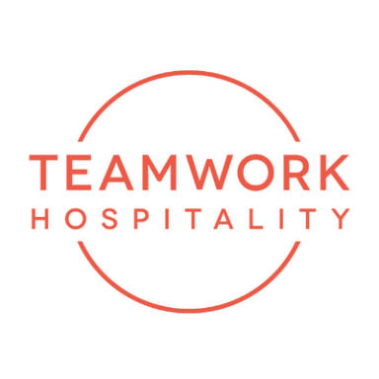

ITHIC 2022: hospitality towards a new season of development.
In a very complex macro-economic context, fundamentals remain strong

Experts and professionals in the real estate and financial sector met with hospitality leaders from seven countries on 10th and 11th October 2022 in Rimini, at ITHIC, a "Davos" meeting of the hotel and finance sector in the hospitality field.
The sector will face an important post-Covid adjustment phase in a very complex macro-economic context, but fundamentals of demand - say the main analysts - remain strong and expectations are focused on those international markets that have long suffered from Covid restrictions.
The real estate markets will for a long time remain compared with attention and scrutiny with other more liquid financial markets (equities, bonds, utilities, etc.) but - according to analysts - among the asset classes, the hotel one will enjoy good health over the two-year period 2023-2024 .
The success of this edition was confirmed by the numbers: an unexpected level of attendance led to an early closure of registrations, with 848 participants from 7 European countries and some attendees from the United States and the MEA area.
Relevant presence of leaders of global companies, such as Accor, NH, Marriott, Hilton and the main investment funds, such as Azora, Blackstone, Cerberus, Goldman Sachs and some of the main Italian banks, Intesa, Unicredit, ICCREA.
The event, now in its fourth year, recorded the presence of some international analysts from CBRE, PWC, KPMG, Deloitte, EY and the extraordinary participation of some of the main foreign investors.
The organizers are very satisfied for an edition finally free from Covid limitations, in the words of Mauro Santinato (Teamwork): "ITHIC confirms itself as the must-be event for Italy in the real estate hospitality scene. The community of investors, brands, Italian chains and banking has given a very good feedback by investing heavily in the event and making it grow almost spontaneously, responding to a sectoral need that was already very strong in the pre-covid phase."
In the words of Giorgio Ribaudo (THRENDS), creator of ITHIC and responsible for the contents and positioning of the conference: "The 2022 edition made the participants feel the sense of planning a more informed, updated and international development path. We are very satisfied above all with the role played towards the Italian chains that in ITHIC find a meeting point - I hope an ideal one - to build alliances and take inspirations from international models. Italy remains an attractive investment target even though the scrutiny used for analysing the opportunities has increased, as stated by the attention on returns. We are already thinking about the 2023 news with the contribution of CBRE, which has been the main sponsor for years, highly contributing to the international relevance of the event and its positioning in the investor community."

TEAMWWORK HOSPITALITY
Rimini, Via Macanno 38/q
Ph. 0541-57474
info@teamworkhospitality.com
www.teamworkhospitality.com

OGS PUBLIC RELATIONS & COMMUNICATION
Milano - Via Koristka 3, (Italia)
Ph. +39 023450610
www.ogscommunication.com – info@ogscommunication.com

