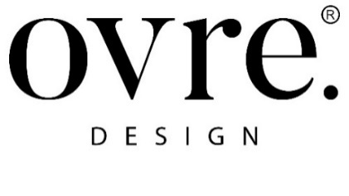

ovre.design® and styling for Fabscarte

Ensuring a high-quality stylistic visual brand identity by valorizing the product with communication. Emphasizing the richness of hand-decorated wallpapers by creating unique atmospheres.

A collaboration was born between ovre.design® – an international team of designers, architects and creators founded by architect Giulia Delpiano and designer Corrado Conti, based in northern Italy and with projects in Europe and the United States, and Fabscarte – an Italian company operating in Milan with a strong international focus, specialized in the conception and exclusively handmade production of precious wallpapers that reinterpret centuries of Italian decorative art with contemporary visuals and innovative techniques.

This encounter resulted from shared creative visions and ideas, fusions between traditions and experiences and projections towards the future. Fabscarte's dedication to beauty and constant pursuit of perfection combined with a passion for creativity has found in the architectural firm ovre.design® - which has always been oriented toward aesthetic and contemporary quality – a creative direction in perfect harmony with the brand's vision and mission.

The set design and styling for wallpapers studied by ovre.design® interprets the values and stylistic language of the brand through the creation of original visual arrangements. They portray moving environments of contemporary elegance to highlight a product intended for an exclusive clientele, mainly from international markets.

The aesthetic sensibility of ovre.design® is the result of creating environments characterized by colors, plays of light and shadow, and props expertly created to make the Fabscarte product the protagonist. Environments embellished with decorative and furnishing elements that communicate through an expressive language of sophisticated elegance the uniqueness of wallpapers, true works of art, made by hand. Immersive, contemporary, evocative and engaging atmospheres that bring out the thorough research and experimental work of Fabscarte in the study of shapes, colors, materials and combinations.

ovre.design®.
Via dell'Abbadessa 10, Reggio Emilia Italy
www.ovredesign.com

OGS PR and Communication
Via Koristka 3, Milan | Italy
ph. +39 02 3450610
info@ogscommunication.com
www.ogscommunication.com - press.ogs.it

