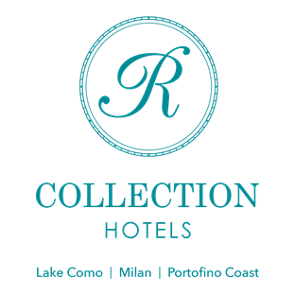

FRANCESCO SARNO, EXECUTIVE CHEF
OF HOTEL ROYAL VICTORIA and VILLA CIPRESSI
IN VARENNA ON LAKE COMO

A special focus on catering is what has always characterised the R Collection Hotels in order to guarantee its facilities high-level chefs with important professional experience.
For this season’s opening in March, Francesco Sarno will be the Chef of the two restaurants of the Hotel Royal Victoria – Victoria Grill and Royal Victoria – and of the Food&Beverage of the Villa Cipressi in Varenna. The Royal Victoria restaurant offers fine dining cuisine with an enchanting view of Lake Como. The Victoria Grill, overlooking the piazzetta of the ancient village of Varenna is opened to both Hotel guests and external Clientele, presenting a more informal setting but enriched by the perfect combination of Italian and international flavoured dishes. Two properties with distinct and complementary souls with the common aim of providing customers with a 360-degree experience, also through wide-ranging gastronomy. For Villa Cipressi, Chef Sarno will oversee the catering for all ceremonies, weddings and special events. A triple challenge for the Chef who counts in his palmarès starred and high-level experiences.

CAREER PATH
Francesco Sarno's professional path began with the discovery of a cuisine rich in authentic products at a typical Campania osteria. Over time, he shifted through different restaurant experiences, specializing in gourmet cuisine and luxury hospitality, holding roles from head chef to sous chef in multiple environments like Acquapetra Resort and SPA – a luxury hotel in the province of Benevento – up to the best Italian restaurants, such as the Michelin-starred I Portici Hotel in Bologna with Chef Agostino Iacobucci, Il Castello di Spaltenna, one Michelin star, in Chef Vincenzo Guarino's brigade, and the two-Michelin-starred Capri Palace.
Francesco Sarno's cuisine is a passion that dialogues with the Italian territory. His journey began in Campania, passing through Tuscany, Lombardy and Emilia-Romagna to arrive in the precious village of Varenna on Lake Como at the Hotel Royal Victoria and Villa Cipressi of the R Collection Hotels Group.
The philosophy behind the creation of each dish is the exaltation of the genuine flavor, with a cuisine that succeeds in encapsulating all the Chef's professional experience. For the restaurants of the Hotel Royal Victoria, the Chef envisions a 100 percent Italian cuisine that is able to restore the authenticity of Mediterranean products through the use of local ingredients revisited with a contemporary and international vision.
"We work on refined research and selection of raw materials to continue to offer a level of quality that has always distinguished both Victoria Grill and the Gourmet restaurant, says Chef Sarno. The result will be a team effort. We are organizing a well-established brigade that can best represent the cuisine of the Royal Victoria hotel and can guarantee excellent quality service in the Banquet of Villa Cipressi."

R Collection Hotels
Lake Como | Milan | Portofino Coast

Instagram: @r_collection_hotels e @hotelroyalvictoria @villacipressi
Facebook: R Collection Hotels e Hotel Royal Victoria e Villa Cipressi
Linkedin: R Collection Hotels

OGS PR and Communication
Via Koristka 3, Milano
www.ogscommunication.com – info@ogscommunication.com
+39 02 3450610

